SPSS Homework 6 Instructions
Prediction - Bivariate Linear Regression
Part 1:
Note: You will use raw data for all homework exercises with no need to convert to z scores.

Green & Salkind: Lesson 33 Exercise

Open Lesson 33 Exercise File 1 found in Blackboard Course content (under Syllabus and Assignment Instructions—Assignment Instructions—SPSS Homework 6—SPSS Homework 6 Files—Mod6_Lesson 33 Exercise File 1).

This data set pertains to Peter’s study on the number of times boys hit a doll and a peer, as described in the end of chapter exercise in Green and Salkind Lesson 33. Read the research scenario in the text, then follow the directions below as some questions have been altered.

- Conduct a linear regression to predict the number of times a boy would strike a classmate from the number of times the boy hit a bobo doll. Use raw scores, not z scores, in the regression analysis. Paste SPSS output, then answer the following questions:

Descriptive Statistics
 | Mean | Std. Deviation | N
Number of times hitting a peer | 11.60 | 20.095 | 10
Number of times hitting a bobo doll | 4.90 | 8.048 | 10

Correlations
 |  | Number of times hitting a peer | Number of times hitting a bobo doll
Pearson Correlation | Number of times hitting a peer | 1.000 | .930
Pearson Correlation | Number of times hitting a bobo doll | .930 | 1.000
Sig. (1-tailed) | Number of times hitting a peer | . | .000
Sig. (1-tailed) | Number of times hitting a bobo doll | .000 | .
N | Number of times hitting a peer | 10 | 10
N | Number of times hitting a bobo doll | 10 | 10

Variables Entered/Removedª
Model | Variables Entered | Variables Removed | Method
1 | Number of times hitting a bobo doll^{b} | . | Enter
a. Dependent Variable: Number of times hitting a peer
b. All requested variables entered.

Model Summary
Model | R | R Square | Adjusted R Square | Std. Error of the Estimate
1 | .930ª | .865 | .848 | 7.835
a. Predictors: (Constant), Number of times hitting a bobo doll

ANOVAª
Model |  | Sum of Squares | df | Mean Square | F | Sig.
1 | Regression | 3143.306 | 1 | 3143.306 | 51.205 | .000^{b}
1 | Residual | 491.094 | 8 | 61.387
1 | Total | 3634.400 | 9
a. Dependent Variable: Number of times hitting a peer
b. Predictors: (Constant), Number of times hitting a bobo doll

Coefficientsª
Model |  | Unstandardized Coefficients |  | Standardized Coefficients | t | Sig. | 95.0% Confidence Interval for B
 |  | B | Std. Error | Beta | t | Sig. | Lower Bound | Upper Bound
1 | (Constant) | .221 | 2.944 |  | .075 | .942 | -6.568 | 7.010
1 | Number of times hitting a bobo doll | 2.322 | .325 | .930 | 7.156 | .000 | 1.574 | 3.071
a. Dependent Variable: Number of times hitting a peer

- What is the value of the slope in your output? 2.322
- What is the value of the additive constant? .221
- What is the mean number of times a boy hit a classmate? 11.60
- What is the correlation between hitting a doll and hitting a classmate, as given in the output? .930/1.0
- Create a scatterplot of the relationship between the two variables. Plot the regression line on the graph.

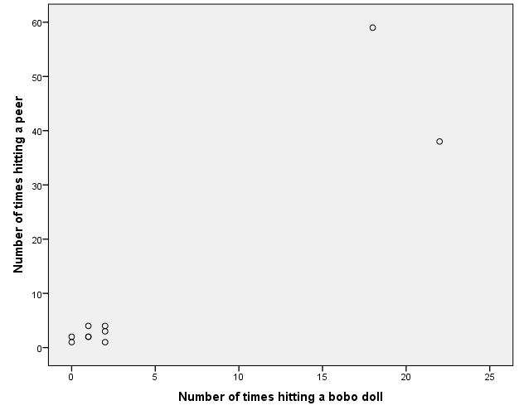

- Write a Results section based on your findings. All homework “Results sections” must follow the example given in the SPSS tutorial presentations and the Course Content document “Writing Results of Statistical Tests in Current APA Format.” Note: The statistical statement for a bivariate linear regression must include at least the equation of the line and the confidence interval for the slope (the second row under Confidence Intervals in the output), as well as a decision about the null hypothesis.
A bivariate linear regression analysis was used to determine the difference in the amount of time a boy would hit his bobo doll and

Part 2:
- Research scenario: A social psychologist is interested in whether the number of days spent in a refugee camp predicts trauma levels in recently resettled refugees. He interviews 17 refugees to determine how many days they spent in a refugee camp before being resettled, then administers the Harvard Trauma Questionnaire Part IV (HTQ Part 4), where a higher score indicates higher levels of trauma (Mollica et al., 1992). He compiles the information in the table below. Conduct a bivariate linear regression to analyze the research question.

The steps will be the same as the ones you have been practicing in Part 1 of the assignment—the only difference is that you are now responsible for creating the data file as well. Remember to name and define your variables under the “Variable View,” then return to the “Data View” to enter the data.

Days Spent in Refugee Camp | HTQ Part 4 Score
12 | 0.4
73 | 1.1
60 | 0.9
105 | 2.3
98 | 1.7
76 | 0.3
89 | 0.7
173 | 2.6
189 | 3.1
203 | 3.0
138 | 1.9
215 | 2.5
71 | 0.7
67 | 1.2
63 | 1.8
184 | 2.9
63 | 0.6

- Paste SPSS output

Descriptive Statistics
 | Mean | Std. Deviation | N
HTQ Part 4 Score | 1.629 | .9674 | 17
Days Spent in Refugee Camp | 110.53 | 60.810 | 17

Correlations
 |  | HTQ Part 4 Score | Days Spent in Refugee Camp
Pearson Correlation | HTQ Part 4 Score | 1.000 | .882
Pearson Correlation | Days Spent in Refugee Camp | .882 | 1.000
Sig. (1-tailed) | HTQ Part 4 Score | . | .000
Sig. (1-tailed) | Days Spent in Refugee Camp | .000 | .
N | HTQ Part 4 Score | 17 | 17
N | Days Spent in Refugee Camp | 17 | 17

Variables Entered/Removedª
Model | Variables Entered | Variables Removed | Method
1 | Days Spent in Refugee Camp^{b} | . | Enter
a. Dependent Variable: HTQ Part 4 Score
b. All requested variables entered.

Model Summary
Model | R | R Square | Adjusted R Square | Std. Error of the Estimate
1 | .882ª | .777 | .763 | .4714
a. Predictors: (Constant), Days Spent in Refugee Camp

ANOVAª
Model |  | Sum of Squares | df | Mean Square | F | Sig.
1 | Regression | 11.642 | 1 | 11.642 | 52.383 | .000^{b}
1 | Residual | 3.334 | 15 | .222
1 | Total | 14.975 | 16
a. Dependent Variable: HTQ Part 4 Score
b. Predictors: (Constant), Days Spent in Refugee Camp

Coefficientsª
Model |  | Unstandardized Coefficients |  | Standardized Coefficients | t | Sig. | 95.0% Confidence Interval for B
 |  | B | Std. Error | Beta | t | Sig. | Lower Bound | Upper Bound
1 | (Constant) | .079 | .243 |  | .325 | .749 | -.439 | .597
1 | Days Spent in Refugee Camp | .014 | .002 | .882 | 7.238 | .000 | .010 | .018
a. Dependent Variable: HTQ Part 4 Score

- Construct a scatterplot of the relationship between the 2 variables. Plot the regression line on this graph.

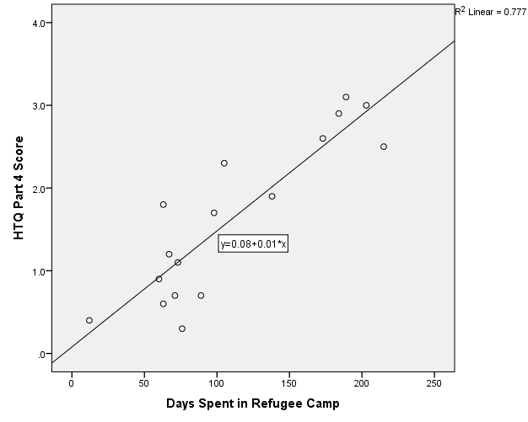

- Are the number of days spent in a refugee camp predictive of trauma in this sample? Write a Results section in current APA style describing the outcome. All homework “Results sections” must follow the example given in the SPSS tutorial presentation and the Course Content document “Writing Results of Statistical Tests in Current APA Format.” The statistical statement for a bivariate linear regression must include at least the equation of the line and the confidence interval for the slope (the second row under Confidence Intervals in the output), as well as a decision about the null hypothesis.

Part 3: Cumulative Homework
- Research scenario: To investigate the relationship between hours spent studying and exam scores, researchers found the scores in the following table. Is there a significant relationship between hours spent studying and scores? Choose the correct test to analyze this question, set up the SPSS file, and run the analysis. Follow the directions under the table on the following page.

Hours Spent Studying | Exam Scores
1  3  3  4  4  5  5  5  6  6  7  7  8 | 40  50  51  61  73  71  64  75  68  76  94  85  84

- Paste appropriate SPSS output.

Descriptive Statistics
 | Mean | Std. Deviation | N
Hours Spent Studying | 4.92 | 1.935 | 13
Exam Scores | 65.47 | 16.565 | 15

Correlations
 |  | Hours Spent Studying | Exam Scores
Hours Spent Studying | Pearson Correlation | 1 | .917**
Hours Spent Studying | Sig. (2-tailed) |  | .000
Hours Spent Studying | N | 13 | 13
Exam Scores | Pearson Correlation | .917** | 1
Exam Scores | Sig. (2-tailed) | .000
Exam Scores | N | 13 | 15
**. Correlation is significant at the 0.01 level (2-tailed).

- Paste appropriate SPSS graph.

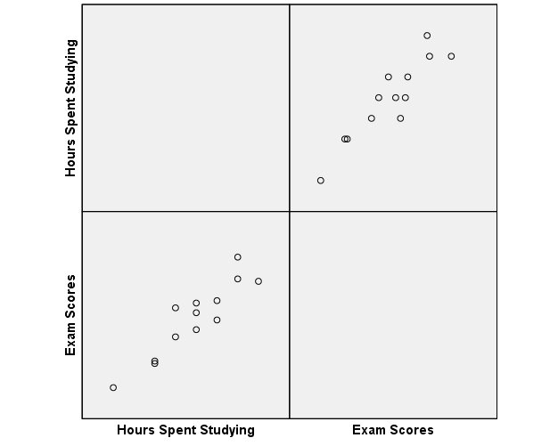

- Write a Results section in current APA style describing the outcome. All homework “Results sections” must follow the example given in the Course Content document “Writing Results of Statistical Tests in Current APA Format.”
A correlation coefficient test was run to determine if the amount of time spent studying directly affected exam scores. The results determined r(11)=.92, p=.000, falling beneath .05, failing to reject the null hypothesis.

Submit this assignment by 11:59 p.m. (ET) on Monday of Module/Week 6.

