- Forensic serology is the study of blood, semen, saliva and other body fluids to legal matters. The identification of body fluids is an important examination to help determine which body fluid stains are suitable for deoxyribonucleic acid (DNA) analysis. Forensic serology utilizes screening or presumptive tests which allow stains on anything that a body fluid may have come into contact with during a crime be identified; for example, weapons, clothing, glass, and carpet.
- Every examination begins with a visual examination of the item, and then screening tests are performed depending on the case scenario. The case scenario helps the analyst determine if should only be looking for possible blood stains or semen and blood stains. An alternate light source may be used to help with the visualization with stains that are normally not visible with the naked eye; for example, semen, saliva, sweat and urine. The stain is then tested with appropriate screening tests and/or confirmation tests. If the stain is positive for the screening test; then those particular stains are either swabbed or cut out and forwarded for DNA analysis.
Sexual Assault Evidence Collection Kits (SAECK) are commonly used in collecting evidence from victims. The SAECK contains swabs for collecting potential body fluids from particular areas on the victim's body. The victim's clothing may also be collected depending on the type of assault.
Purpose: To demonstrate body fluid stains on items of evidence and determine the type of examination to perform.
Procedure: Based on the scenarios and photos, discuss how you would analyze this particular item for forensic serology. Please make sure you discuss all aspects of analysis, type of tests (presumptive or confirmatory), specialized equipment, et cetera (refer to the reading material or Internet for assistance). Remember to use APA format, if you obtain information from an outside source.

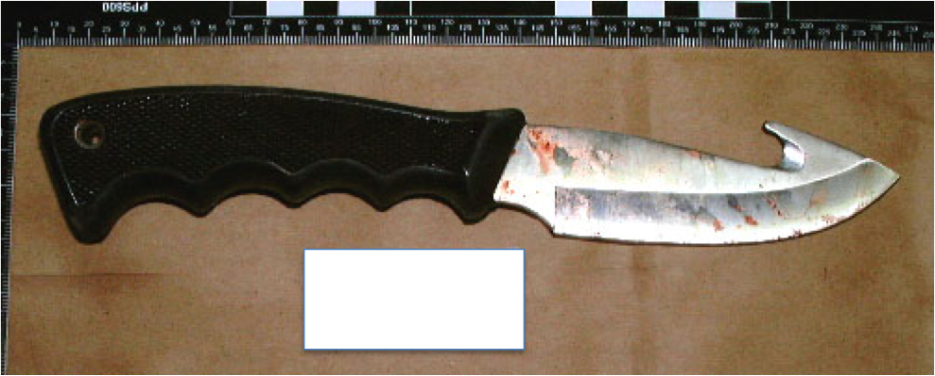

What type of forensic serological analysis would you perform on this knife? (Discuss how you would begin your analysis and what testing would be performed).

Scenario 2
This pair of underwear was included in the Sexual Assault Evidence Collection Kit that was collected from the victim at the local hospital. The victim stated that she was walking home through town when someone grabbed her from behind and shoved her into an alley. The perpetrator sexually assaulted her, took her purse and then left her in the alley. (The white box was the case information when this photo had been taken).

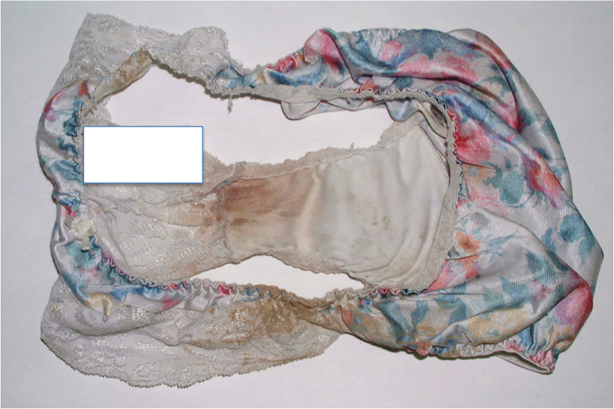

What type of forensic serological analysis would you perform on this item? (Discuss how you would begin your analysis and what testing would be performed).
Assignment must have the following below for full credit.
- Ensure that you are defending your responses with the use of course material via in-text citations and a reference section. The in-text citations and reference section should be in APA format. Please review the Weekly Assignment Rubric for the specific number of resources required for maximum points.
- The student provided ample supporting detail to each question.
Utilizes at least 3 resources from course material to defend responses.
- The student demonstrates full knowledge and clearly reflects specific information presented in the course material.
- Description of scientific terms, facts, concepts, principles, theories, results and methods are complete and correct.
- The student demonstrates full knowledge and clearly reflects specific information presented in the course material.
- Description of scientific terms, facts, concepts, principles, theories, results and methods are complete and correct.
- The student demonstrates full knowledge and clearly reflects specific information presented
- Student applies scientific knowledge, skills, and methods to manipulate, analyze, synthesize, create and evaluate. Applications are thorough, appropriate, and accurate.

