- Given a directed graph G and a pair of nodes u and v, design a Python program that determines if u is reachable from v, and v is reachable from u.

- An undirected graph G (think of it as a social network) is a graph in which edges are not directed. If (u,v) is an edge, then (v,u) is also an edge. Here is how you can generate a random undirected graph from the graph module we used:

G = graph.random_graph(10, 0.4, directed=False)

Write a Python program to count the number of communities in an undirected graph. Two communities, in this problem, are not connected at all. For example, the graph below has 3 communities:

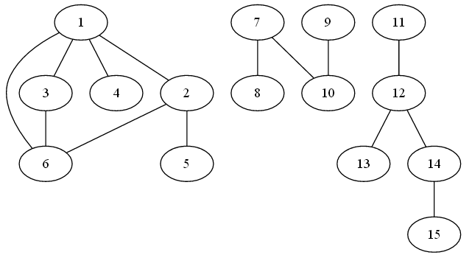
Hint: you can explore undirected graphs the same way you explore directed graphs. Nodes in undirected graphs do not have .In and .Out neighbors. Instead, they only have a .Neighbors attribute. In other words, the ids of neighbors of node 0 are G.Neighbors[0].

