 | Course Code | Type Course Code Here
 | Description | Computer Programming 2
College / Department:  Online Education | Laboratory  Exercise No. | 003
LABORATORY EXERCISE |  | Page 1 of 3
Instructions:
• Upload your solution to the link provided on the course page.
• You may submit the java file, or the rar or zip file.

• For the java file, your filename must be in this format: Lab2_<lastname_firstname>.java
Example: Lab2_Blanco_Maria.java

• For multiple java files, save them into one folder. The folder name should be in this format:
Lab2_<lastname_firstname>, Example: Lab2_Blanco_Maria
Compress the folder into .rar or .zip format before uploading.

• For projects created using NetBeans, the project name should be in this format:
Lab2_<lastname_firstname>, Example: Lab2_Blanco_Maria
Compress the project folder into .rar or .zip format before uploading.

• DO NOT SUBMIT THE WORD FILE. Failure to follow the instructions will mean a deduction
from your score.

Write the program based on the given instructions.

1. Circle Calculator. Write a circle calculator program that computes the area, circumference and diameter of a circle. The program will accept input number (radius) and that number will be used to get the area, circumference and diameter of a circle. Use this formula to find the area, circumference and diameter of a circle:
Π = 3.14
Area = πr²
Diameter = 2r
Circumference = 2πr

Below is the sample output of the program:
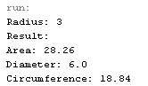

 | Course Code | Type Course Code Here
 | Description | Computer Programming 2
College / Department:  Online Education | Laboratory  Exercise No. | 003
LABORATORY EXERCISE |  | Page 2 of 3

2. Using JOptionPane, create a program that will ask the user to enter their personal information, such as name, age, address and contact number. The program should display all the information that the user have entered. For example:
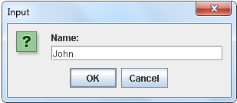
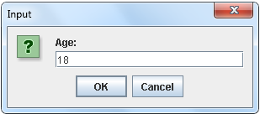
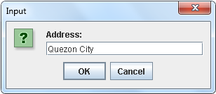
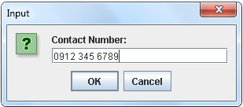

 | Course Code | Type Course Code Here
 | Description | Computer Programming 2
College / Department:  Online Education | Laboratory  Exercise No. | 003
LABORATORY EXERCISE |  | Page 3 of 3

