Using IDLE 3.6.1.

Small program with a UI
Program takes a user input of seconds and converts it into hours, minute and seconds and displays it back to them. Make use of dialogs.

Takes a user input of seconds and convert it into hours, minute and seconds and display it back to them. Make use of dialogs. Here are the requirements for this lab:

- A Calculate button will convert the seconds to the hours/minutes/seconds
- Include all the widgets provided in the below screens
- The Seconds and Converted Time labels shall be left aligned
- An "Invalid Input" error when the user provides an invalid value (non-integer) using exception handling
- The quit button will close the dialog and end the execution of your program. (I.e. the shell prompt should become active again.
- A title for the program in the title base. "Seconds Converter"
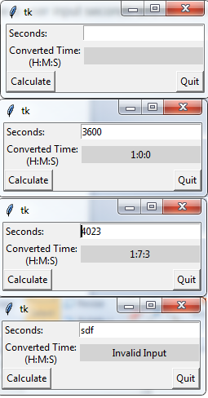

- Invalid Input Dialog
- If an invalid user input is entered into the program an error dialog will be displayed to inform the user that they have entered an invalid input
- The dialog will have a message to the user letting them know that their input was invalid
- Once the user presses close the program will return to the UI where the user provides the seconds and continues to operate normally "Close"
- The text in the results area from your main program will be cleared

- Quit Dialog
- When the user hits the quit button, a dialog will appear with the following:
- A "Continue" button that allows them to close the Quit dialog and end the conversion program
- A "Cancel" button that will allow them to close the Quit dialog and return to the conversion program
- A message of ask the user if they are sure they want to quit.

