H4 Correlation& Regression

Answer every question in the blue boxes provided below each question prompt.

- Read the two versions of the article linking childhood candy consumption to adult violence. First document is the word document then; the other article is on this website http://bjp.rcpsych.org/content/195/4/366

Answer the following questions (5 points):
  - What claim is being made? (a sentence)
Answer:

  - Describe two plausible explanations of the association between candy consumption and adult violence other than the impact of ingesting sugar. (two to four sentences)
Answer:

  - Why not conduct an experiment on the effects of childhood candy consumption on adult violence? (a couple of explanatory sentences)
Answer:

- Dr. Carefree placed unobtrusive video recording devices in the living rooms of 20 children. Later, coders (Matt, Mark, and Peter) viewed tapes of the living areas and coded how many minutes each child spent playing video games. Dr. Carefree wants to use the two most reliable coders. Whom should she pick and why? (1 point)

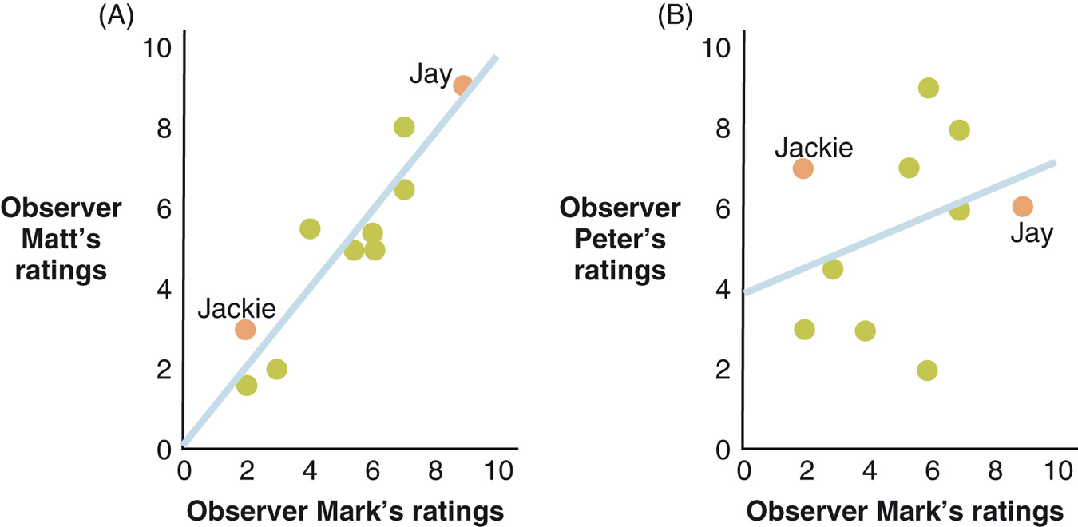

Answers:
Coders:
Why:

- What is the best estimate for the correlation that summarizes each of the four following scatterplots (1 point each)?

Use one these values for your best guess for each graph:
-.80, -.20, 0, .20, .80

Answers:
Scatterplot | Value

- Dr. Miller walks into a bar. He asks a random sample of patrons how confident they feel (their chances of picking up a member of the opposite sex, measured by subjective probability), and also how many beers they have drunk this evening. His results are shown in the following graph:

  - In his study, what is the independent variable? The dependent variable? How are the two variables related in his data? (3 points)
IV:
DV:
How are they related?:

  - If the average person has drunk 2.5 beers, approximately what does the average person think their chances are of picking up somebody in the bar in this study? (1 point)
Answer:

  - The regression equation shows a significant beta weight for beer of .41. What is the best interpretation of this estimate? (1 point)
Answer:

- Dr. Miller has a couple of research assistants rate the physical attractiveness of each of the participants in his bar study. Miller wants to know if differences in physical attractiveness might offer an alternative explanation of why some people are more confident than others. Perhaps more attractive people are more confident and also drink more beer. Miller combines the data, that is, the average of his raters’ attractiveness ratings along with the number of beers consumed, in a multiple regression equation. He finds that the beta weights for attractiveness and beers consumed are .25 and .39, respectively, and that both are significant at the .01 level (that level is a p value, not a blood alcohol level). What should Dr. Miller conclude about the apparent effects of attractiveness and beer? (2 points for each variable). Do his results suggest that he can rule out attractiveness as a third variable explanation of the effects of beer? (1 point).
Answers:
What should Dr. Miller Conclude? | Attractiveness:
What should Dr. Miller Conclude? | Beer:
Do his results suggest that he can rule out attractiveness as a third variable explanation?

