Homework 7
CSC005

1. (4 pts) What is a gate? What is a circuit?
A:

2. (6 pts) What are the three notations for describing the behavior of gates and circuits? Give the definition of each one
A:

3. (18 pts) Give the three representations of the six types of gates and say in words what each of the gates means.
Logic Diagram  Symbol | Boolean Expression | Truth Table | Mean in words
 | Boolean expression: X = A' | 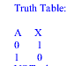 | A is the input signal and X is the output signal.  NOT takes a binary input value and inverts it.
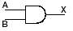
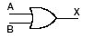
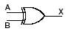
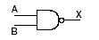
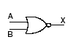

4. (24 pts) Answer question A and question B.

Question A: Draw circuit diagrams corresponding to the following Boolean expressions:
X = (AB + C) CD | Logic Diagram:
X = A'(B⊕C) | Logic Diagram:

Question B: Give the Boolean expression for the following circuit diagrams.

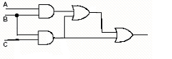 | Boolean expression:
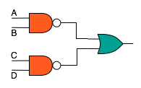 | Boolean expression:

5. (24 pts) Answer the following questions:

- What is the stored-program concept and why is it important?
- Explain what is meant by "fetch an instruction."
- Explain what is meant by "decode an instruction."
- Explain what is meant by "execute an instruction."

6. (24 pts) After reading the two articles on John von Neumann and Alan Turing, write an essay describing the contributions of each to computer science and their importance and then, debate who had a bigger impact on the history of computers (there is no right or wrong answer, you have to justify your choice well with data and examples). (At least 3/4 of a page, single spaced). In the reference list include the two articles and any other sources you found and used in your writing. Throughout the text, refer to readings as appropriate.

