Question 1

Which of the following best represents a multi-valued attribute?

Question 1 options:

A) A person's name

B) A person's GPA [grade point average]

C) A person's social security number

D) A person's favorite foods

Question 2

Garden Glory is a company that provides yard maintenance services to its customers. Garden Glory offers many types of services such as grass cutting, shrubby maintenance, flowering planting, trimming, etc. Many of its customers have multiple properties [houses, office buildings, apartment complexes] that require gardening and lawn maintenance services. Garden Glory wants to maintain data on customers, properties, services offered and also track services provided. For services provided, they want to know what property, who that property belongs to and what services the property receives.

Which of the following represent entities for this scenario. THERE MAY BE MORE THAN ONE ANSWER.

Question 2 options:

[] Type of property such as apartment complex [] Type of service such as grass cutting

[] City [] Customer Last Name [] Property

[] Service Tracking [] who the property belongs to

[] Street Address [] Yard Service [] Customer

Question 3

Garden Glory is a company that provides yard maintenance services to its customers. Garden Glory offers many types of services such as grass cutting, shrubby maintenance, flowering planting, trimming, etc. Many of its customers have multiple properties [houses, office buildings, apartment complexes] that require gardening and lawn maintenance services. Garden Glory wants to maintain data on customers, properties, services offered and also track services provided. For services provided, they want to know what property, who that property belongs to and what services the property receives.

Which of the following represent attributes for this scenario. THERE MAY BE MORE THAN ONE ANSWER.

Question 3 options:

[] Type of service such as grass cutting [] Service Tracking [] Customer

[] Who the property belongs to [] Customer Last Name [] Yard Service
[] Property [] Street Address [] City

Question 4
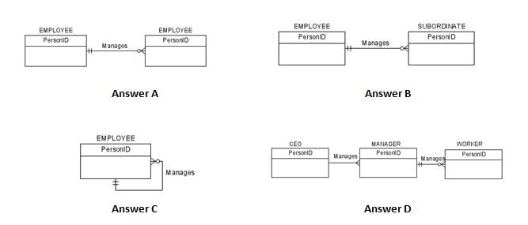

Given the following scenario, choose the best ERD diagram.

An employee may manage many employees or may not manage any employee. Every employee is managed by one and only one employee.

Question 4 options:

A) ER Diagram A

B) ER Diagram B

C) ER Diagram C

D) ER Diagram D

Question 5
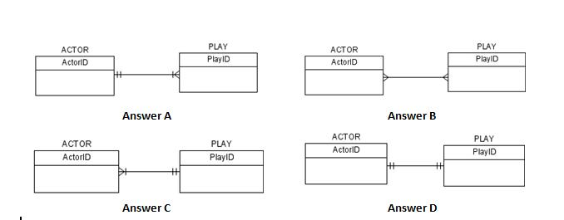

Given the following scenario, choose the best ERD diagram.

An actor can perform in many plays. A play can have many actors.

Question 5 options:

A) ER Diagram A

B) ER Diagram B

C) ER Diagram C

D) ER Diagram D

Question 6
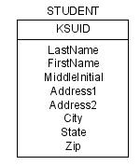

What is the identifier of the displayed entity?

Question 6 options:

A) First Name

B) KSU ID

C) Last Name

D) ZIP
Question 7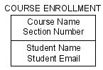
What is the identifier of the displayed entity?

A) Section Number

B) Course Name and Section Number

C) Course Name

D) Course Name and Student Name

Question 8
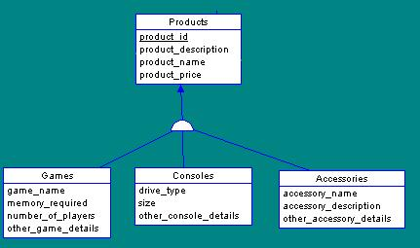

What type of relationship does the displayed ER Diagram represent?

Question 8 options:

A) Unary

B) A strong -weak entity

C) Supertype-subtype

D) Many to Many mandatory

Question 9
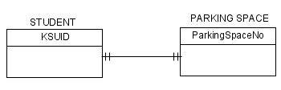
The displayed diagram would be read as which of the following statements?

Question 9 options:

A) Students are never assigned a parking space.

B) A student is assigned a specific parking space and a parking space is assigned to a specific student.

C) A student may be assigned a parking space and a parking space might be assigned to a student.

D) A student may park in many different parking spaces and parking spaces can be designated for students.

Question 10
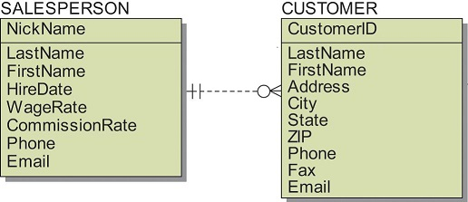
Which statement best represents the model shown in the following ER Diagram

Question 10 options:

A) A salesperson must have customers assigned to them but a customer does not need to be assigned to a salesperson.

B) A salesperson must have customers assigned to them and a customer has to be assigned to a salesperson.

C) A salesperson may have many or no customers assigned to them. A customer must be assigned to a salesperson.

D) A salesperson may or may not have customers assigned to them and a customer may or may not be assigned to a salesperson.

Question 11
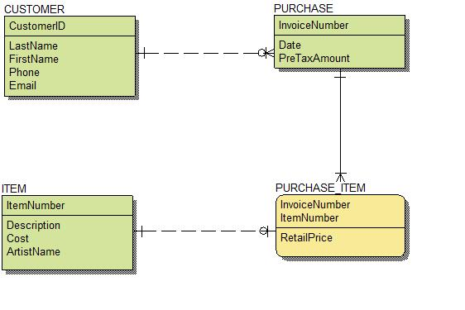

Match the following relationships to those depicted in the ER Diagram displayed.
Question 11 options:

CUSTOMER – ITEM  ITEM – PURCHASE_ITEM  CUSTOMER – PURCHASE  PURCHASE – PURCHASE _ITEM |  | 1. 1:M, M-O  2. No relationship  3. 1:M, M-M  4. 1:1, M-O

Question 12
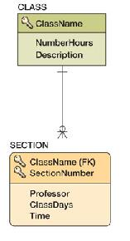
The displayed ER Diagram represents a Non-identifying (non id dependent) relationship.

Question 12 options:

A) True
B) False

