Lab: Configuring BGP Routing
Objective
The overall objective of this lab is to configure BGP routing between two routers so that there is a routed BGP network connection between computers in the two LANs. You configure the network topology and the IP addresses for the appropriate router interfaces. This requires that the serial connection between routers be configured and enabled.
Topology
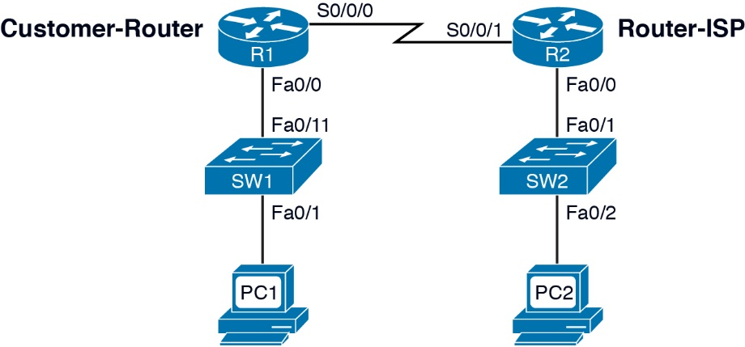
Figure 1: The Network Topology for This Lab
Key Concepts
The following concepts, terms, commands, and steps should be mastered in this laboratory exercise.
1. How do you configure BGP routing?
2. How can you assign the AS number?
3. What are the steps to configure the neighbor IP address and remote-as 65001?
4. How can you advertise the network to its BGP peers?
5. Examine the use of the show ip bgp sum command.
Reference Tables
For convenience, Table 1 provides the IP address and mask of all necessary interfaces used to complete the lab.
Table 1: The Computer IP Addresses, Subnet Masks, and Gateway Addresses for Lab 9
Computer/Interface – R1 | IP Address | Subnet Mask | Gateway Address
PC1 | 10.10.12.1 | 255.255.255.0 | 10.10.12.250
R1-Fa0/0 | 10.10.12.250 | 255.255.255.0 | ------------------
R1-S0/0/0 | 172.16.25.1 | 255.255.255.252 | ------------------
Computer/Interface – R2 | IP Address | Subnet Mask | Gateway Address
PC2 | 10.10.30.65 | 255.255.255.0 | 10.10.30.250
R2-Fa0/0 | 10.10.30.250 | 255.255.255.0 | ------------------
R2-S0/0/1 | 172.16.25.2 | 255.255.255.252 | ------------------
Detailed Lab Steps
In the following tasks, you must demonstrate your knowledge to configure computer networks. Each task specifies a particular network setting you are required to input. You are required to document the command(s) used to accomplish each task.
Task # 1
In this lab, you configure BGP from the Customer-Router to the ISP Router [Router-ISP] based on the network topology provided in Figure 1. You use the IP addresses provided in Table 1. You will be asked to verify that computers in your LAN can ping the neighbor LAN. You are configuring BGP routing for 10.10.12.0/24, 10.10.30.0/24, and 172.16.25.0/30 networks. Note that a serial interface is used to interconnect the LANs. Use 56000 for the clock rate on the serial link (DCE interface). The enable secret and line console 0 password should be set to ciscopress.
1. Configure the gateway address for your LAN routers according to the addresses listed in Table 1. List the prompt and the command used to configure the gateway address and subnet mask on each of the routers.

2. Configure the hostname for your routers; R1 should be renamed the Customer-Router and R2 should be renamed Router-ISP. List the router prompt and command used to configure the router’s hostname.

3. Enable BGP routing on the Customer-router using an AS number of 65000. Advertise the 10.10.12.0 network to its BGP peers. Use the command to specify the IP address of the BGP neighbor. Use the command to specify this is the ISP BGP Connection.

4. Enable BGP routing on Router-ISP using an AS number of 65001. Advertise the 10.10.30.0 network to its BGP peers. Use the command to specify the IP address of the BGP neighbor. Use the command to specify this is the Customer BGP Connection.

5. Use the ping command to verify that you have the customer ping the ISP using the IP address provided by the ISP.

