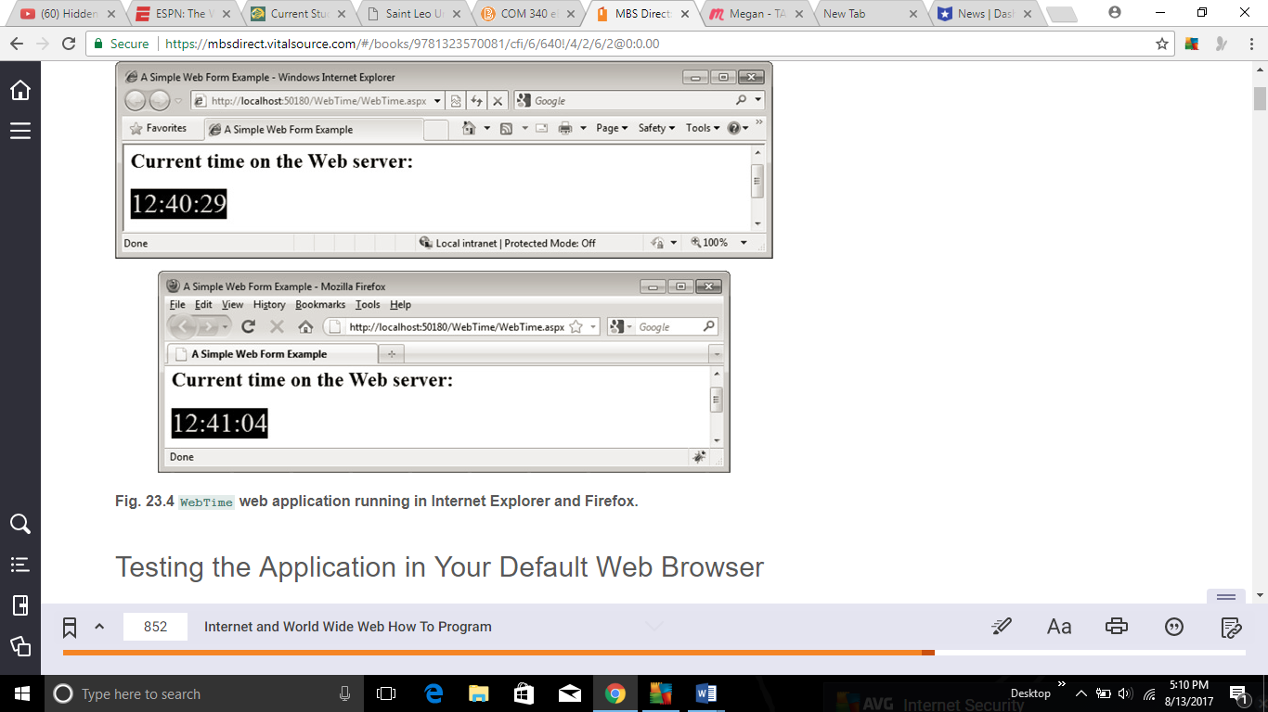

23.3 (WebTime Modification) Modify the WebTime example in Section 23.4 to contain drop-down lists that allow the user to modify such Label properties as BackColor, ForeColor and Font-Size. Configure these drop-down lists so that a postback occurs whenever the user makes a selection. When the page reloads, it should reflect the specified changes to the properties of the Label displaying the time.

*Figure 23.4 is pictured above

