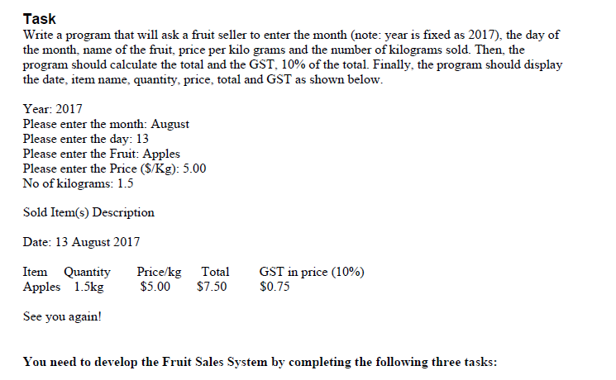

Task 1

Draw Nassi Shneiderman (NS) diagram/s that present the steps of the algorithm required to perform
the task specified. Some examples of NS diagrams can be found at the following web links:
- http://www.thern.org/projects/nassi-schneiderman/nassi.htm
- https://en.wikipedia.org/wiki/Nassi%E2%80%93Shneiderman_diagram
- https://www.cs.umd.edu/hcil/members/bshneiderman/nsd/Yoder-Schrag-nassi_schart.pdf
There are tools (see links below) that can be useful in drawing a NS diagram. However, you can draw
the diagram/s with a pen/pencil on a piece of paper and scan it for submission. Please ensure that the
scanned file and your handwriting are clear and legible.
- https://www.edrawsoft.com/Nassi-Schneiderman.php
- http://www.breezetree.com/articles/nassi-shneiderman-diagram.htm
- http://wiki.c2.com/?NassiShneidermanDiagrams

Task 2
Select three sets of test data that will demonstrate the 'normal' operation of your program; that is, test
data that will demonstrate what happens when a VALID input is entered. Select two sets of test data
that will demonstrate the 'abnormal' operation of your program.
Set it out in a tabular form as follows: test data type, test data, the reason it was selected, the output
expected due to using the test data, and finally the output actually observed when the test data is used.
It is important that the output listings (i.e., screenshots) are not edited in any way.
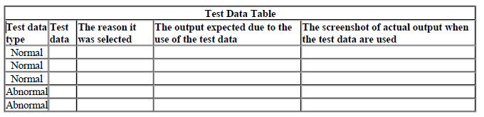Note: Add additional columns for each input and each output.

Task 3 -
Implement your algorithm in Python. Comment on your code as necessary to explain it clearly. Run
your program using the test data you have selected and complete the test data table above.
Your submission will consist of:
Your algorithm through Nassi Shneiderman (NS) diagram/s.
The table recording your chosen test data and results.
Source code for your Python implementation.

