Complete and submit the following items found in your textbook. Show all your calculations and explain how you came up with that answer. Please highlight all your solutions with GREEN color. (Leave the RED for my comments)

Chapter 23: The Bottom Line (page 619)

1) Classify a light source based on optical output power and wavelength. The OSHA Technical Manual describes the Optical Fiber Service Group (SG) Designations based on ANSI Z136.2. These SG designations relate to the potential for ocular hazards to occur only when the OFCS is being serviced. OSHA also classifies standard laser systems.
Question Master It. An OFCS does not fall into any of the SG designations defined in the OSHA Technical Manual because during servicing it is possible to be exposed to laser emissions greater than 750mW. What classification would be assigned to this OFCS based on the OSHA Technical Manual?
Solution:

2) Identify the symptoms of exposure to solvents. Solvents can cause organ damage if inhaled or ingested. The molecules that make up most solvents can take the place of oxygen in the bloodstream and find their way to the brain and other organs. As the organs are starved of oxygen, they can become permanently damaged.
Question Master It. Your co-worker spilled a bottle of liquid several minutes ago and now appears impaired. What has your co-worker potentially been exposed to?
Solution:

3) Calculate the proper distance the base of a ladder should be from a wall. Remember non-self-supporting ladders, such as extension ladders, require a firm vertical support near the work area and a stable, nonslip surface on which to rest the ladder. When setting up a non-self-supporting ladder, it is important to place it at an angle of 75½° to support your weight and be stable.
Question Master It. A non-self-supporting ladder is 10′ in length. How far should the feet of the ladder be from the wall?
Solution:

Chapter 27: The Bottom Line (pages 789-792)

1) Determine the minimum optical output power for an LED transmitter. The minimum optical output power of an LED transmitter should be defined in the manufacturer’s data sheet.
Question: Master It. Refer to the following table (see the text book) to determine the BOL and EOL values for the minimum optical output power of a 50/125μm optical fiber.
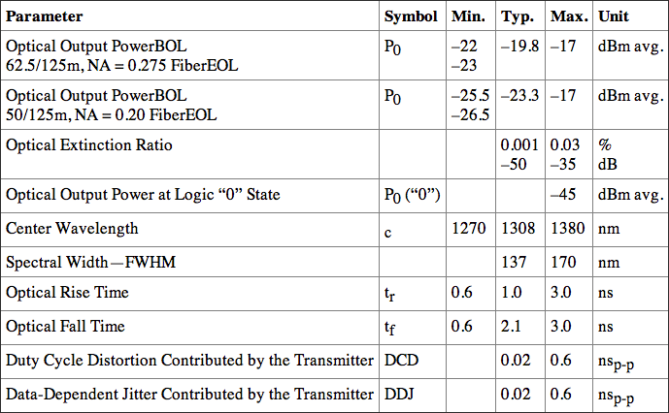
Solution:

2) Determine the maximum optical output power for an LED transmitter. The manufacturer’s data sheet should contain the maximum value for the optical output power of an LED transmitter.
Question: Master It. Refer to the following table (see the text book) to determine the maximum optical output power of a 62.5/125μm optical fiber.
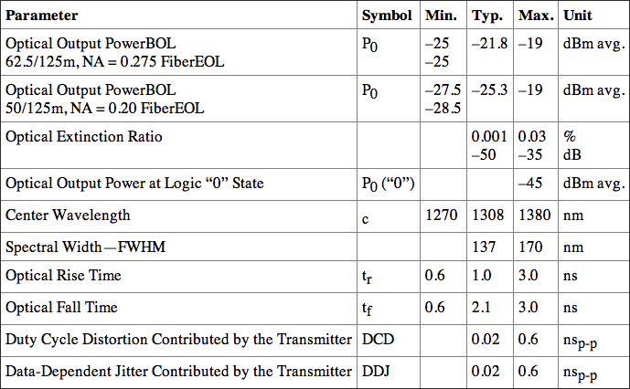
Solution:

3) Determine the minimum optical output power for a laser transmitter. The manufacturer’s data sheet should contain the minimum, maximum, and typical value for the optical output power of a laser transmitter.
Question: Master It. Refer to the following table (see the text book) to determine the BOL and EOL values for the minimum optical output power.
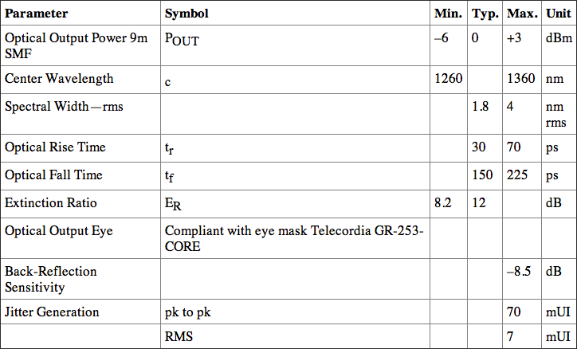
Solution:

4) Determine the maximum optical output power for a laser transmitter. The manufacturer’s data sheet should contain the maximum value for the optical output power of a laser transmitter.
Question: Master I.t Refer to the following table (see the text book) to determine the maximum optical output power.
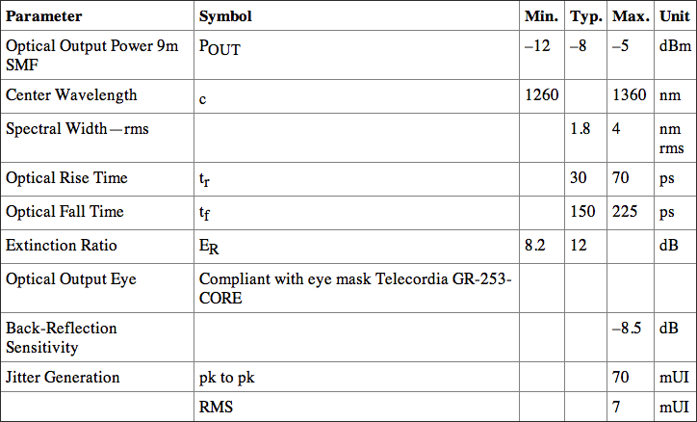
Solution:

Chapter 28: The Bottom Line (pages 816-817)

1) Calculate the dynamic range for an LED receiver. The dynamic range of the LED receiver is the difference between the minimum value for the maximum optical input power and the maximum value for the minimum optical input.
Question: Master It. Refer to the following table (see the text book) and calculate the dynamic range for the LED receiver.
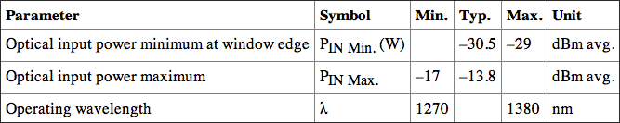
Solution:

2) Calculate the dynamic range for a laser receiver. The dynamic range of the laser receiver is the difference between the minimum value for the maximum optical input power and the maximum value for the minimum optical input.
Question: Master It. Refer to the following table (see the text book) and calculate the dynamic range for the laser receiver.
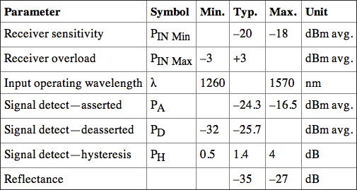
Solution:

