1,000 The Hard Way

Table of Contents
Overview 3
Project Scope 3
Project Benefits 3
Return on Investment 4
Budgetary Estimate 5
Stakeholders ………………………………………………………………………………………………………………………………………….5
Stakeholder Register…………………………………………………………………………………………………………………………….6
Organizational Structure 6
Roles and Responsibilities 6
Work Breakdown Structure 7
Gantt Chart 7
Timeline 7
Milestones 8
Critical Path ………………………………………………………………………………………..……………………………………………….8
Risk Plan 9
Risk Identification and Mitigation Strategies 9
Communications Plan 9
Reporting 9

Overview
A pharmaceutical firm is going to update or refresh their network from Windows 7 Professional 32 bit to Windows 10 Enterprise 64. The total number of PC’s to be updated is 1000, a mixture of laptops and desktops. Along with the refresh, SAS will be implemented on 500 of the PCs.

Project Scope
The complete scope of the project is to refresh the number of PC’s listed in the overview with the SAS implementation. All PC’s that will be refreshed will be upgraded to 8 Gb of Ram and a 250Gb SSD hard drive if deemed viable. All PC’s will be tested thoroughly before being placed in production. All printers will be updated with 64-bit drivers. The time frame for the refresh is 6 weeks, and the budget is $250,000.00.

Benefits
The benefits of upgrading your network from Windows 7 to Windows 10 are listed below; these results are from a survey from Forrester, the company Microsoft commissioned to do a study of the benefits an organization will realize after implementing Windows 10.
The benefits are:
- IT management cost savings - Administrators estimate a 20% improvement in management time, Windows 10 requires less time to install, manage, and support.and has reduced the need for some third-party software products.
- Security remediation costs and security risk are reduced - With features such as Credential Guard and Device Guard, along with new software, like BitLocker, security events requiring IT remediation are reduced or avoided by 33%.
- Improved user productivity - Mobile employees can take advantage of 25% of the time that is unavailable for work, allowing them to get more done wherever they may be.
- Improved employee tools and resources enabling effective customer interactions – With Windows 10’s increased mobility and improved wake and boot times enabling client-facing employees to meet with more clients. PCs boot up in less than 5 minutes, versus waiting 20 minutes for their PC to boot up and log into critical systems.

Return on Investment
Forrester’s interviews with eight customers were summarized as an unbiased organization. The TEI analysis resulted in an estimated, risk-adjusted three-year study present value of benefits for more than $14 million versus the present value of costs of $4.4 million, which adds up to a net present value of $10.3 million, which translates into $515 per user, and an ROI of 233%. Below is a graph representing the estimated savings:
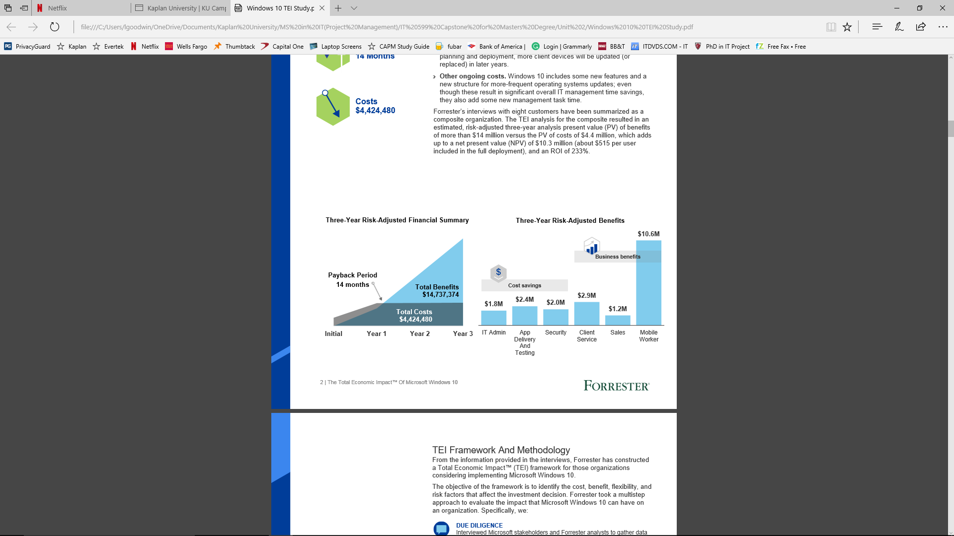
(A Forrester Total Economic Impact™ Study Commissioned By Microsoft December 2016)
Budgetary Estimate
After the hardware survey, the stakeholders decided upon ordering upgrading Ram for all PCs for the corporation. This way all PC’s are the same, there was too much variety of the PC’s to maintain uniformity.
Still utilizing Lenovo hardware, the corporation ordered ram for 250 laptops, 100 desktops, and the 50 printers were ordered new, 500 laptops, and 150 desktops met specifications deemed acceptable by stakeholders and Project Team. Being that the printers were old, they order 50 new printers also. Plus, the hours a five man team occurs at 40 hours per week.
The budgetary estimate for the PC’s, printers and the man hours for implementing this, is in the chart below:
Hardware | Quantity | Cost of Ram | Cost
Laptops | 250 | $100 | $25,000
Desktops | 100 | $75 | $7,500
Printers | 50 | $500 | $25,000
Man Hours | 1200 | $50 hourly | $60,000 | Total Cost
 |  |  |  | $117, 500

The remaining monies from the $250,000.00 will be used as a contingency fund, for unforeseen issues, like new cabling for frayed cables and etc.

Stakeholders
The stakeholders will be listed in the Stakeholders registry, following:

Stakeholders Registry
Name | Title
Sean Connery | CEO | Director
Morgan Freeman | CIO | Information Technology
Arnold Schwarzenegger | CFO | Finance

Organizational Structure
Name | Role and Responsibility
Leonard Goodwin | Project Manager
Denis Chernonok | SCCM Administrator – creates images, pushes images out in stages
Christopher Abreu | Implementor, Technical hands On -ensuring images are pushed out properly, replace ram and SSD
Phillip Graham | Implementor, Technical hands On -ensuring images are pushed out properly, replace ram and SSD
Vincent Tillery | Implementor, Technical hands On -ensuring images are pushed out properly, replace ram and SSD
Michael Brooks | Implementor, Technical hands On -ensuring images are pushed out properly, replace ram and SSD

Work Breakdown Schedule
Gantt Chart
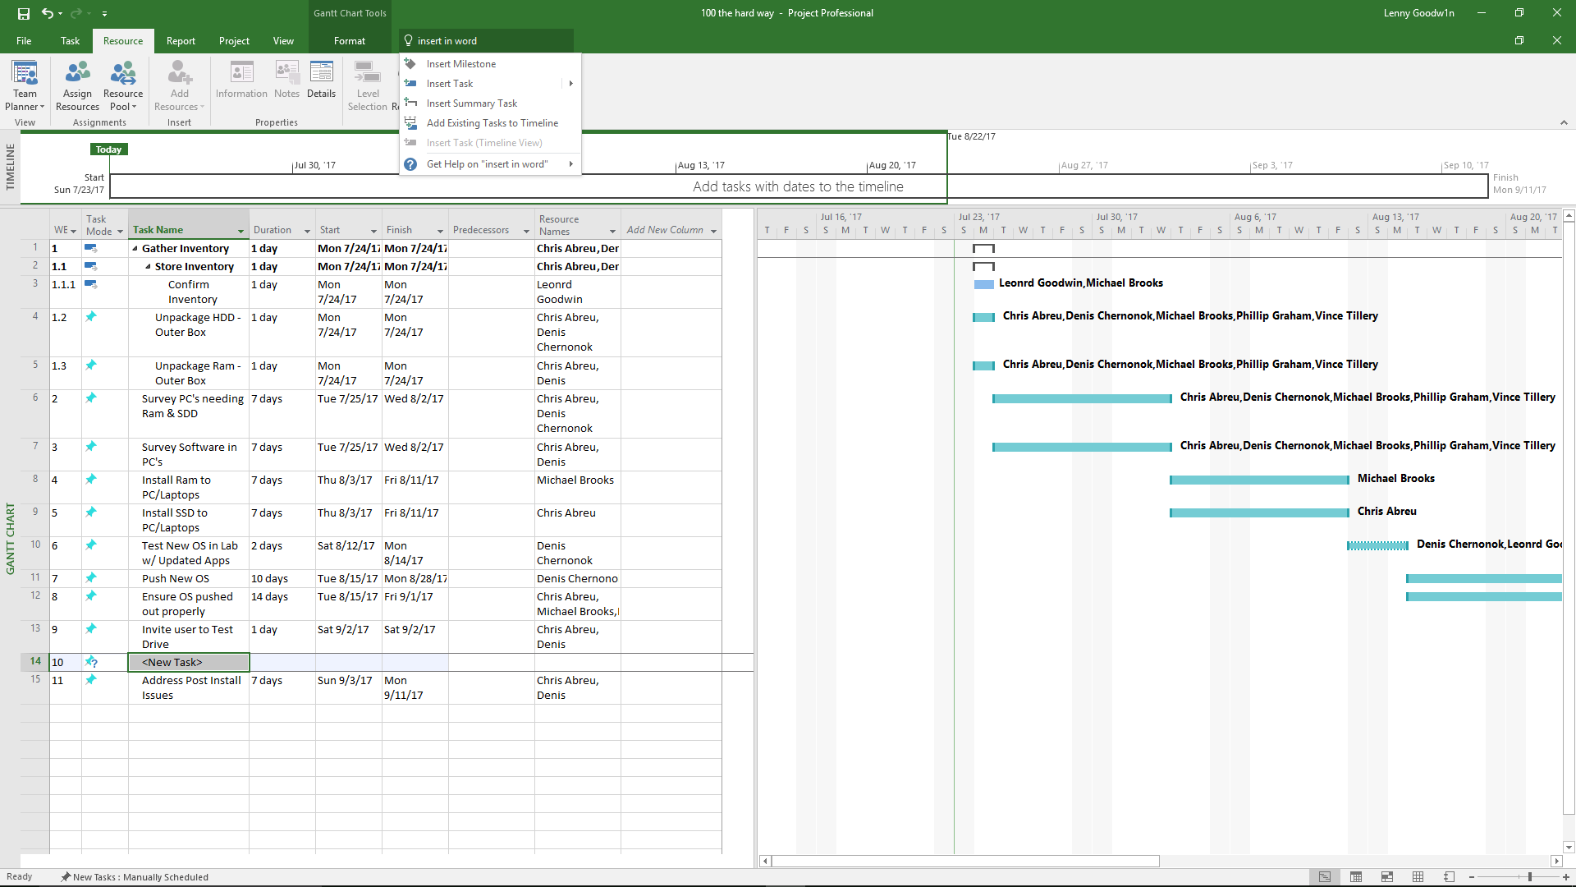
Timeline
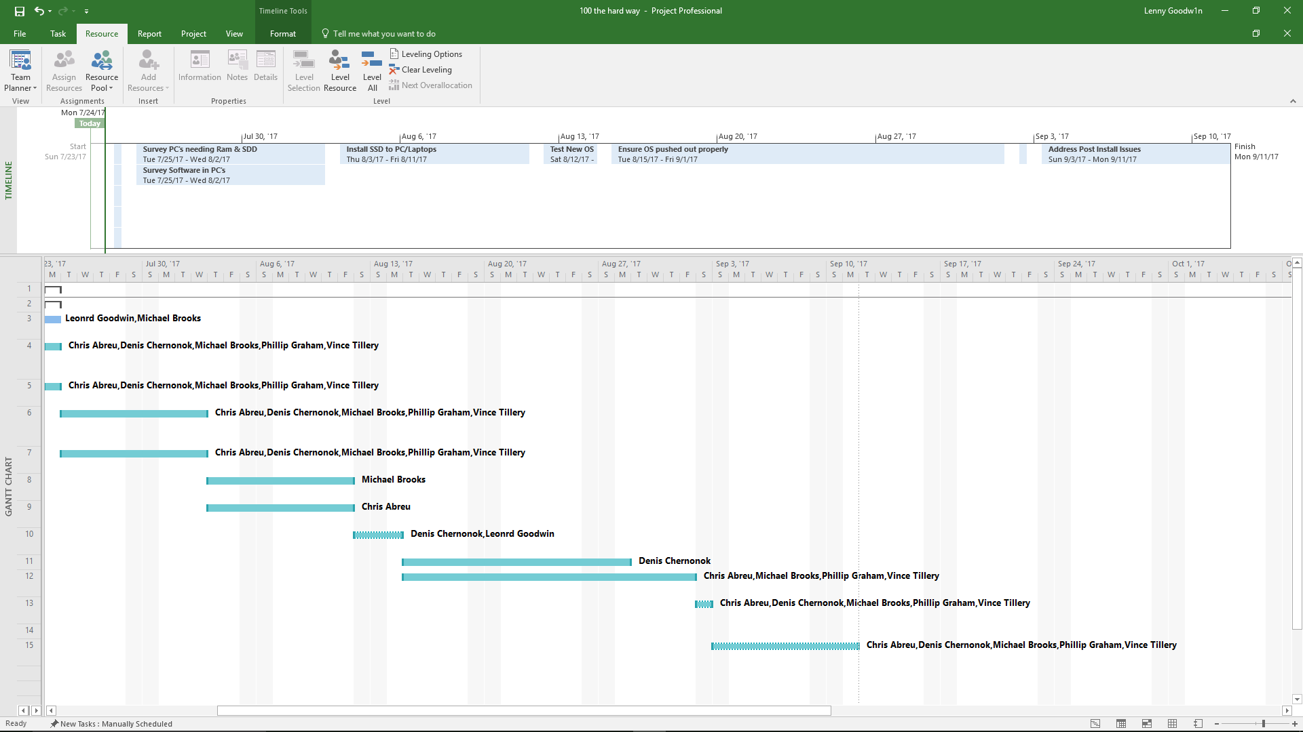
Milestones
Survey PC's needing Ram & SDD
Survey Software in PC's
Install Ram to PC/Laptops
Install SSD to PC/Laptops
Push New OS
Invite user to Test Drive the New OS

Critical Path
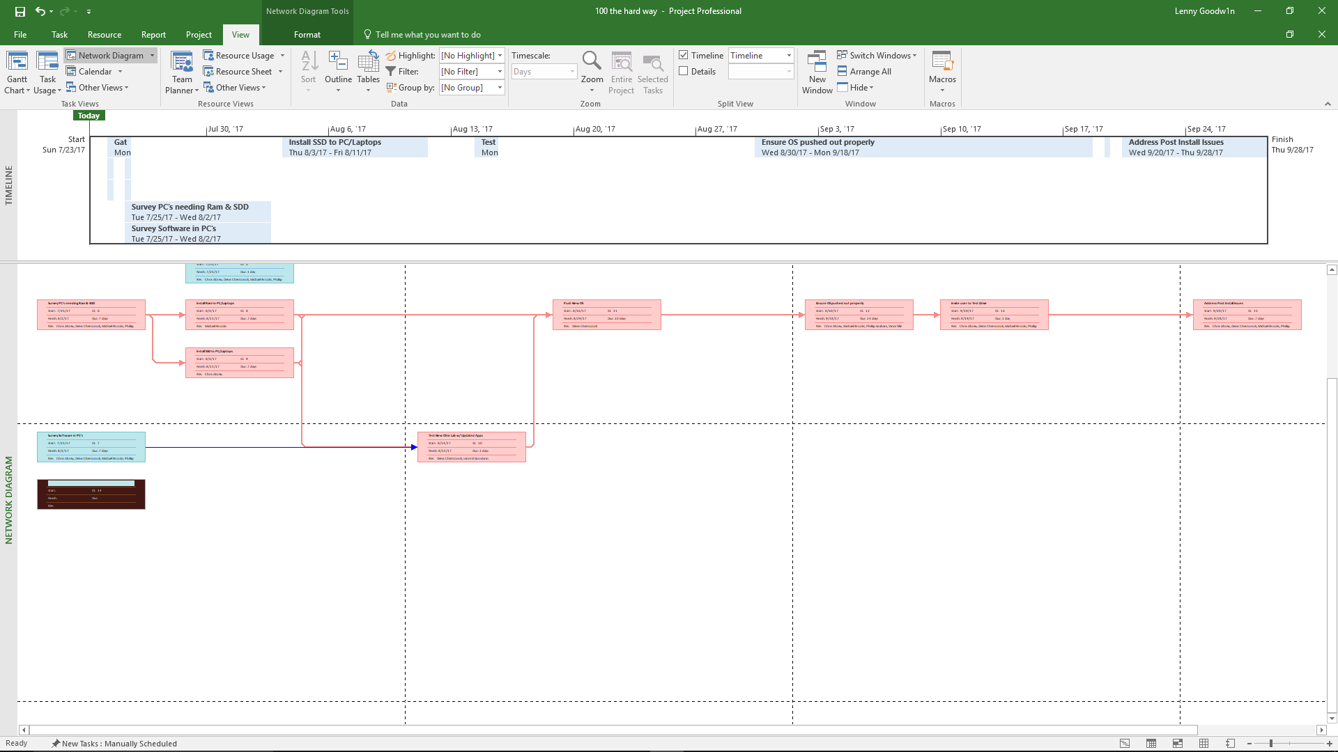
****Critical Path in Pink****

Risk Plan
Identified Risks
The concern about this migration is the backup of the user’s documents and .pst files. The backup of the user’s documents and .pst files are done automatically through the SCCM OS upgrade. This is the main concern of the corporation.

Preventive Risk Strategies
Each user’s data is compared to the folder on their laptop/PC to ensure the folders are of the same size; this will provide and indicate complete and successful backup. If the folder size does not match, a technician will manually backup the user’s data and .pst files. As a fail safe, the user’s data and .pst files are backup nightly to one of the corporate server’s.

Communications Plan
The communications plan is necessary to ensure that all stakeholders, key personnel, and project team receive the exact correspondence for the project in a timely manner. There will be a handout with all stakeholders, key staff and project team contact information with their roles and responsibilities so as to call the proper personnel for specific issues or concerns. The best method of distribution for this is to follow this reporting schedule.

Reporting
Weekly Meetings | Department Heads | Weekly Update of Project
Bi Weekly Meetings | Executive Staff and Department Heads | Update on Project
Issues | To correct department head or executive staff | As Needed
Emails | All affected personnel | Weekly
Telephone Directory | All Stakeholders and key personnel roles and responsibilities | Distributed to all Stakeholders and Key Personnel

