Jennifer Lagumen
CMIS 102
25 July 2017
Week 8 Hands-On Lab
Test Plan
To verify this program is working properly the input values could be used for testing:
Test Case | Input | Expected Output
1 | Enter data? = y  1.2  2.2  3.3  2.2  10.2  12.2  2.3  0.4  0.2  1.1  2.1  0.4  1.1  2.2  3.3  2.2  10.2  12.2  2.3  0.4  0.2  1.1  2.1  0.4  1.1  2.2  3.3  2.2  10.2  12.2  2.3  0.4  0.2  1.1  2.1  0.4  1.1  2.2  3.3  2.2  10.2  12.2  2.3  0.4  0.2  1.1  2.1  0.4  1.1  2.2  3.3  2.2  10.2  12.2  2.3  0.4  0.2  1.1  2.1  0.4 | Please try the Precipitation program again.
  Year | Month | Rain
  2011 | Jan | 1.20
  2011 | Feb | 2.20
  2011 | Mar | 3.30
  2011 | Apr | 2.20
  2011 | May | 10.20
  2011 | Jun | 12.20
  2011 | Jul | 2.30
  2011 | Aug | 0.40
  2011 | Sep | 0.20
  2011 | Oct | 1.10
  2011 | Nov | 2.10
  2011 | Dec | 0.40
  2012 | Jan | 1.10
  2012 | Feb | 2.20
  2012 | Mar | 3.30
  2012 | Apr | 2.20
  2012 | May | 10.20
  2012 | Jun | 12.20
  2012 | Jul | 2.30
  2012 | Aug | 0.40
  2012 | Sep | 0.20
  2012 | Oct | 1.10
  2012 | Nov | 2.10
  2012 | Dec | 0.40
  2013 | Jan | 1.10
  2013 | Feb | 2.20
  2013 | Mar | 3.30
  2013 | Apr | 2.20
  2013 | May | 10.20
  2013 | Jun | 12.20
  2013 | Jul | 2.30
  2013 | Aug | 0.40
  2013 | Sep | 0.20
  2013 | Oct | 1.10
  2013 | Nov | 2.10
  2013 | Dec | 0.40
  2014 | Jan | 1.10
  2014 | Feb | 2.20
  2014 | Mar | 3.30
  2014 | Apr | 2.20
  2014 | May | 10.20
  2014 | Jun | 12.20
  2014 | Jul | 2.30
  2014 | Aug | 0.40
  2014 | Sep | 0.20
  2014 | Oct | 1.10
  2014 | Nov | 2.10
  2014 | Dec | 0.40
  2015 | Jan | 1.10
  2015 | Feb | 2.20
  2015 | Mar | 3.30
  2015 | Apr | 2.20
  2015 | May | 10.20
  2015 | Jun | 12.20
  2015 | Jul | 2.30
  2015 | Aug | 0.40
  2015 | Sep | 0.20
  2015 | Oct | 1.10
  2015 | Nov | 2.10
  2015 | Dec | 0.40
2 | Enter Data? = n | No data was input at  this time.  Please try the  Precipitation program  again.

Learning Exercises for you to complete
- Demonstrate you successfully followed the steps in this lab by preparing screen captures of you running the lab as specified in the Instructions above.
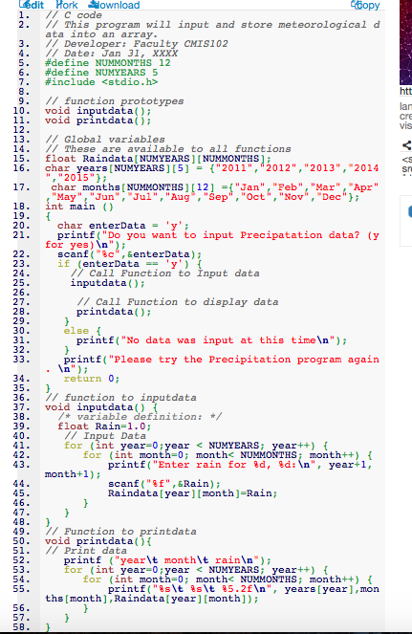
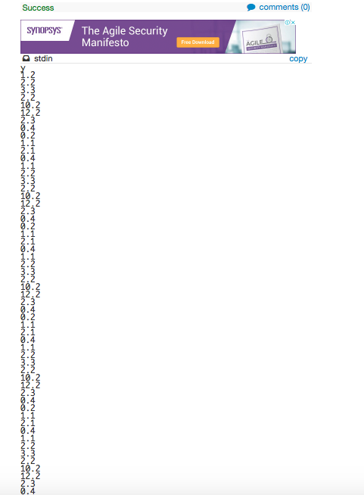
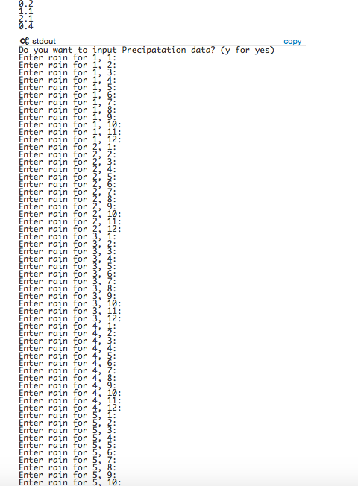
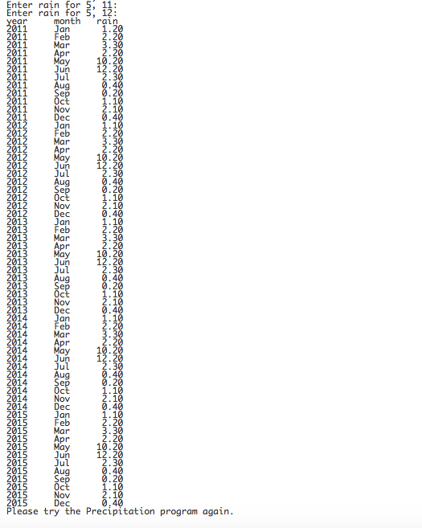

- Modify the program to add a function to sum the rainfall for each year.
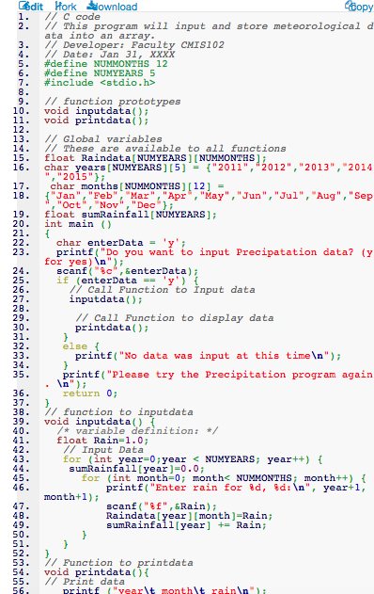
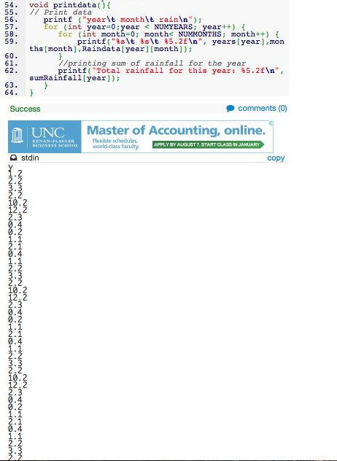
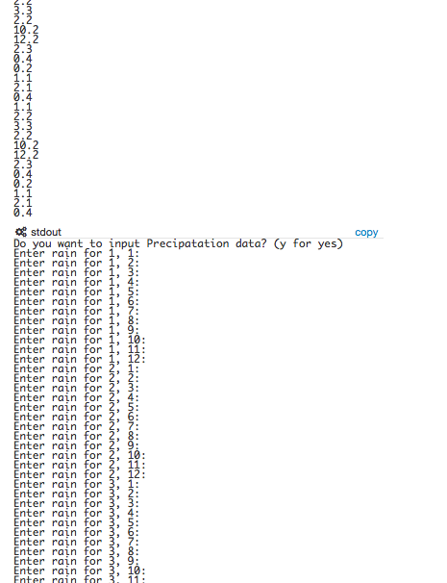
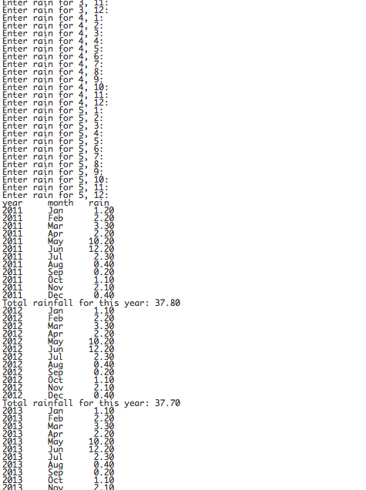
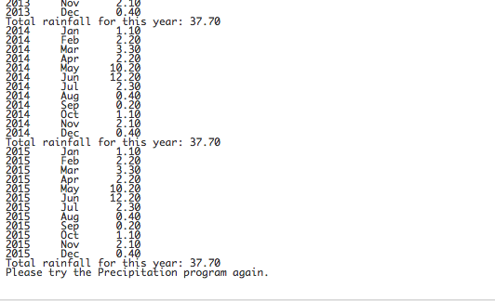

- Enhance the program to allow the user to enter another meteorological element such as wind speed (e.g. 2.4 mph). Note, the user should be able to enter both rainfall and wind speed in your new implementation. Support your experimentation with screen captures of executing the new code.
- I alternated the code for the complier to output wind speed.

- Prepare a new test table with at least 2 distinct test cases listing input and expected output for the code you created after step 2.
Test Case | Input | Expected Output
1
2

Test Case 1:

Test Case 2:
- What happens if you change the NUMMONTHS and NUMYEARS definitions to other values? Be sure to use both lower and higher values. Describe and implement fixes for any issues if errors results. Support your experimentation with screen captures of executing the new code.
    - Changing the NUMMONTHS value:
    - Changing the NUMYEARS value:

