
Shelly Cashman Excel 2016 | Module 1: SAM Project 1a
Blooming Everywhere Delivery
creatING a worksheet and a chart

GETTING STARTED
- Open the file SC_EX16_1a_FirstLastName_1.xlsx, available for download from the SAM website.
- Save the file as SC_EX16_1a_FirstLastName_2.xlsx by changing the “1” to a “2”.
  - If you do not see the .xlsx file extension in the Save As dialog box, do not type it. The program will add the file extension for you automatically.
- With the file SC_EX16_1a_FirstLastName_2.xlsx still open, ensure that your first and last name is displayed in cell B6 of the Documentation sheet.
  - If cell B6 does not display your name, delete the file and download a new copy from the SAM website.

PROJECT STEPS
- Bob is the co-owner of Blooming Everywhere Delivery, a floral delivery service accessed exclusively through mobile apps, and is preparing a report for his business partner on the company’s financials for the years 2018-2020.
Open the Company Analysis worksheet and use AutoFit to adjust the width of column A.
- Select cell A1, enter the text Blooming Everywhere Delivery, and then center the merged range A1:D1.
- Apply the Heading 1 cell style to the merged range A1:D1.
- Enter the text Revenue in cell A2, and then merge and center the range A2:D2.
- Clear the contents of cell E3.
- Enter the data shown in Table 1 below into the range B7:D7.

Table 1: Data for the Range B7:D7

Cell | B7 | C7 | D7
Value | 1800 | 1950 | 2020

- Using the Fill Handle, copy the formula in cell B8 into the range C8:D8.
- Merge and center the range A10:D10.
- Select the range B12:D16, and then apply the Accounting number format with two decimal places and $ as the symbol.
- The Expenses table shows all of the company’s expenses from 2018 to 2020. Bob wants to calculate the total expenses by adding up the total expenses from each year.
In cell E16, create a formula using the SUM function to calculate the total expenses from 2018 to 2020 (B16:D16).
- Update the formatting of the merged range A18:D18 as described below:
  - Bold the contents of the merged range.
  - Change the font to Calibri.
  - Change the font size to 13 pt.
  - Change the font color to Green, Accent 6, Darker 25% (10th column, 5th row of the Theme Colors palette).
- The company’s competition and taxes have increased through the years, and Bob will only recommend continuing to grow the business if the profit increases every year.
In cell B20 create a formula without using a function that calculates the profit earned in 2018 by subtracting the total expenses in 2018 (cell B16) from the total revenue in 2018 (cell B8).
Using the Fill Handle, fill the range C20:D20 with the formula from cell B20.
- Change the tab color of the Company Analysis worksheet to Orange (3rd column, 1st row of the Standard Colors palette).
- Select the clustered column chart with the title Blooming Everywhere Delivery 2018 – 2020 Revenue. Update the chart as described below:
  - Change the chart style of the clustered column chart to Style 5.
  - Move the chart to its own chart sheet. Use 2018-2020 Revenue as the name for the new chart sheet.
- Switch back to the Company Analysis worksheet. Select the non-adjacent ranges A12:A15 and D12:D15, and then create a 3-D Pie chart. Update the chart as described below:
  - In the title placeholder, enter Expenses in 2020 as the chart title.
  - Change the chart style of the 3-D pie chart to Style 3.
  - Move the chart to its own chart sheet, using 2020 Expenses as the name for the new chart sheet.
Your workbook should look like the Final Figures on the following pages. Save your changes, close the workbook, and then exit Excel. Follow the directions on the SAM website to submit your completed project.

Final Figure 1: Company Analysis Worksheet

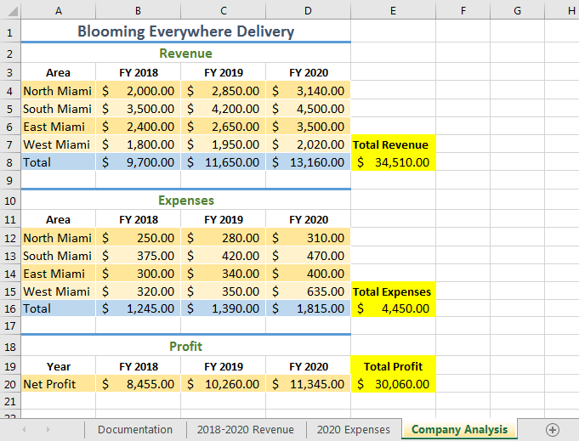

Final Figure 2: 2018-2020 Revenue Worksheet
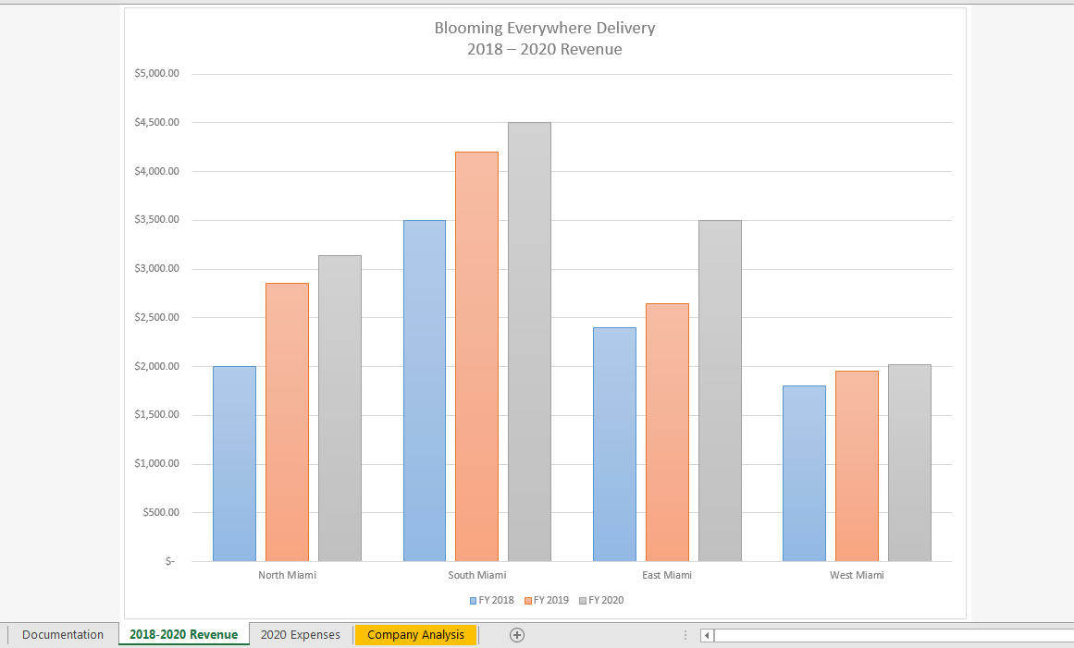

Final Figure 3: 2020 Expenses Worksheet

