CIS355A Week 3 Lab
Enhanced GUI Application using Additional Swing Components

OBJECTIVES
- Create a GUI that uses JCheckBox, JRadioButton, JTextArea, and menus.
- Process multiple events.

PROBLEM: BurgersRUs Point of Sale system
Burger Barn needs a point of sale application. The products and prices are as follows.
Burgers: single $3.50, double $4.75
Add cheese: + $.50
Add bacon: + $1.25
Make it a meal: + $4.00

FUNCTIONAL REQUIREMENTS
You can code the GUI by hand or use NetBeans GUI builder interface.
The GUI should use JRadioButton to choose single or double burger.
- Single burger
- Double burger
It should use JCheckBox for add ons.
- Add cheese
- Add bacon
- Make it a meal
JTextField for item price, order quantity, order total
JTextArea to display the receipt
Create a menu with the following options.
File Order
Exit Add to Order
Clear for next item
New Order

As the user selects items, the item price should be calculated and updated accordingly.
Note that quantity should default to 1. The user can change if needed.
Once choices are made and quantity is entered, process the order using the menu options.
Order—Add to Order Displays the choice and price in each text area.
Note that multiple items can accumulate in a single order
Updates the order total
Order—Clear for next item Clears the checkboxes. Note that quantity should default to 1
Order—New Order Clears the GUI and totals for a new order
File—Exit Exits the program. Use System.exit(0) commad.

Sample GUI

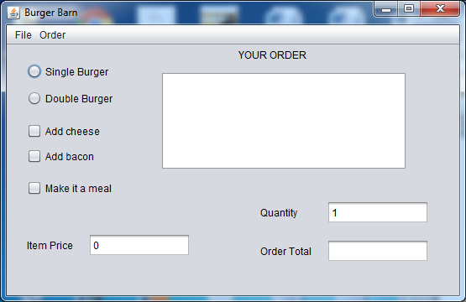

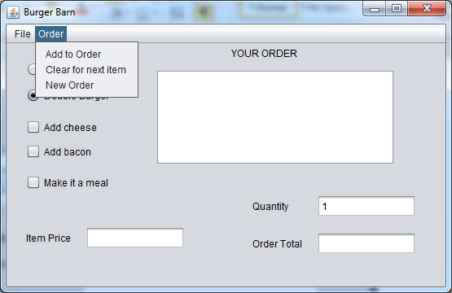
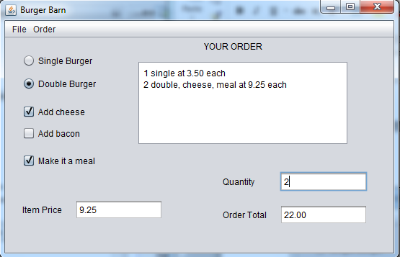

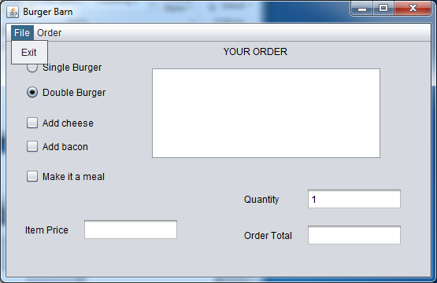

GRADING RUBRIC
Functional Requirements  - All components on GUI created correctly  - Item price updated properly with radio and checkbox selections  - Items added to text area  - Total price accumulates correctly  - Clear for next item works correctly  - Clear for new order works correctly  - All prices displayed with two decimal places  - File exit works correctly  - Error messages for any invalid/missing user input using JOptionPane | 40
Code style | 5
Lab Report | 10
TOTAL | 55

CODE STYLE REQUIREMENTS
- Include meaningful comments throughout your code.
- Use meaningful names for variables.
- Code must be properly indented.
- Include a comment header at beginning of each file, example below.
/****************************************************
Program Name: ProgramName.java
Programmer's Name: Student Name
Program Description: Describe here what this program will do
***********************************************************/

DELIVERABLES
Submit as a SINGLE zip folder
- All java files
- Lab report

Follow assignment specification regarding class/method names.
Note that your java filename must match class name (DO NOT rename).

