Programming Task – GUI Application Minimum Requirements

Your GUI application must contain/use, at a minimum, the following:

- At least one component, from among a JButton, a JTextField, a JTextBox, a JSlider, etc. As a consequence, you must implement a required Listener inner class.
- At least one image.
- One of the Layout Managers that were discussed in class, or choose one from the Java API.
Please see the lecture slides, or see the course website, of example applications.

Rubric

10 points Project Description
10 points Layout & pseudocode
10 points Proper use of a Layout Manager, of your choice
20 points Correctly implementing an event/action listener
15 points The GUI compiles, and runs as expected
15 points Use of at least one image
15 points Proper use of variable names, adequate commenting
5 points Include a README.txt file, with the final submission of your project



README File

An industry practice is to include a README.txt, README, or similar file, in the directory with your code. Traditionally the file's name is written in upper case so that on case-preserving environments the file will appear near the beginning of a directory listing. The purpose of the file is to provide details about the code, to give instructions on how to run the program, and/or to explain any bugs or potential problems that a user might experience.

Contents of the file may include:

- Configuration instructions
- Installation details
- Operating instructions
- Contact information
- Known bugs • Et cetera.
An example file: 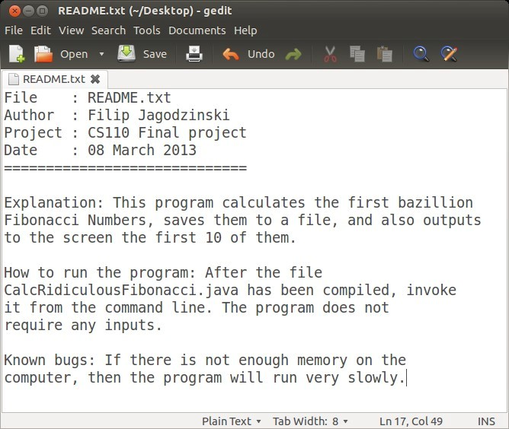
Your name goes here

