CIS355A Week 2 Lab—Developing a GUI Application

OBJECTIVES
- Create a GUI that uses JTextField, JLabel, and JButton.
- Write event handlers to process user data.

PROBLEM: Health Profile App
GymsRUs would like to replace their console program with an updated app using a graphical user interface. You will use the HealthProfile class that you created in the Week 1 Lab and build a GUI for it.

FUNCTIONAL REQUIREMENTS
Make sure your HealthProfile class from the Week 1 Lab is in a named package, not default (i.e., package lab1).

You must ADD the project that contains the HealthProfile class to this week’s project by
right click project, go to properties; and
click Libraries, Add Project, click OK.

Then you will be able to reference your existing class as
import lab1.HealthProfile.

Your project will have three classes:
- HealthProfile class from Week 1 Lab
- HealthProfileGUI class
- Lab2Main class

Your HealthProfildGUI class should have the following components (see sample GUI below).
- JTextField objects to enter: name, age, height in feet, height in inches, weight in pounds
- JButton objects to display results, clear the GUI
- JTextField objects to display the BMI, category, and max heart rate
- JLabels to describe all textboxes
You are free to layout and design your GUI as you like as long as it includes these components.

Add default and parameterized constructors to your HealthProfile class. The parameterized constructor should have five arguments: the name, age, weight, height in feet, and height in inches. Note it should convert the height to inches to store in the private instance variable.
Code event handlers for each button:
- Display: Make sure all user input is present and valid
Use the HealthProfile class to process the data
Display the results on the GUI
- Clear Clear all text boxes on the GUI

Sample GUI
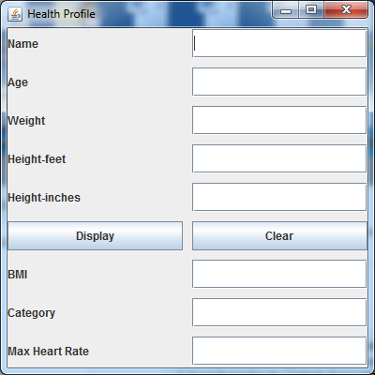

GRADING RUBRIC
HealthProfile class  - Add default and parameterized constructors | 10
HealthProfileGUI class  - All components on GUI  - Display button event handler coded properly  - Clear button event handler coded properly  - Error messages for any invalid/missing user input using JOptionPane | 25
Lab2Main class  - Displays the GUI properly | 5
Code style | 5
Lab Report | 10
TOTAL | 55

CODE STYLE REQUIREMENTS
- Include meaningful comments throughout your code
- Use meaningful names for variables
- Code must be properly indented
- Include a comment header at beginning of each file, example below
/****************************************************
Program Name: ProgramName.java
Programmer's Name: Student Name
Program Description: Describe here what this program will do
***********************************************************/

DELIVERABLES
Submit as a SINGLE zip folder
- All java files
- Lab report

Follow assignment specification regarding class/method names.
Note that your java file name must match class name (DO NOT rename).

