POJECT I | Java GUI Components and Interfaces
Due July 16 11:30 pm | Objectives  ■ Java swing components  ■ GroupLayout  ■ ActionListener interface  ■ MouseListener interface

For Project I, as discussed in class, you will need to implement a programming calculator as below.
Disable Dword, Word, Byte, but keep the buttons there. Also, no interaction of the mouse on the binary bits area is required. Just display 64 bits for all the items with appropriate bits filled in based on the value in the number field.
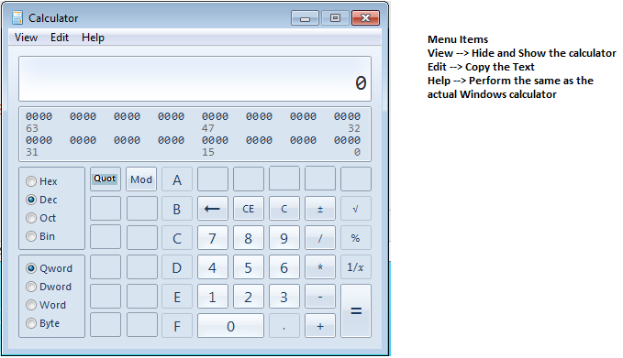

Test Case:

Please find below the list of test cases.
1.Look and feel of the calculator.
2.The 64 bits binary value of the entered number in the number field should be displayed correctly.
3.Should be able to access some help documentation from the menu item “Help”. Does not have to be the same as the Windows Calculator
4.Should be able to hide and show the calculator using the menu item “View”.
5.Should be able to copy the content (in the number field) using the menu item “Edit”.
6.All basic arithmetic operations (+, - , / , *, etc.) must be performed correctly. Results with decimal places or negative values should be displayed appropriately.
7.There is no order of operation expected; if someone has implemented it that way then it is OK either way
8.There should be no interaction of the mouse expected on the binary bits area.
9.Functionality of “C”, “CE” and “Backspace” should be the same as that of windows calculator.

Functionality Test Cases
•Addition of two integer numbers.
•Addition of two negative numbers.
•Addition of one positive and one negative number.
•Subtraction of two integer numbers.
•Subtraction of two negative numbers.
•Subtraction of one negative and one positive number.
•Multiplication of two integer numbers.
•Multiplication of two negative numbers.
•Multiplication of one negative and one positive number.
•Division of two integer numbers.
•Division of two negative numbers.
•Division of one positive number and one integer number.
•Division of a number by zero.
•Division of a number by negative number.
•Division of zero by any number.
•Basic Conversion of Hex, Dec, Bin, Oct shall work (Handling of Overflow of numbers is not required)

