Computer Systems Architecture

Q1: Explain and compare Interrupts and polling. Compare hardware interrupts and software interrupts.

Q2: In the following charts, (a) if MOS >=4, which codec will you choose to reach the best bandwidth utilization. Explain the reason with sufficient details. (b) Between G.711 5 ms frames and G.711 20 ms frames, which one has better bandwidth utilization? (c) Between G.711 20 ms frames and G.729 20 ms fames, which one has better bandwidth utilization? **Correction to snapshot: G.729 20 ms codec should have 44 + 20 = 64 bytes, since in 20 ms, there are only 20 bytes of VoIP payload.

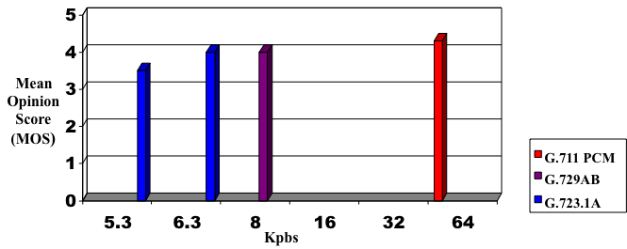

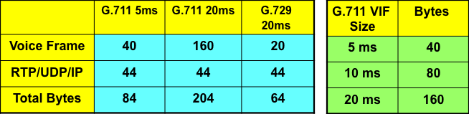

Q3: (a) What is Nyquist Sampling Theory? (b) T1 channel bank has 24 channels, plus 1 framing bit. Each channel has 8 bits / sample. What is T1 channel rate? Show your calculation, instead of just the results.

