SQL Commands
After each question, construct the SQL statement that answers the question.

- List all the information about the properties.

- List information about damages including the street address.

- What were the different sources of damage (no duplicate reporting)?

- What was the total amount of damages assessed?

- What were the total damages for each property?

- List the damages sorted by location (where the damage was located not where the property was located).

- How many damages were reported?

- List the information about the properties whose zip codes start with 301.

- List the properties in Woodstock that were damaged.

- What properties were damaged (street address), what were the damages (description) and what was the amount of the damage?

- List the report information for inspectors Jones, Smith, White [use the IN keyword].

- Which inspector(s) reported total damage amounts >$30,000 for all properties they inspected?

- Which property (by address) had damages from flooding on the first floor?

- List all property street addresses and show the description of the damage for those that had damage.

- Create a View to show street address and city of properties that had damage to their floors (wet carpet or buckled floor). Call the view FloorDamage.

Data Tables for IS3280 Test 2-Part 2 {This data is fictitious.}
PROPERTY
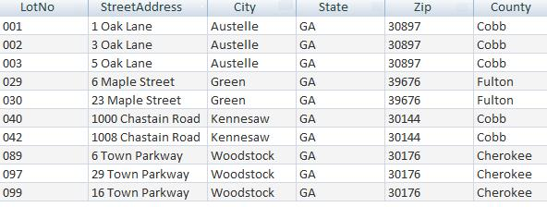
DAMAGE
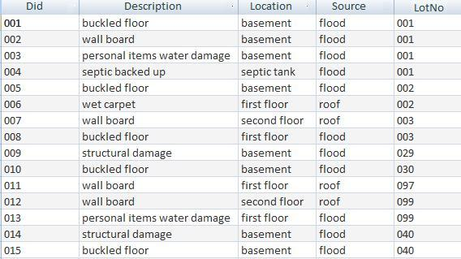
DAMAGEREPORT
