I. Introduction

To motivate this lab, assume that a robot factory assembly line builds futuristic robots, all with the first name Johnny and a last name that is an integer value. The combined first and last name for each robot is used to construct a robot’s ID number (serialID). For example the factory might produce robots with IDs Johnny36723 or Johnny23232. A robot is made up of a head and torso.

Your task is to write a program that simulates a robot garage, which is an array of three Robot objects. The RobotTorso and RobotHead classes are small. The Robot class is a bit more complex, because it contains an equals() methods, a copy() method, as well as a few getter and setter methods. The third robot in your array must have a serialID that is identical to the serialID of one of the other robots (you’ll use the copy() method to create the third robot). The Robot class has a static field, numRobots, that keeps count of how many robots there are. The figure below is a schematic representation of your robot garage:

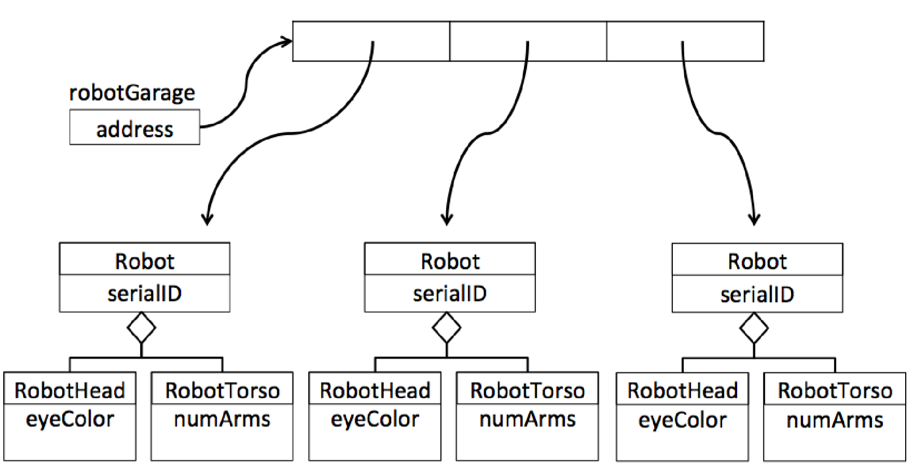

II. The RobotTorso Class

Create a RobotTorso.java class per the UML diagram shown below.

RobotTorso
- int numArms
+ RobotTorso()
+ toString() : String

The numArms field must be private. The constructor should set the value of the numArms instance field to a random integer between 0 and 9 (inclusive).

As was discussed in lecture, it is a good practice to include a toString() method in each class, which should output a String that contains the information (or state of) the instance RobotTorso. In this case, for example if the RobotTorso field numArms is 7, the toString method might output:

number of arms : 7

Make sure that your RobotTorso class compiles before you proceed to the next section.

III. The RobotHead class

The RobotHead class is also straight-forward. It is made up of a single instance field, a constructor, and a toString method, as shown in the below UML diagram:

RobotHead
- String eyeColor
+ RobotHead()
+ toString() : String

The constructor should generate a random number between 0 and 4 (inclusive), and based on that number, assign a unique value to the instance field eyeColor. You select the eye colors. In the example code shown in the last section of this lab, the eye colors in use are blue, green, evil red, creepy yellow, or black. The toString() method, as in the RobotTorso class, should output a String that gives details about the RobotHead instance. For example, if the eyeColor field of the instance is creepy yellow, then the toString() method might output:

Eye color : creepy yellow

Make sure that your RobotHead class compiles before you proceed to the next step.

IV. The Robot class

The Robot class is an aggregate class, that is made up of four instance fields (one of which is static), a constructor, and 6 utility methods (one of which is static), as show in the below UML diagram (by convention in a UML diagram a static field or method is underlined). Make sure that all of the instance fields are private.

Robot
- numRobots : int = 0
- robotHead : RobotHead
- robotTorso : RobotTorso
- serialID : String
+ Robot()
+ getRobotCount() : int
+ copy() : Robot
+ setSerialID(serial : String) : void
+ equals(aRobot : Robot) : Boolean
+ getSerialID() : String
+ toString() : String

The constructor should:

- Increment by 1 the static field numRobots
- Generate a random integer between 0 and 99999 as the robot’s “last” name, and create a SerialID String value that is “Johnny” appended with the random number. For example, Johnny36278
- Instantiate the fields robotHead and robotTorso. For example, to create a new RobotHead instance field, you’d write:

robotHead = new RobotHead();

Be sure you understand that this would be create a new instance of a RobotHead object, and assign the reference variable of the new object to the instance field robotHead.

The copy() method should:

- Create a new Robot object
- Set the serialID of the newly created object to be the serialID of the Robot object from which the copy method is called. The full code for the copy method is provide for you below. Make sure you understand what this code is doing.

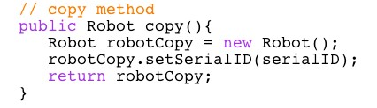

The setSerialID(), getSerialID(), and getRobotCounts() methods are all
standard setter or getter methods. They should set and retrieve, respectively, the value of the serialID instance field.
The equals() method should check if the serialID in the instance from where the method is being invoked is the same as the serialID of the instance that is being received as the argument. Refer to the lecture slides to see how it is done. You’ll need to include a conditional (if), and return either a true or a false. Because the serialID field is a String, you must use the equals method of the String class to see if the serialIDs are the same.

The toString() method in the Robot class is slightly more advanced than the toString methods of the RobotHead and RobotTorso classes. This is because the Robot class’s toString() method should output a String that is the robots ID, and invoke the toString methods of the robotTorso and robotHead instance fields. The entirety of the toString method of the Robot class is given to you below. Make sure you understand how it invokes the toString methods of robotTorso and robotHead instance fields.

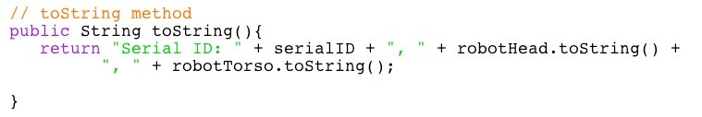

Make sure that your Robot class compiles before you proceed to the next step.

V. Your RobotGarage class

Now that you’ve written the Robot, RobotTorso, and RobotHead classes, create an array of Robot objects, and use the copy and/or toString methods, as well as the equal method in the Robot class, to manipulate those objects.

Create a RobotGarage.java file with a main routine for which the pseudocode is shown below.

// Declare an array of 3 Robot objects

// Instantiate new Robot objects into indices 0 and 1 of the array of Robots

// Use the copy() method from one of the robots in indices 0 or 1 to create a
// new robot object, and place the copy of the robot into index 2 of the // array of Robots

// Use the toString method in each robot object to print to the screen // details about that robot

// Retrieve the value of the static variable numRobots and print it to the // screen

// Use a series of if-then statements to check if robots at indices 0 and 1,
// 0 and 2, or 1 and 2 are identical using the equals method in the Robot
// class, and print to the screen which robots are identical

VI. Sample invocation

Two sample invocations for the program RobotGarage are shown below.

