Here are the 5 tables to refer to.
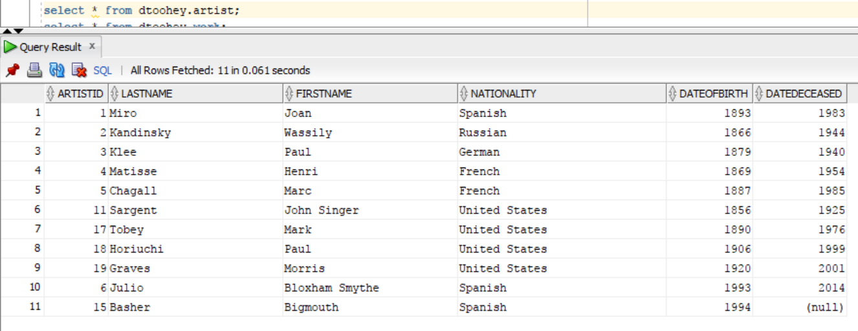

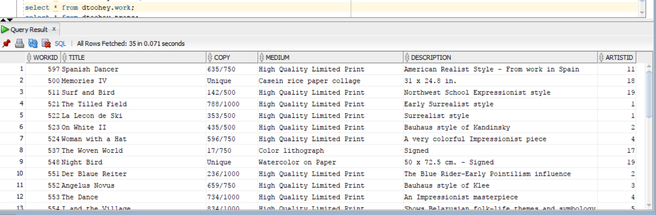

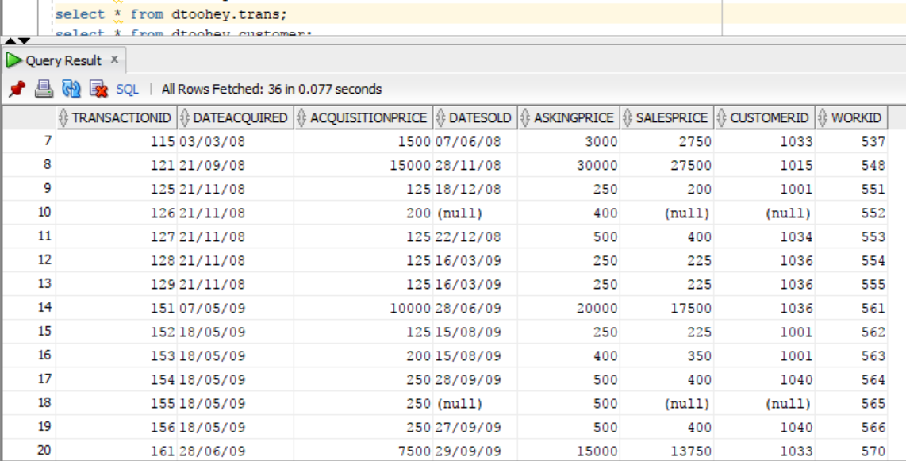

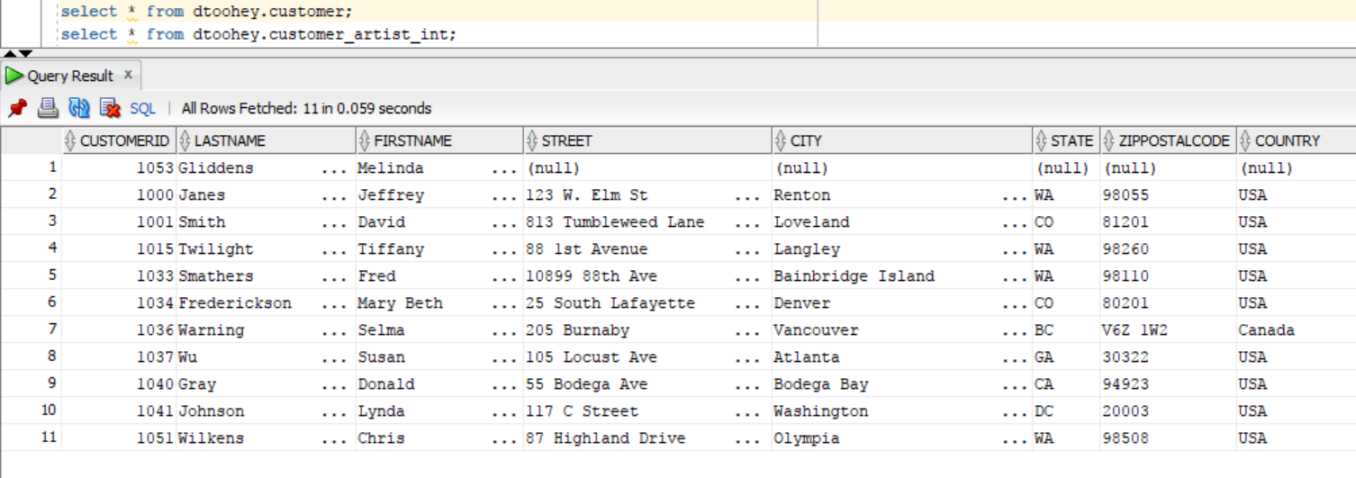

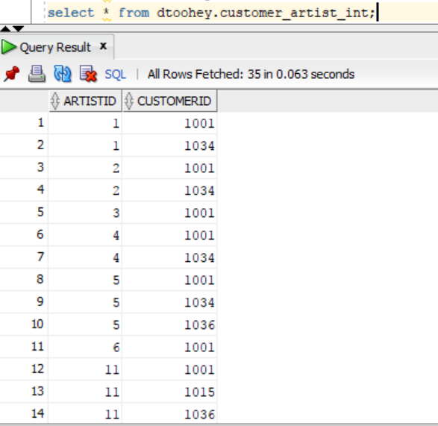

This question is based on the View Ridge Gallery database you have been using in the labs. See the textbook for background to the case and the table structures.
The tables are:
ARTIST
CUSTOMER
WORK
TRANS
CUSTOMER_ARTIST_INT

You can use the dtoohey tables that we have been using. If you prefer, you can create your own copies of these tables under your own account to work with. If you do so, you should ensure you copy the same sample data as in dtoohey’s tables.
Provide SQL AND result tables for the following queries. Paste the queries AND the result tables from either your ssh client or SQL Developer into your assignment document.

h. Which artist (give his/her full name) has the most customers interested in him or her, and how many customers are interested in them?
i. List the total dollar amount of sales each artist (give his/her full name) has made on their works, in descending order of total.
j. List the name of any customers who have an interest in all the artists from the United States. Your query should not need to include names of individual artists.

