Module 6. Written Assignments

- Use the content found from the data table to answer the case study questions below.
- Create a document with your answers and save it in either Adobe Portable Document Format (PDF) or Microsoft Word .doc format. Please do not submit items in Microsoft Excel format; they will receive a score of zero (0).
- Title the document with your last name and the assignment, such as “Smith_ModuleXCaseStudy.pdf.”
- Although it is not necessary to include the questions in your assignment, please number your answers and show all work including, but not limited to: calculations, assumptions, commentary, calculation notes, screenshots, reference citations, etc.

Case: SQL for Acme Music
You are the data scientist for Acme Music, a large music store. Acme Music specializes in selling musical instruments to jazz musicians. Over time, Acme Music has created a robust customer database and saved it in a SQL database.

See the associated dataset for the case, “DataScience_6_Case_AcmeMusic.xls”. The screenshot below shows a portion of the data.

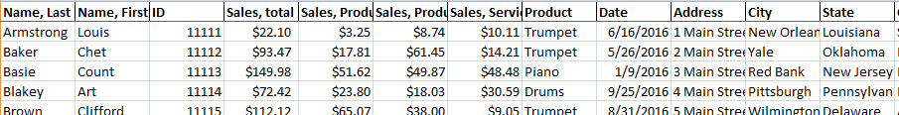

In order to learn more about your customers and their purchases, you plan to query your SQL database.

For the questions below, specify the SQL statements necessary to obtain the information required. Use ANSI SQL. Refer to the name of the database as “AcmeMusic”. You do not need to write out the results, or show a screenshot of them. Simply indicate the SQL command relevant to the data desired.

1. SELECT: To prepare to do your deep dives into the customer database, you will need some practice. Practice using the SELECT command by executing the following statements.

a. Create a SQL statement to display the last name and the State for each customer in the database.

b. Create a SQL statement to display all the customers who purchased “Trumpet” as a product.

c. Create a SQL statement to display the customers born in the State of New York.

2. CREATE TABLE: Acme Music has asked you to create a new table. The table is to record purchases by customer. The table is to contain the columns indicated below. Specify the SQL statement to create the table.
- ID (capable of holding 8 digits)
- Date (capable of holding date data)
- Product (capable of holding a variable-length character string of up to 20 characters)
- Price (capable of holding a number with a maximum number of digits of 10, and 2 digits to the right of the decimal)

SQL Statement:

3. UPDATE: Acme Music has asked you to make some updates to the customer database. Specify the SQL commands required to perform the following updates.
- Change the name of “Armstrong”, “Louis” to “Armstrong”, “Satchmo”.
- Change the type of product used by Jimmy Smith from “Organ” to “Organ, Hammond”.
- It turns out that one of the clerks did not enter in the service sales amounts correctly. Add $10 to all of the amounts in “Sales, Service”.

SQL Statements:

Commentary: What is a problem with the way the sales amounts are specified in the dataset? How would we benefit from having separate “Customers” and “Purchases” tables?

Include research: How do small to mid-sized companies keep track of their customers? What type of database system do they use?

Commentary

