Module 3 - Case

Public-Key Cryptosystems

Assignment Overview
Principles of Public-Key Cryptosystems
The concept of public-key cryptography evolved from an attempt to attack two of the most difficult problems associated with symmetric encryption. The first problem is that of key distribution. Key distribution under symmetric encryption requires either (1) that two communicants already share a key, which somehow has been distributed to them; or (2) the use of a key distribution center. Whitfield Diffie, one of the discoverers of public-key encryption (along with Martin Hellman, both at Stanford University at the time), reasoned that this second requirement negated the very essence of cryptography: the ability to maintain total secrecy over your own communication. As Diffie put it, “what good would it do after all to develop impenetrable cryptosystems, if their users were forced to share their keys with a KDC that could be compromised by either burglary or subpoena?”
The second problem that Diffie pondered, and one that was apparently unrelated to the first, was that of digital signatures. If the use of cryptography was to become widespread, not just in military situations but for commercial and private purposes, then electronic messages and documents would need the equivalent of signatures used in paper documents. That is, could a method be devised that would stipulate, to the satisfaction of all parties, that a digital message had been sent by a particular person?
Diffie and Hellman achieved an astounding breakthrough in 1976 by coming up with a method that addressed both problems and was radically different from all previous approaches to cryptography, going back over four millennia.
In this module, we look at the overall framework for public-key cryptography. Then we examine the requirements for the encryption/decryption algorithm that is at the heart of the scheme.
Public-Key Cryptosystems
Asymmetric algorithms rely on one key for encryption and a different but related key for decryption. These algorithms have the following important characteristic.
- It is computationally infeasible to determine the decryption key given only knowledge of the cryptographic algorithm and the encryption key.
In addition, some algorithms, such as RSA, also exhibit the following characteristic.
- Either of the two related keys can be used for encryption, with the other used for decryption.
A public-key encryption scheme has six ingredients (Figure 1a).
- Plaintext: This is the readable message or data that is fed into the algorithm as input.
- Encryption algorithm: The encryption algorithm performs various transformations on the plaintext.
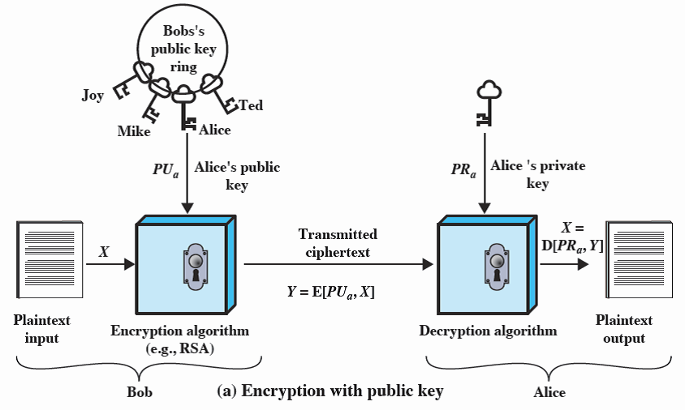

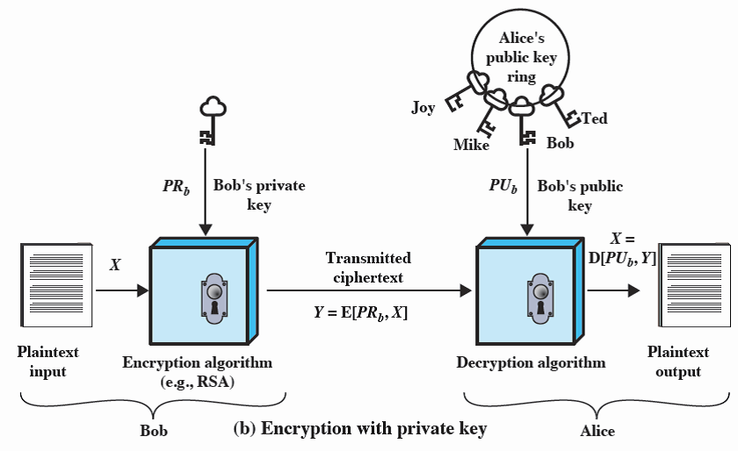

Figure 1 Public-Key Cryptography
- Public and private key: This is a pair of keys that have been selected so that if one is used for encryption, the other is used for decryption. The exact transformations performed by the algorithm depend on the public or private key that is provided as input.
- Ciphertext: This is the scrambled message produced as output. It depends on the plaintext and the key. For a given message, two different keys will produce two different ciphertexts.
- Decryption algorithm: This algorithm accepts the ciphertext and the matching key and produces the original plaintext.
The essential steps are the following.
- Each user generates a pair of keys to be used for the encryption and decryption of messages.
- Each user places one of the two keys in a public register or other accessible file. This is the public key. The companion key is kept private. As Figure 1a suggests, each user maintains a collection of public keys obtained from others.
- If Bob wishes to send a confidential message to Alice, Bob encrypts the message using Alice’s public key.
- When Alice receives the message, she decrypts it using her private key. No other recipient can decrypt the message because only Alice knows Alice’s private key.
With this approach, all participants have access to public keys, and private keys are generated locally by each participant and therefore need never be distributed. As long as a user’s private key remains protected and secret, incoming communication is secure. At any time, a system can change its private key and publish the companion public key to replace its old public key.
Table 1. Conventional and Public-Key Encryption

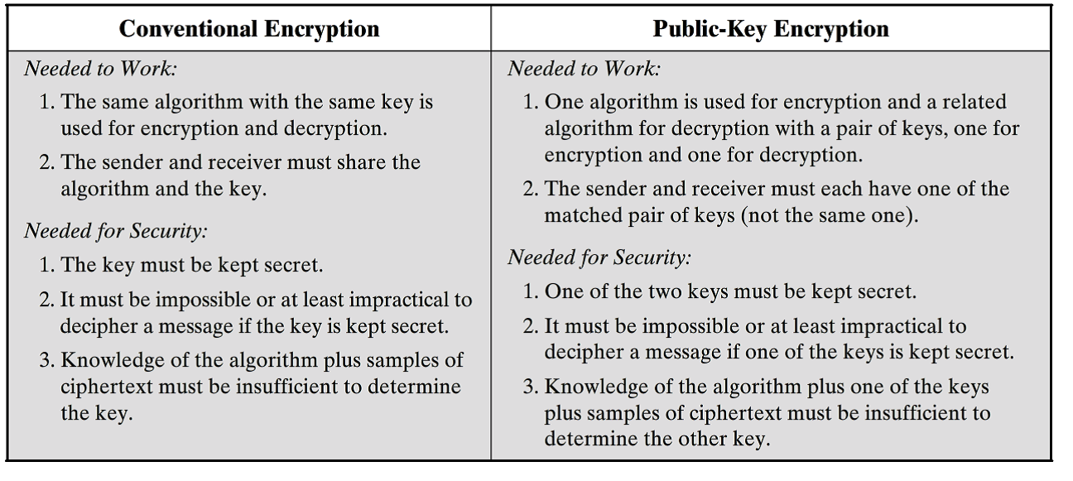

Table 1 summarizes some of the important aspects of symmetric and public-key encryption. To discriminate between the two, we refer to the key used in symmetric encryption as a secret key. The two keys used for asymmetric encryption are referred to as the public key and the private key. Invariably, the private key is kept secret, but it is referred to as a private key rather than a secret key to avoid confusion with symmetric encryption.
Let us take a closer look at the essential elements of a public-key encryption scheme, using Figure 1. There is some source A that produces a message in plaintext, X = [X1, X2, … , XM]. The M elements of X are letters in some finite alphabet. The message is intended for destination B. B generates a related pair of keys: a public key, PU_{b}, and a private key, PR_{b}. PR_{b} is known only to B, whereas PU_{b} is publicly available and therefore accessible by A.
With the message X and the encryption key PU_{b} as input, A forms the ciphertext
Y = [Y1, Y2, … , YN] by encrypting X using PU_{b}:
Y = E(PU_{b}, X)
The intended receiver, in possession of the matching private key, is able to invert the transformation, which means that B can recover X by decrypting Y using PR_{b}:
X = D(PR_{b},Y)
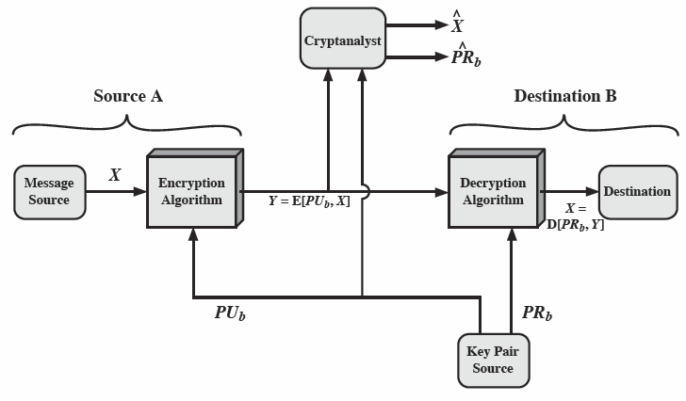
Figure 2. Public-Key Cryptosystem: Secrecy

An adversary, observing Y and having access to PU_{b}, but not having access to PR_{b} or X, must attempt to recover X and/or PR_{b}. It is assumed that the adversary does have knowledge of the encryption (E) and decryption (D) algorithms. If the adversary is interested only in this particular message, then the focus of effort is to recover X by generating a plaintext estimate. Often, however, the adversary is interested in being able to read future messages as well, in which case an attempt is made to recover PR_{b} by generating an estimate.
We mentioned earlier that either of the two related keys can be used for encryption, with the other being used for decryption. This enables a rather different cryptographic scheme to be implemented. Whereas the scheme illustrated in Figure 2 provides confidentiality, Figures 1b and 3 show the use of public-key encryption to provide authentication:
Y = E(PR_{a},X)
X = D(PU_{a},Y)
In this case, A prepares a message to B and encrypts it using A’s private key before transmitting it. B can decrypt the message using A’s public key. Because the message was encrypted using A’s private key, only A could have prepared the message. Therefore, the entire encrypted message serves as a digital signature. In addition, it is impossible to alter the message without access to A’s private key, so the message is authenticated both in terms of source and in terms of data integrity.
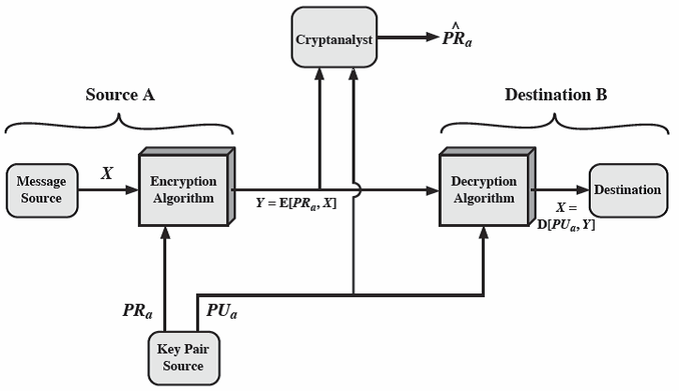
Figure 3 Public-Key Cryptosystem: Authentication
Applications for Public-Key Cryptosystems
Before proceeding, we need to clarify one aspect of public-key cryptosystems that is otherwise likely to lead to confusion. Public-key systems are characterized by the use of a cryptographic algorithm with two keys, one held privately and one available publicly. Depending on the application, the sender uses either the sender’s private key or the receiver’s public key, or both, to perform some type of cryptographic function. In broad terms, we can classify the use of public-key cryptosystems into three categories:
- Encryption/decryption: The sender encrypts a message with the recipient’s public key.
- Digital signature: The sender “signs” a message with its private key. Signing is achieved by a cryptographic algorithm applied to the message or to a small block of data that is a function of the message.
- Key exchange: Two sides cooperate to exchange a session key. Several different approaches are possible, involving the private key(s) of one or both parties.
Some algorithms are suitable for all three applications, whereas others can be used only for one or two of these applications.
To learn more about public-key cryptosystems, check the following sites:
Introduction to Public-Key Cryptography
https://access.redhat.com/documentation/en-US/Red_Hat_Certificate_System/8.1/html/Deploy_and_Install_Guide/Introduction_to_Public_Key_Cryptography.html
Public key encryption
https://www.youtube.com/watch?v=Ao5pMFe9fHU
Cryptography on public keys
http://www.internet-computer-security.com/VPN-Guide/Diffie-Hellman.html

Case Assignment
For the Module 3 Case Assignment, write a paper to discuss public-key cryptosystems. Make sure that you answer the following questions:
- What are the principal elements of a public-key cryptosystem?
- What are the roles of the public and private key?
- What are three broad categories of applications of public-key cryptosystems?

Assignment Expectations
Use information from the modular background readings as well as the given resources. Also, you could use any good quality resource you can find. Please cite all sources and provide a reference list at the end of your paper.
Length: 2-3 pages (excluding the title page and reference pages) and double-spaced.
The following items will be assessed in particular:
- Your ability to consolidate ideas from reading materials and your understanding of the materials.
- Your ability to write a report with strong argument.
- Some in-text references to modular background readings.

