    this is page 2 - when someone opens the brochure they will see this page - here you can have your explanation of what an experimental psychologist does  NOTE: These images are clipart from MSWord - you can find more there. I made these so you could move them around easily. | This is the back of the brochure  References go here.    You could also put contact information |   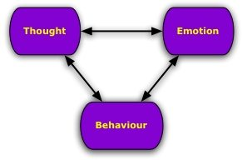  This is your front cover - this should make your reader want to open it and read more  Remember to balance images and text - too much of either and your brochure won't look right.
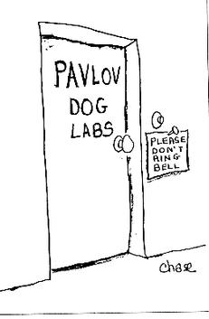  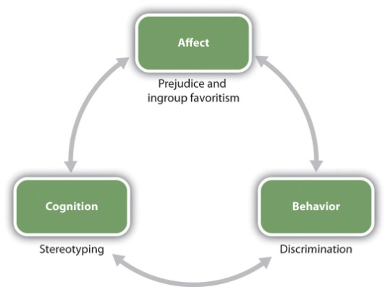  When the brochure is fully opened, the reader will see all three of these pages at once - give them some good information to read! | 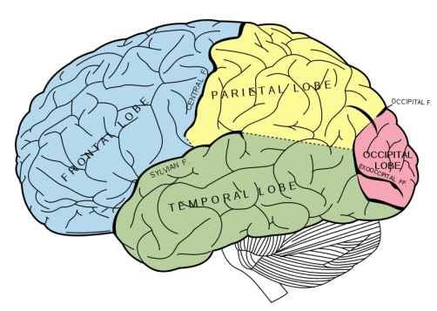  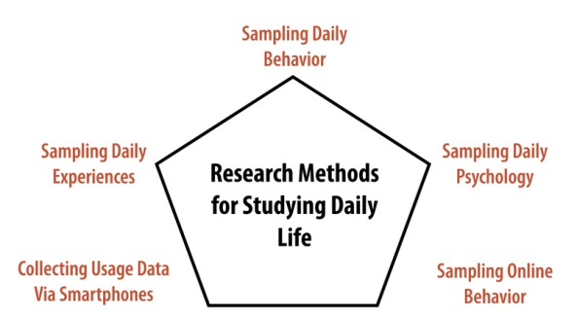  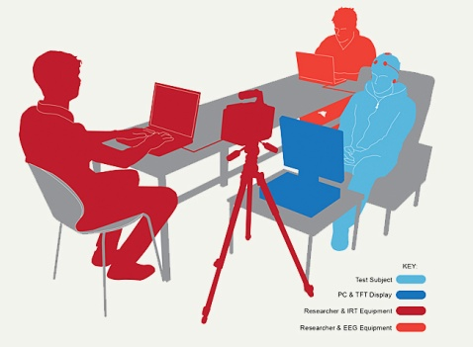  You might want to put your study here - it should be an experiment that has real world significance.(remember the Amir Raz study - but you can't use that one) | 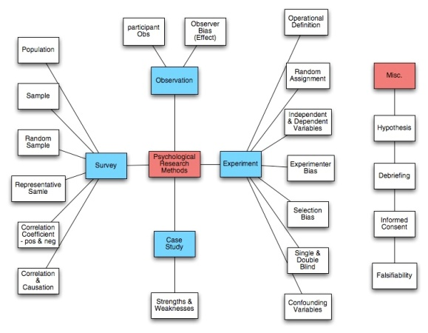  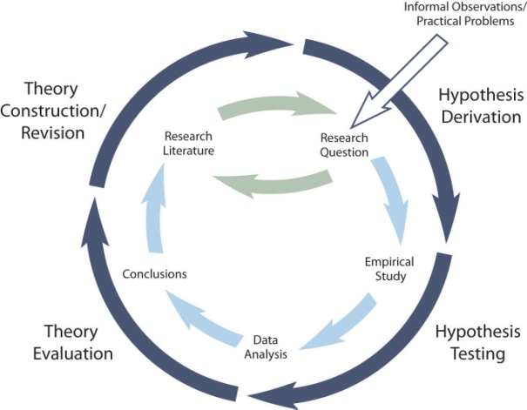  Wrap it all up on this page - your conclusion and perhaps contact information

