Breanna Axelgard
SPSS Homework 5 Instructions
Correlation
Part 1:

Green & Salkind: Lesson 31, Exercises 1–4

The following helpful tips are numbered to correspond with the exercise number to which they refer (a dash indicates that no tips are needed):

- ---------- (2 pts for output and 2 pts each for a–c)

Descriptive Statistics
 | Mean | Std. Deviation | N
Overall quality as an instructor | 4.1670 | .59731 | 50
Overall course quality | 3.9310 | .64664 | 50
Number of publications | 8.40 | 11.348 | 50
Number of times cited by other authors | 49.52 | 57.272 | 50

Correlations
 |  | Overall quality as an instructor | Overall course quality | Number of publications | Number of times cited by other authors
Overall quality as an instructor | Pearson Correlation | 1 | .638** | .232 | .312*
Overall quality as an instructor | Sig. (2-tailed) |  | .000 | .105 | .028
Overall quality as an instructor | N | 50 | 50 | 50 | 50
Overall course quality | Pearson Correlation | .638** | 1 | .347* | .372**
Overall course quality | Sig. (2-tailed) | .000 |  | .014 | .008
Overall course quality | N | 50 | 50 | 50 | 50
Number of publications | Pearson Correlation | .232 | .347* | 1 | .828**
Number of publications | Sig. (2-tailed) | .105 | .014 |  | .000
Number of publications | N | 50 | 50 | 50 | 50
Number of times cited by other authors | Pearson Correlation | .312* | .372** | .828** | 1
Number of times cited by other authors | Sig. (2-tailed) | .028 | .008 | .000
Number of times cited by other authors | N | 50 | 50 | 50 | 50
**. Correlation is significant at the 0.01 level (2-tailed).
*. Correlation is significant at the 0.05 level (2-tailed).

- Answer this question in sentence form. Include the correlation (r) and degrees of freedom, the p value, and whether these values indicate a significant correlation between the variables or not. (2 pts)
r(48)= .638, p= 0.000001 (or p<0.1) df -2
This is a significant positive linear correlation between the overall course quality and the number of publications. With a correlation significant at the 0.01 2tail, and a signigicant at the 0.05 level (2-tail)
- All homework “Results sections” must follow the example given in the Course Content document “Writing Results of Statistical Tests in Current APA Format” (Note: you do not have to refer to a figure). (2 pts) Using a correlation rating between the overall course quality, the numberof publications, and the times the material was cited. This is a significant positive linear correlation between the overall course quality and the number of publications. With a correlation significant at the 0.01 2tail, and a signigicant at the 0.05 level (2-tail) with an r(48) =.638, p=0.000001 (or p<.01)

---------- (2 pts) 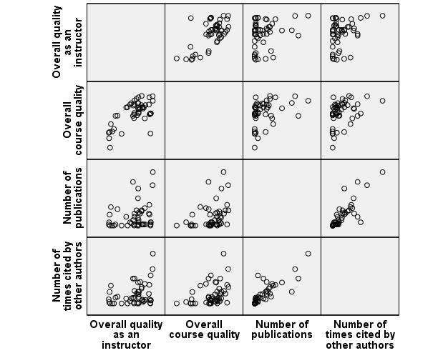

Part 2:

- A clinical psychologist would like to determine whether there is a relationship between observer ratings of children’s anxious behaviors and scores on an established diagnostic interview assessing anxiety disorders. He administers the diagnostic interview to 28 children and records these scores. He then trains an observer to independently rate anxiety-specific behaviors for each of the 28 children. These ratings are totaled for an overall “anxious behavior” score. On both the interview and the behavioral ratings, a higher score indicates higher levels of anxiety. These scores are listed in the table on the following page. Conduct a Pearson correlation coefficient analysis to determine whether there is a relationship between the interview scores and the behavioral ratings for this group of children.

The steps will be the same as the ones you have been practicing in Part 1 of the assignment—the only difference is that you are now responsible for creating the data file as well. Remember to name and define your variables under the “Variable View,” then return to the “Data View” to enter the data. (3 pts)
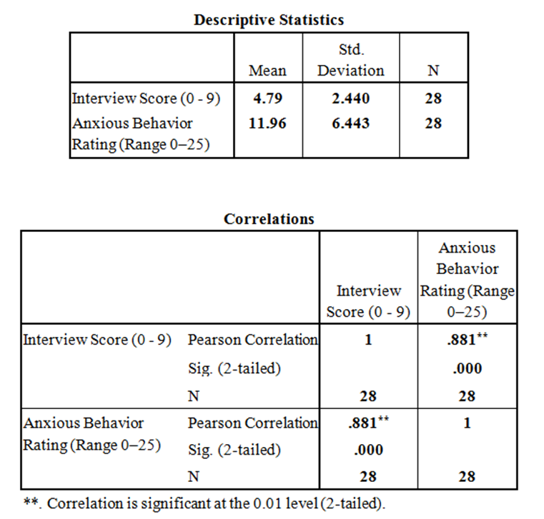
Interview (Range 0–9) | Anxious Behavior Rating (Range 0–25)
3 | 7
2 | 6
4 | 6
9 | 21
7 | 20
7 | 18
4 | 10
8 | 9
3 | 5
3 | 7
2 | 5
1 | 3
6 | 17
8 | 19
8 | 23
7 | 22
1 | 4
2 | 7
3 | 7
3 | 3
5 | 13
8 | 20
7 | 16
4 | 12
6 | 13
6 | 18
5 | 15
2 | 9

- Create a simple scatterplot of the relationship between these variables (define interview scores as the x-axis and behavioral ratings as the y-axis). (3 pts)
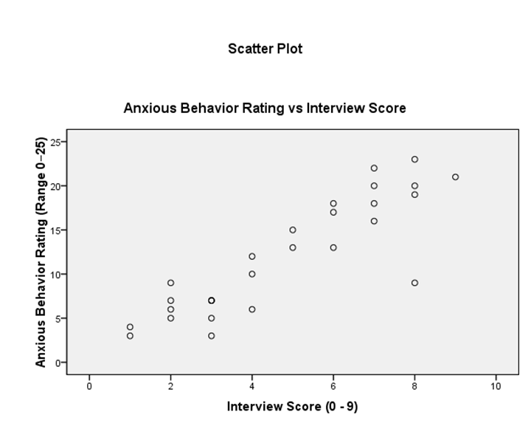

- Write an APA-style Results section describing the outcome. All homework “Results sections” must follow the example given in the Course Content document “Writing Results of Statistical Tests in Current APA Format” (Note: you do not have to refer to a figure). Be sure to include the direction of the relationship between the variables (positive? negative? none?) in your section. (3 pts)
The results indicated a statistically significant relationship, r(26) = .881, p = .000, between the anxious behavior rating (M = 11.96, SD = 6.443) and interview score (M = 4.79, SD = 2.440). The positive value of the correlation indicates the direction of the relationship between the variables is positive. It also suggests that higher interview score tends to be associated with higher anxious behavior rating.
- A neuropsychologist is assessing the relationship between brain function and performance on a visuo-spatial task. He administers a test to 14 patients on which scores can range from 1–20: a high score indicates normal brain function, and a low score indicates some levels of brain dysfunction. He then asks each patient to complete a maze and records the number of mistakes the patient makes from start to finish. The scores are listed in the table below. Conduct a Pearson correlation coefficient analysis to determine what the relationship is, if any, between brain function and performance on the maze task.

The steps will be the same as the ones you have been practicing in Part 1 of the assignment—the only difference is that you are now responsible for creating the data file as well. Remember to name and define your variables under the “Variable View,” then return to the “Data View” to enter the data. (3 pts)

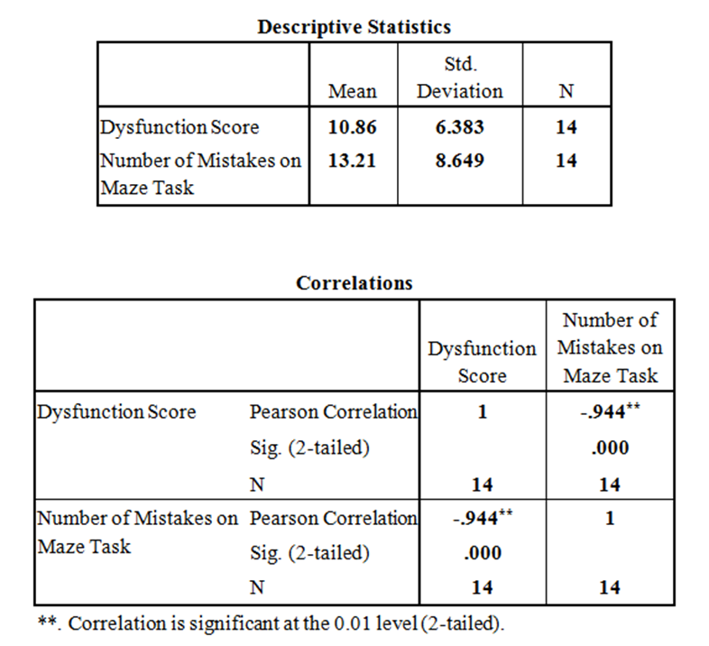

Dysfunction Score | Number of Mistakes on Maze Task
3 | 25
8 | 18
9 | 18
4 | 26
15 | 6
6 | 19
18 | 3
17 | 4
19 | 6
6 | 16
5 | 14
20 | 2
17 | 5
5 | 23

- Create a simple scatterplot of the relationship between these variables. (3 pts)
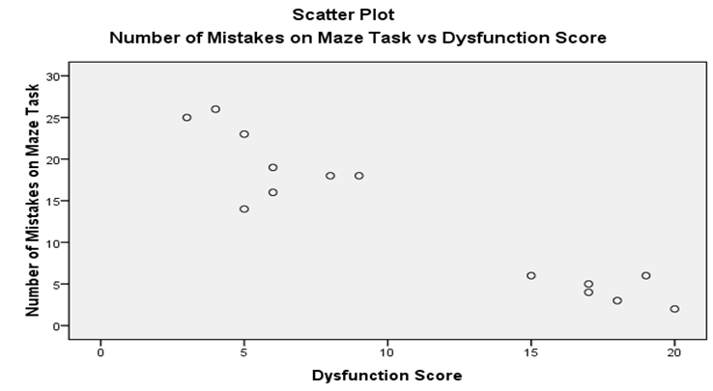

- Write an APA-style Results section describing the outcome. All homework “Results sections” must follow the example given in the Course Content document “Writing Results of Statistical Tests in Current APA Format” (Note: you do not have to refer to a figure). (3 pts)
The results indicated a statistically significant relationship, r(12) = –.944, p = .000, between the number of mistakes on maze task (M = 13.21, SD = 8.649) and dysfunction score (M = 10.86, SD = 6.383). The negative value of the correlation indicates the direction of the relationship between the variables is negative. It also suggests that higher dysfunction score tends to be associated with lower number of mistakes on maze task

- The null hypothesis for this scenario can be written as follows: “There is no relationship between level of brain function and the number of mistakes made on a maze task.” Based on your results, should this hypothesis be rejected or retained, and why? Write your answer in sentence form. (2 pts)

Since r(12) = –.944, p = .000 < 0.001, data suggests rejection of the null hypothesis that “There is no relationship between level of brain function and the number of mistakes made on a maze task.”

Part 3: Cumulative Homework

- A developmental psychologist is studying whether students in a certain preschool program perform better than preschoolers in the state in general on a measure of reading readiness. The mean score for preschoolers in the state on the measure is 83. The psychologist tests the preschoolers in the program and records the scores in the table below. Choose the correct test to analyze this question, set up the SPSS file, and run the analysis. Follow the directions under the table below.

Reading Readiness Scores
90
78
86
91
78
91
88
72
76
88
88
91
76
89
92

- Paste appropriate SPSS output. (3)
- Paste appropriate SPSS graph. (2)
- Write an APA-style Results section based on your analyses. All homework “Results sections” should follow the example given in the SPSS tutorials and the Course Content document “Writing Results of Statistical Tests in APA Format” (note: you do not have to refer to a figure). Remember to include a decision about the null hypothesis. (3)

- In a study of the relationship between girls’ playtime activities and self-esteem, 16 girls in a fourth-grade class are selected and randomly assigned to one of two groups. One group plays with a selection of Barbie™ dolls for one hour, and the other group plays with a selection of toy animal figures. At the end of the hour, the girls are given a verbal interview designed to measure self-esteem. Scores range from 1–12, and higher scores = higher feelings of self-esteem. Is there a significant difference between the groups on feelings of self-esteem? Choose the correct test to analyze this question, set up the SPSS file, and run the analysis. Follow the directions under the table below.

Barbie™ Group | 4  5  7  9  6  10  4  6  5
Toy Animal Group | 8  8  5  11  10  7  7  9

- Paste appropriate SPSS output. (2)
- Paste appropriate SPSS graph. (2)
Write an APA-style Results section based on your analyses. All homework “Results sections” should follow the example given in the SPSS tutorials and the Course Content document “Writing Results of Statistical Tests in APA Format” (note: you do not have to refer to a figure). Remember to include a decision about the null hypothesis. 2)

Submit this assignment by 11:59 p.m. (ET) on Monday of Module/Week 5.

