This exercise you will be exploring more usage of the static keyword.

You must following the specifications exactly

The Account class
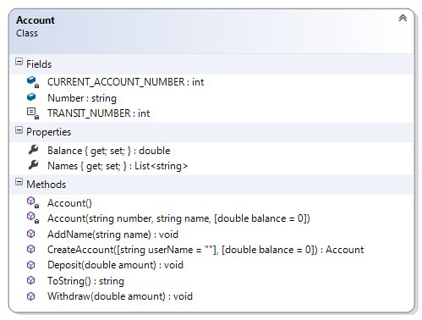
This is the front end of the application. There are 12 members.

Description of class members

Fields:
CURRENT_ACCOUNT_NUMBER – this private class variable is an int representing the unique number to be used when creating a new account. This is initialized in the static constructor. This is incremented in the instance constructor
Number – this public instance variable is a string indicating the current account number of this object reference. This must be decorated with the readonly keyword. This is set in the CreateAccount() method.
A readonly field is like a consts but it is normally assigned when the program is running.
A const is a value that cannot be modified. Its value is set at declaration. i.e. When the program is compiled.
TRANSIT_NUMBER – this private int is a constant representing the branch number of all the accounts. That is initialized to 314. It is used in the CreateAccount() method to build the account number of this account.

Properties:
Balance – this property is a double that represents the current balance of this object. . This getter is public and the setter is private.
Names – this property is a list of string representing the name associated with this object. This getter is public and the setter is private.

Constructor:
There are two constructors for this class: a static and a private one
static Account() – This is the static constructor. It will be used to initialize the class variable CURRENT_ACCOUNT_NUMBER to a suitable value e.g. 100000
A static constructor is used to initialise the static fields and properties. It is invoked once in the life time of a program, before ANY member is accessed. There is no access modifier i.e. public, protected or private
private Account(string number, string name, double balance) – This is a private constructor that does the following:
- The Number field and the Balance property are initialized to the values of the arguments
- The Names property is initialised to an empty list (use the new operator). And the argument is added to this collection

Methods
public void AddName(string name) – This is a public method adds the argument int0 the Names collection. It is possible to have multiple names associated with this account. This method does not return a value.
public void Deposit(double amount) – This is a public method that increases the property Balance by the amount specified by the argument. This method does not return a value.
public void Withdraw(double amount) – This is a public method that decreases the property Balance by the amount specified by the argument. This method does not return a value.
The static string method Join enables you to stringify a collection. Use the following code to get string from a collection:
string.Join(", ", Names);
public override string ToString() – This is a public method overrides the corresponding method in the object class to return a stringify form of the object. To display the Names field, you will have to do some extra work because it is a list of strings []
public static Account CreateAccount(string name, double balance = 0) – This is a public static method is used to create accounts. It does the following:
- Builds an account number from the TRANSIT_NUMBER and CURRENT_ACCOUNT_NUMBER according to the template “AC-[transit number]-[current account number]. e.g. if the value of TRANSIT_NUMBER and CURRENT_ACCOUNT_NUMBER are 314 and 10005 respectively then the account number will be “AC-314-10005”. [Hint: use string.Format() method to do this.]
- It also increments the CURRENT_ACCOUNT_NUMBER field so the next object will have a unique number.
- Instantiate a new account object with the appropriate arguments.
  - Returns the above object

Test Harness
Insert the following code statements in your Program.cs file:

List<Account> accounts = new List<Account>();
Random rand = new Random();

accounts.Add(Account.CreateAccount("Narendra", rand.Next(50, 500)));
accounts.Add(Account.CreateAccount("Ilia", rand.Next(50, 500)));
accounts.Add(Account.CreateAccount("Yin", rand.Next(50, 500)));
accounts.Add(Account.CreateAccount("Arben", rand.Next(50, 500)));
accounts.Add(Account.CreateAccount("Patrick", rand.Next(50, 500)));
accounts.Add(Account.CreateAccount("Joanne", rand.Next(50, 500)));
accounts.Add(Account.CreateAccount("Nicoleta", rand.Next(50, 500)));
accounts.Add(Account.CreateAccount("Mohammed", rand.Next(50, 500)));

Console.WriteLine("\nAll accounts");
foreach (Account account in accounts)
{
Console.WriteLine(account);
}

foreach (Account account in accounts)
{
account.Deposit(55.55);
}

Console.WriteLine("\nAfter $55.55 deposit ");
foreach (Account account in accounts)
{
Console.WriteLine(account);
}

foreach (Account account in accounts)
{
account.Withdraw(1.11);
if(account.Balance > 300)
account.AddName("(Hacked)");
}

Console.WriteLine("\nAfter $1.11 withdrawal");
foreach (Account account in accounts)
{
Console.WriteLine(account);
}

Test Harness
Output

All accounts
[AC-314-10000] Narendra $390.00
[AC-314-10001] Ilia $228.00
[AC-314-10002] Yin $210.00
[AC-314-10003] Arben $351.00
[AC-314-10004] Patrick $224.00
[AC-314-10005] Joanne $210.00
[AC-314-10006] Nicoleta $126.00
[AC-314-10007] Mohammed $194.00

After $55.55 deposit
[AC-314-10000] Narendra $445.55
[AC-314-10001] Ilia $283.55
[AC-314-10002] Yin $265.55
[AC-314-10003] Arben $406.55
[AC-314-10004] Patrick $279.55
[AC-314-10005] Joanne $265.55
[AC-314-10006] Nicoleta $181.55
[AC-314-10007] Mohammed $249.55

After $1.11 withdrawal
[AC-314-10000] Narendra, (Hacked) $444.44
[AC-314-10001] Ilia $282.44
[AC-314-10002] Yin $264.44
[AC-314-10003] Arben, (Hacked) $405.44
[AC-314-10004] Patrick $278.44
[AC-314-10005] Joanne $264.44
[AC-314-10006] Nicoleta $180.44
[AC-314-10007] Mohammed $248.44
Press any key to continue . . .

