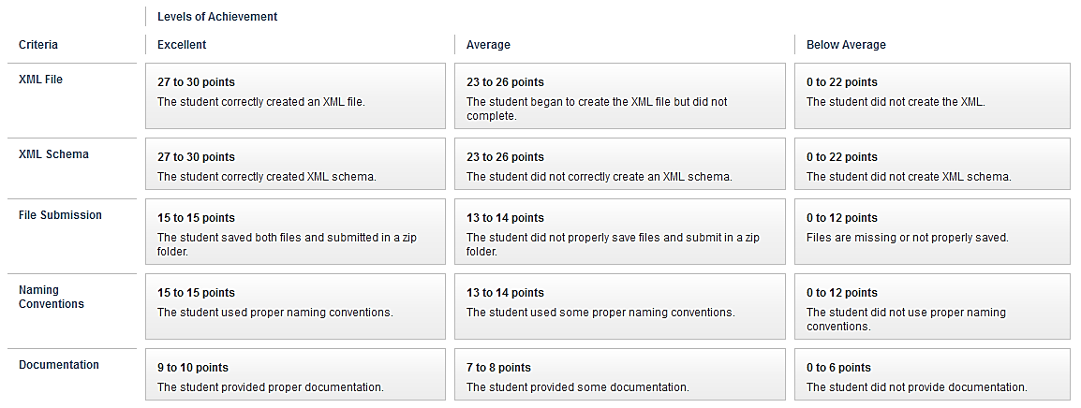
Data Mapping Exercise Grading Rubric

