Programming

This is the most complex application that you have seen so far. It is comprised of six user defined types: four classes and two enums. This assignment attempts to simulate a simple version of a Theater application. In this application the user is able to search for a movie based on genre, name of actor, the time of the day and the day of the week.
You should define your types in the following order: the two enums, Time, Movie, Show and then Theater You will perform some simple queries on this collection.
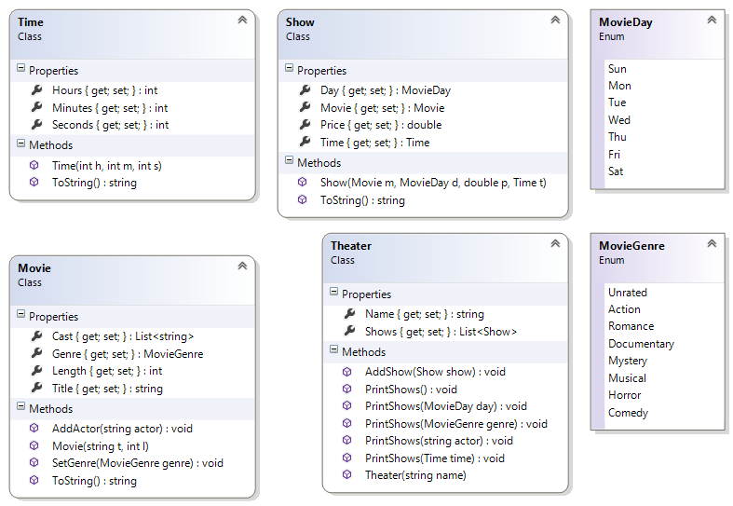

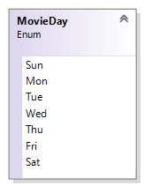
The MovieDay Enum
This type represents the days of the week and is comprised of seven constants. The constants are the first three letters of the day of the week.

The MovieGenre Enum
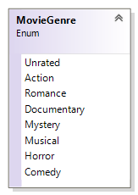
This type represents the various categories of movie. Because a movie may fall under multiple categories, you will have to use the [Flags] to decorate this enum.
The bit-wise operator is used to combine more than one genre. E.g. MovieGenre genre = MovieGenre.Action | MovieGenre.Romance | MovieGenre.Comedy;
For this to work correctly, you will have to assign appropriate values for each name. Appropriate values are 0, 1, 2, 4, 8, 16, 32 etc.

The Time Class
This type represents the days of the week.

Time
Class
Properties
+ Hours {get; set;} : int
+ Minutes {get; set;}: int
+ Seconds {get; set;}: int
Methods
+ Time(hours : int, minutes : int, seconds : int)
+ ToString() : string

Properties:
All of the properties have public getters and private setters and are self-explanatory.
- Hours – this property is an int representing the hour. The getter is public and the setter is private.
- Minutes – this property is an int representing the minute. The getter is public and the setter is private.
- Seconds – this property is an int representing the second. The getter is public and the setter is private.

Methods:
- Time(int hours, int minutes, int seconds) – This public constructor takes three int parameters and assigns them to the appropriate properties
- ToString() – This method overrides the same method of the Object class. It does not take any parameter but return a string representation of itself. You decide on the format for the output.

The Movie Class
This class will model a movie.

Movie
Class
Properties
+ Length {get; set;} : int
+ Title {get; set;}: string
+ Genre {get; set;}: MovieGenre
+ Cast {get; set;}: List<string>
Methods
+ Movie(title : string, length : int)
+ AddActor(actor : string) : void
+ SetGenre(genre : MovieGenre) : void
+ ToString() : string

Properties:
All of the properties have public getters and private setters and are self-explanatory.
- Length – this property is an int representing the length of the movie in minutes. The getter is public and the setter is private.
- Title – this property is a string representing the title of the movie. The getter is public and the setter is private.
- Genre – this property is an enum representing the genre of this movie. The getter is public and the setter is private.
- Cast – this property is a list of string representing the names of the actors in this movie. The getter is public and the setter is private.

Methods:
- Movie(string name, int length) – This public constructor takes one string and one int parameter. It does the following:
  - Assigns the arguments to the appropriate properties.
  - Initialize the Cast property to
- AddActor(string actor) – This public method takes a single a string argument and adds it to the collection of actors (Cast).
- SetGenre(MovieGenre genre) – This public method takes a single enum argument and assigns it to the property of the same name.
- ToString() – This method overrides the same method of the Object class. It does not take any parameter but return a string representation of itself. You will need to build a single string comprising all of the actors in this movie. You decide on the format for the output.

The Show Class
This class models a movie show. You will also implement this in Visual Studio. A short description of the class members is given below:
Show
Class
Properties
+ Price {get; set;} : double
+ Day {get; set;} : MovieDay
+ Movie {get; set;} : Movie
+ Time {get; set;} : Time
Methods
+ Show(movie : Movie, day : MovieDay, price : double, time : Time )
+ ToString() : string

Properties:
- Price – this property is a double representing the price of admission to this show. The getter is public and the setter is private.
- Day – this property is an enum representing the day of the week of this show. The getter is public and the setter is private.
- Movie – this property is an object reference of the movie class. The getter is public and the setter is private.
- Time – this property is an object of the Time class representing the time of this show. The getter is public and the setter is private.

Methods:
- Show(Movie movie, MovieDay day, double price, Time time) – This is the public constructor that takes four arguments and assigns them to the appropriate properties.
- ToString() – This is the public method overrides the method of the same name in the object class to return a meaningful description of this object.

The Theater Class
This class models a theater. You will also implement this in Visual Studio. A short description of the class members is given below:

Theatre
Class
Properties
+ Shows {get; set;} : List<Show>
+ Name {get; set;} : string
Methods
+ Theater(name : string)
+ AddShow(show : Show) : void
+ PrintShows() : void
+ PrintShows(genre : MovieGenre) : void
+ PrintShows(day : MovieDay) : void
+ PrintShows(time : Time) : void
+ PrintShows(actor : string) : void

Properties:
- Shows – this private field is a list of Show objects. The getter is public and the setter is private.
- Name – this private field is a string representing the name of the theater.

Methods:
- Theater(string name) – This is the public constructor that takes the name of the theater. This constructor does the following:
  - Assigns the argument to the property.
  - Initialize the Shows property to a new list of show
- AddShow(Show show) – This public method takes a show object and adds it to the collection of shows.
Again, this is a good example of method overloading
- PrintShows() – This public method does not take any argument neither does it return a value. It displays all the shows that is available.
- PrintShows(MovieGenre genre) – This public method takes a genre as an argument and display all the shows that contains the flag of this genre.
- PrintShows(MovieDay day) – This public method takes a day object as an argument and display all the shows matching this day object.
- PrintShows(Time time) – This public method takes a time object as an argument and display all the shows matching the hour value of this time object.
- PrintShows(string actor) – This public method takes a string representing the name of an actor as an argument and display all the shows that this actor appears in.

Testing
In your test harness (the Main() method in the Program Class), copy and paste the following code:
Movie terminator = new Movie("Judgement Day", 105);
terminator.AddActor("Arnold Schwarzenegger");
terminator.SetGenre(MovieGenre.Horror | MovieGenre.Action);
terminator.AddActor("Linda Hamilton");
Show s1 = new Show(terminator, MovieDay.Mon, 5.95, new Time(11, 35, 0));

Console.WriteLine(s1);
Theater eglinton = new Theater("Cineplex");
eglinton.AddShow(s1);
eglinton.PrintShows(); //displays one object

Movie godzilla = new Movie("Godzilla 2014", 123);
godzilla.AddActor("Aaron Johnson");
godzilla.AddActor("Ken Watanabe");
godzilla.AddActor("Elizabeth Olsen");
godzilla.SetGenre(MovieGenre.Action);

Movie trancendence = new Movie("Transendence", 120);
trancendence.AddActor("Johnny Depp");
trancendence.AddActor("Morgan Freeman");
trancendence.SetGenre(MovieGenre.Comedy);
eglinton.AddShow(new Show(trancendence, MovieDay.Sun, 7.87, new Time(18, 5, 0)));

Movie m1 = new Movie("The Shawshank Redemption", 120);
m1.AddActor("Tim Robbins");
m1.AddActor("Morgan Freeman");
m1.SetGenre(MovieGenre.Action);
eglinton.AddShow(new Show(m1, MovieDay.Sun, 8.87, new Time(14, 5, 0)));

m1 = new Movie("Olympus Has Fallen", 120);
m1.AddActor("Gerard Butler");
m1.AddActor("Morgan Freeman");
m1.SetGenre(MovieGenre.Action);
eglinton.AddShow(new Show(m1, MovieDay.Sun, 8.87, new Time(16, 5, 0)));

m1 = new Movie("The Mask of Zorro", 136);
m1.AddActor("Antonio Banderas");
m1.AddActor("Anthony Hopkins");
m1.AddActor(" Catherine Zeta-Jones");
m1.SetGenre(MovieGenre.Action | MovieGenre.Romance);
eglinton.AddShow(new Show(m1, MovieDay.Sun, 8.87, new Time(16, 5, 0)));

m1 = new Movie("Four Weddings and a Funeral", 117);
m1.AddActor("Hugh Grant");
m1.AddActor("Andie MacDowell");
m1.AddActor("Kristin Scott Thomas");
m1.SetGenre(MovieGenre.Comedy | MovieGenre.Romance);
eglinton.AddShow(new Show(m1, MovieDay.Sat, 8.87, new Time(15, 5, 0)));

m1 = new Movie("You've Got Mail", 119);
m1.AddActor("Tom Hanks");
m1.AddActor("Meg Ryan");
m1.SetGenre(MovieGenre.Comedy | MovieGenre.Romance);
eglinton.AddShow(new Show(m1, MovieDay.Sat, 8.87, new Time(15, 5, 0)));

Show s2 = new Show(godzilla, MovieDay.Mon, 6.89, new Time(13, 15, 0));
eglinton.AddShow(s2);

s2 = new Show(godzilla, MovieDay.Sun, 6.89, new Time(14, 15, 0));
eglinton.AddShow(s2);

s2 = new Show(godzilla, MovieDay.Sun, 6.89, new Time(16, 55, 0));
eglinton.AddShow(s2);

eglinton.PrintShows(); //displays ten objects

eglinton.PrintShows(MovieDay.Sun); //displays six objects

eglinton.PrintShows(MovieGenre.Action); //displays seven objects

eglinton.PrintShows(MovieGenre.Romance); //displays three objects

eglinton.PrintShows(MovieGenre.Action | MovieGenre.Romance); //displays one object

eglinton.PrintShows("Morgan Freeman"); //displays three objects

eglinton.PrintShows(new Time(14, 30, 0)); //displays two objects

