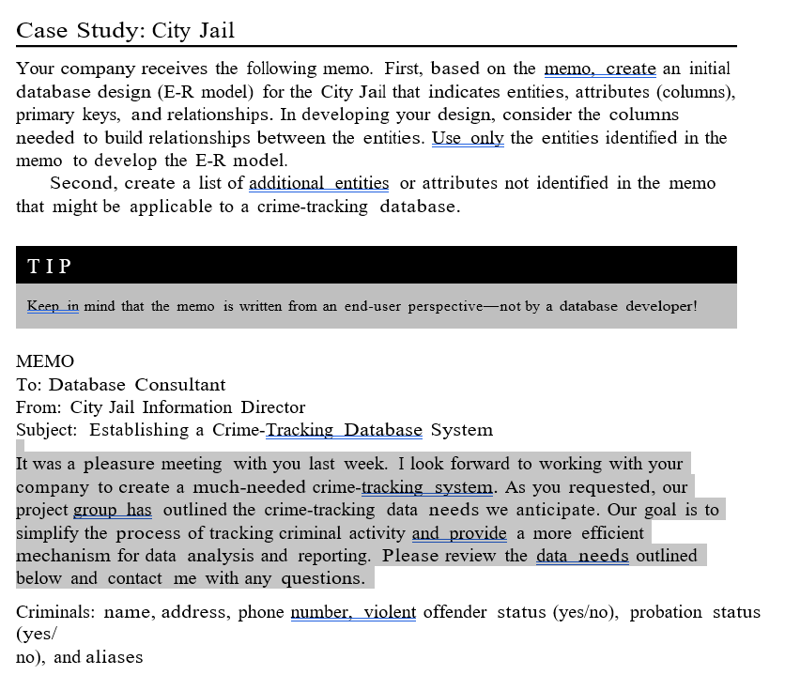
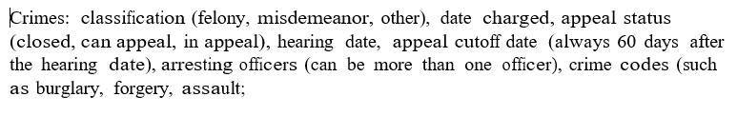
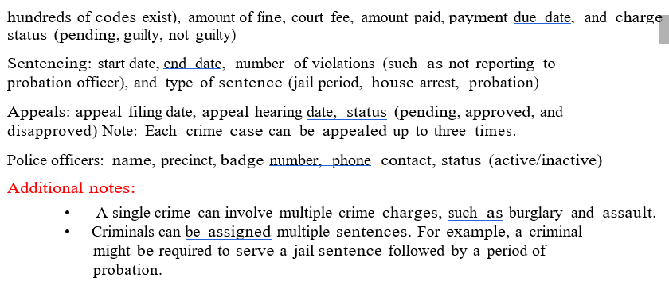

My work:

CREATE TABLE Criminals (
CRIMINAL_NAME CHAR(9),
ADDRESS CHAR(20),
PHONE_NUMBER NUMBER(10),
VIOLENT_OFFENDER_STATUS CHAR(1) DEFAULT 'N',
PROBATON_STATUS CHAR(1) DEFAULT 'N',
ALIASES CHAR(9))

CREATE TABLE Crimes (
CLASSIFICATION CHAR(11),
DATE_CHARGED DATE,
APPEAL_STATUS CHAR(2),
HEARING_DATE DATE DEFAULT SYSTEM,
APPEAL_CUTOFF_DATE DATE DEFAULT SYSTEM,
ARRESTING_OFFICERS NUMBER(2),
CRIMES_CODES NUMBER(9),
AMOUNT_OF_FINE NUMBER(7,2),
COURT_FEE NUMBER(7,2),
AMOUNT_PAID NUMBER(7,2),
PAYMENT_DUE_DATE DATE DEFAULT SYSTEM,
CHARGE_STATUS CHAR(11))

CREATE TABLE Sentencing (
START_DATE DATE DEFAULT SYSTEM,
END_DATE DATE DEFAULT SYSTEM,
NUMBER_OF_VIOLATIONS NUMBER(4),
TYPE_OF_SENTENCE CHAR(2) DEFAULT 'P')

CREATE TABLE Appeals (
APPEAL_FILING_DATE DATE DEFAULT SYSTEM,
APPEAL_HEARING_DATE DATE DEFAULT SYSTEM,
STATUS CHAR(1) DEFAULT 'P')

CREATE TABLE Police_officers (
OFFICER_NAME CHAR(9),
PRECINCT CHAR(4),
BADGE_NUMBER VARCHAR2(14),
PHONE_CONTACT NUMBER(10),
STATUS CHAR(1) DEFAULT 'A')

