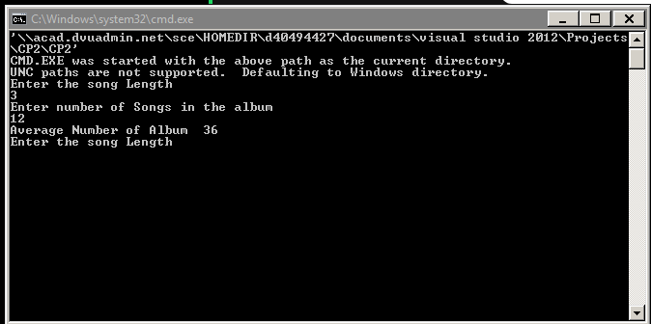
#include <iostream>
#include <cmath>
#include <conio.h>
using namespace std;

int main() {
public:
// constructor
int calculatePaylist (int songLen, int numberOfSongs ){
songLen = songLen;
numberOfSongs= numberOfSongs;

avPlayListlen = songLen* numberOfSongs;

return avPlayListlen;
}

// hidden data from outside world

int songLen;
int numberOfSongs;
int avPlayListlen;
};

int main( ) {

int songlen;
int numOfSongs;
Jocker a;
int counter =0;

while(counter < 9){

cout << "Enter the song Length" << endl;

std:: cin >> songlen ;

cout << "Enter number of Songs in the album" << endl;

std:: cin >> numOfSongs ;

int playList = a.calculatePaylist (songlen, numOfSongs);

cout << "Average Number of Album " << playList <<endl;

counter ++;
}

_getch();

return 0;
}

