Boolean Algebra

- Evaluate the following Boolean expressions with x = y = 1 and w = z = 0.

- Indicate whether the following Boolean expressions are in conjunctive normal form or disjunctive normal form, or both, or neither.

- Give a Boolean expression for each of the functions below specified by the input/output table. Use the sum of minterm expression described in the text.
(For part a, the function should be f(x, y), not f(x, y, z).)
a.
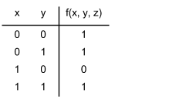

b.
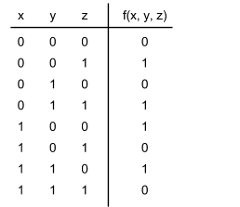

- Draw circuits that compute the following Boolean expressions:

- Draw a circuit that computes the function -- f(x,y), not f(x,y,z) -- described in the input/output table:
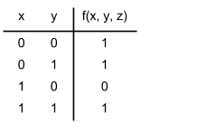

- Give an equivalent Boolean expression for the following circuit:

