Answer the following questions in one page each excluding the pictures if necessary. Please use pictures to explain your points too. It’s conceptual analysis so the concepts need to be analyzed

1.Conceptual analysis is a human cognitive activity. Our aim is to identify the concepts "behind" the words. Look carefully at the Sowa-Sloman heuristic. Try it out with two or three concepts that are important to you, personally with examples if necessary. You can use this examples and add an extra one
a) Cognitive Load (Our brains can only hold so much information at once)
b) Family

2.Think about your own Boulding-images. Describe three of them (your choice):
a) of an academic field (computer science.)
b) world politics as you see it now (Donald trump and the US)
c) Canada (your view of it)

3. If there are concepts "behind" words, then most certainly there are concepts "behind" the various images that we see.

Going from images (visual signs) to concepts is non-trivial.
Pick two or three examples(images) from Hall (pdf attached below) and review them critically.

Look below
|

These are two images and responses from the textbook.
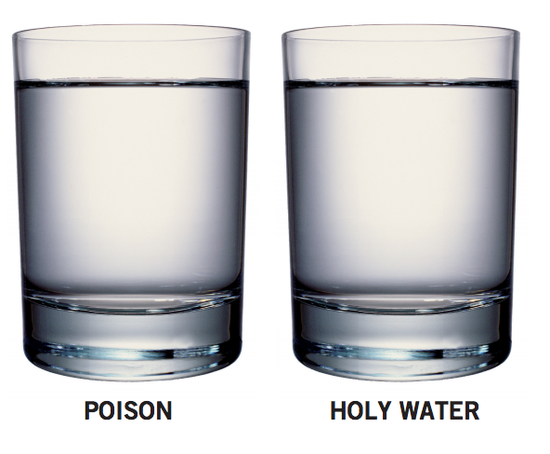

What text is telling the truth
To understand some of the numerous interactions that can occur between words and images one might first consider books that have no text. In books for small children that have pictures but no writing parents are forced to make up large parts of the story. This gives a great deal of control to the reader. In this instance, the reader becomes a key locus for the reading of the book. Now, in contrast, consider a text without pictures or illustrations of any kind, such as a novel. In this case, as there is no visual guidance, we have to rely on textual descriptions in order to know what the characters or places in the novel look like. Images on their own are often so open to interpretation that they fail to provide a stable meaning for the reader to grasp. This may be why we might need to supplement them with words. Words help to reduce the number of interpretations available. Words aid us in anchoring images. (Just how important it is to anchor an image properly can be seen from the picture on the previous page. For it obviously matters greatly whether a glass turns out to contain poison rather than holy water.) The problem of open interpretation occurs with texts too. And this is where illustration comes in. For example, Sir John Tenniel’s illustrations for Lewis Carroll’s Alice in Wonderland help to elaborate on, and ground, what is to be found in the text in such a powerful way that people think that Alice really is blond when, in fact, Carroll does not actually specify the color of her hair in the book. Pieces of text, then, can simplify, complicate, elaborate, amplify, confirm, contradict, deny, restate, or help to define different sorts of meanings when they interact with images and objects. This can occur in cartoon strips, in photographs with captions, in maps with place names, in advertisements with overlapping text, in ready-to-assemble furniture with instructions, or in the case of sculptures that have written provenances. WORDS AND IMAGES W

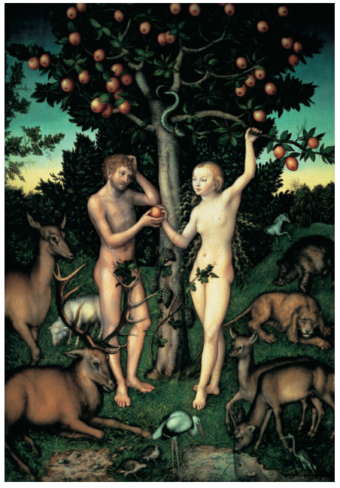

WHAT DOES THE APPLE IN THIS PICTURE SIGNIFY?

This painting by Lucas Cranach (1472–1553) depicts Adam and Eve in the Garden of Eden. The apple represents the fruit of the Tree of Knowledge. Satan, who takes the form of a serpent, uses the apple to tempt Eve. Eve picks the apple and gives it to Adam. With this act Adam and Eve fall from grace in the eyes of God. It is easy to assume that the image of Eve being tempted by the apple accurately reflects the story in the Bible. But in the Bible there is no mention of an apple. Fruit is mentioned, but not apples. So perhaps it was really an orange that tempted Eve. Or a fig. What seems to matter in the picture by Cranach is that the apple (what we call the “signifier”) is the fruit used to signify temptation (what we call the “signified”). However, while the apple means temptation, some other fruit could have been chosen to represent the same idea. It is only because there is already a well-established connection in our minds between the appearance of an apple and the idea of temptation that this fruit is used in the picture. It is this connection that makes the picture successful in terms of communication. There are numerous relationships that can exist between signifier and signified. Two important things about the relationship stand out though. One is that we can have the same signifier with different signified. The other is that we can have different signifiers with the same signifieds.

