You will be learning to read from a file and building the three interconnected types illustrated below:

All the above type must decorated with the public keyword

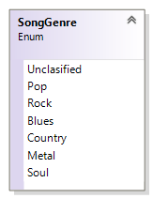
The SongGenre enum
This enum comprise of seven types of songs
To code this add a new item to your project and select the class option. Make the necessary changes to the header to reflect the enum type. You should decorate this enum with the Flags attribute, because values may be combined e.g. Country+Blues.
In order to make the flags work better, you must set each value to ascending powers of 2 e.g. 0, 1, 2, 4, 8, 16 …

The Song class
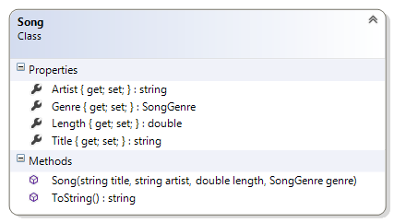
This acts like a record for the song.

Description of the class members

Fields
There are no fields

Properties:
This class comprise of four properties with public getters and private setters. See the class diagram for more details

Constructor:
public Song(string title, string artist, double length, SongGenre genre) – This constructor that takes four arguments and assigns them to the appropriate properties

Method:
public override string ToString() – This public method overrides the ToString() method of the object class. It does not take any argument and returns a string representation of the object. See the output for hints on the return value of this method.

The Library class
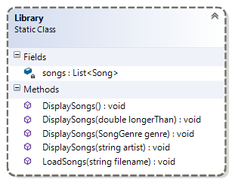
This is the front end of the application. This is a static class hence, all the members are also static.

Description of class members

Fields:
songs – this private field is a list of song object is a class variable.

Properties:
There are no properties.

Constructor:
There is no constructor for this class.

Methods
public static void DisplaySongs() – This is a public class method that does not take any argument and displays all the songs in the collection.
public static void DisplaySongs(double longerThan) – This is a public class method that takes a double argument and displays only songs that are longer than the argument.
public static void DisplaySongs(SongGenre genre) – This is a public class method that takes a SongGenre argument and displays only songs that are of this genre.
public static void DisplaySongs(string artist) – This is a public class method that takes a string argument and displays only songs by this artist.
public static void LoadSongs(string fileName) – This a class method that is public. It takes a single string argument that represents a text file containing a collection of songs. You will read all the data and create songs and add it to the songs collection. Examine the contents of the files for a better understanding of how this should be done. You will have to read four lines to create one Song. Your loop body should have four ReadLine(). The recipe below might clarify things:
The contents of text file
Baby
Justin Bebier
3.35
Pop
- Declare four string variable to store the four reads.
- The first read is the title of the song. This can and should used as a check for termination condition.
- Do three more read and assign them to the appropriate variables.
This is a complex method and rightfully it should be a part of the Song Class
- Use the four variables to create a Song object (you will have to convert the third to a double and the fourth to a SongGenre).
- Add the newly created object to the collection.
- And finally do one more read for the title to re-enter the loop.
P.S. Before running the Library.LoadSongs() you will need to copy the files Week_03_lab09_song.txt, Week_03_lab09_song2.txt, Week_03_lab09_song3.txt and Week_03_lab09_song4.txt to the bin\debug folder.

Test Harness
Insert the following code statements in the Main() method of your Program.cs file:

//To test the constructor and the ToString method
Console.WriteLine(new Song("Baby", "Justin Bebier", 3.35, SongGenre.Pop));
Console.WriteLine(new Song("The Promise", "Chris Cornell ", 4.26, SongGenre.Country | SongGenre.Rock));

Library.LoadSongs("Week_03_lab_09_songs4.txt"); //Class methods are invoke with the class name
Console.WriteLine("\n\nAll songs");
Library.DisplaySongs();

SongGenre genre = SongGenre.Rock;
Console.WriteLine("\n\n{0} songs", genre);
Library.DisplaySongs(genre);

string artist = "Bob Dylan";
Console.WriteLine("\n\nSongs by {0}", artist);
Library.DisplaySongs(artist);

double length = 5.0;
Console.WriteLine("\n\nSongs more than {0}mins", length);
Library.DisplaySongs(length);

Program output

Baby by Justin Bebier (Pop) 3.35min
The Promise by Chris Cornell (Rock, Country) 4.26min
All songs
Baby by Justin Bebier (Pop) 3.35min
Fearless by Taylor Swift (Pop) 4.03min
Runaway Love by Ludacris (Pop) 4.41min
My Heart Will Go On by Celine Dion (Pop) 4.41min
Jesus Take The Wheel by Carrie Underwood (Country) 3.31min
If Tomorrow Never Comes by Garth Brooks (Country) 3.40min
Set Fire To Rain by Adele (Soul) 4.01min
Don't You Remember by Adele (Soul) 3.03min
Signed Sealed Deliverd I'm Yours by Stevie Wonder (Soul) 2.39min
Just Another Night by Mick Jagger (Rock) 5.15min
Brown Sugar by Mick Jagger (Rock) 3.50min
All I Want Is You by Bono (Metal) 6.30min
Beautiful Day by Bono (Metal) 4.08min
Like A Rolling Stone by Bob Dylan (Rock) 6.08min
Just Like a Woman by Bob Dylan (Rock) 4.51min
Hurricane by Bob Dylan (Rock) 8.33min
Subterranean Homesick Blues by Bob Dylan (Rock) 2.24min
Tangled Up In Blue by Bob Dylan (Rock) 5.40min
Love Me by Elvis Presley (Rock) 2.42min
In The Getto by Elvis Presley (Rock) 2.31min
All Shook Up by Elvis Presley (Rock) 1.54min

Rock songs
Just Another Night by Mick Jagger (Rock) 5.15min
Brown Sugar by Mick Jagger (Rock) 3.50min
Like A Rolling Stone by Bob Dylan (Rock) 6.08min
Just Like a Woman by Bob Dylan (Rock) 4.51min
Hurricane by Bob Dylan (Rock) 8.33min
Subterranean Homesick Blues by Bob Dylan (Rock) 2.24min
Tangled Up In Blue by Bob Dylan (Rock) 5.40min
Love Me by Elvis Presley (Rock) 2.42min
In The Getto by Elvis Presley (Rock) 2.31min
All Shook Up by Elvis Presley (Rock) 1.54min

Songs by Bob Dylan
Like A Rolling Stone by Bob Dylan (Rock) 6.08min
Just Like a Woman by Bob Dylan (Rock) 4.51min
Hurricane by Bob Dylan (Rock) 8.33min
Subterranean Homesick Blues by Bob Dylan (Rock) 2.24min
Tangled Up In Blue by Bob Dylan (Rock) 5.40min

Songs more than 5mins
Just Another Night by Mick Jagger (Rock) 5.15min
All I Want Is You by Bono (Metal) 6.30min
Like A Rolling Stone by Bob Dylan (Rock) 6.08min
Hurricane by Bob Dylan (Rock) 8.33min
Tangled Up In Blue by Bob Dylan (Rock) 5.40min
Press any key to continue . . .

