Database Security CSS330-1702B-01

Database Security Architecture Unit 2 Project
May 31, 2007

Table of Contents
Database Security Architecture 3
Define and differentiate between a Database Management System to a database 3
Describe the Netowrk Infrastructure needed to put a Database Server in an appropriate location 4
Network Diagram 4
Describe additional security mechanisms that could be implemented to protect the database server 5
User Account Security 6
Database Vulnerabilities 7
Auditing Techniques 8
Auditing Policies 9
References 10

Database Security Architecture

Database Security Structure
As organizations try to adopt the dynamic Information Systems, security is key when implementing the databases. Without security many organization would fall due to malicious attacks that lead to loss of assets and information. This paper focuses on ensuring data and information security by looking into methods of securing a database.

Define and differentiate between a Database Management System and a database
A database in simple terms is a collection of information stored in an orderly manner for ease of retrieval, update and manipulation. The database holds the records that make information. In a nut shell it is a collection of data.
The database is then managed by software that is referred to as the database management system, (DBMS). A DBMS is therefore a tool that is a computer program or a collection of programs that help in managing the database. It is the DBMS that makes the database usable by enabling data manipulations within the database. DBMS software comprise examples like Oracle, Access, SQL Server. All these are systems that are used to run a database. One needs a DBMS to be able to easily manipulate records in a database.
Therefore, a database is a collection of information that runs on a DBMS. The DBMS makes the database usable.

Describe the network infrastructure needed for Database Server
To protect information, one needs to protect what holds that information. To ensure data security and privacy in any organization then the database server needs to be safe. The Internet is a necessary devil that must be handled with care. It is through the internet that most bugs spread. From the same Internet we get hackers who can steal information or make the database unusable. Therefore, securing the database from the Internet is key. This is possible by not allowing direct access to the database from the internet. Firewalls help in this. Any attempt to access the database must pass through serious authentication checks and then through the firewall. A good firewall will detect and malicious codes and denying them access. Computers should not be directly connected to the database server to avoid security risks. All PCs must pass through the Firewall to access data from the database server.

Network Diagram
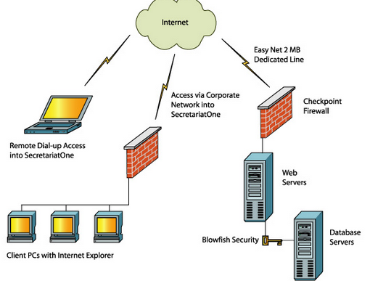

Describe additional security mechanisms that could be implemented to protect the database server.

It is also important not to forget to provide physical security for the database server. The room holds the database server should be burglar-proof. This protects it from those who want to get in to steal data manually or carry away the whole server or may be destroy it.
The use of private networks can also protect the servers from the malice that comes from the Internet. Through VPNs, secure connections can be created between the servers and remote clients.
Authentication is very important. Biometric identification methods and passwords should be used to authenticate those who are using the servers. By knowing who was logged into the server at a particular time helps in auditing possible threats.
Implementing Intrusion detection systems in the servers can help in detecting possible threats to the information stored and help prevent them. He early a threat is detected the better since less harm is caused.
It would be useless to implement a database system without considering security. This would lead to losses and not profits. Database is a very important part of implementing a database system. Without security there would be no need of bringing information together since that would only make it easy for the enemy to destroy you completely. Number one factor in information systems is information security.

User Account Security
TBD

Database Vulnerabilities
TBD

Auditing Techniques TBD

Auditing Policies
TBD

References
7 Security Measures to Protect Your Servers | DigitalOcean. (2017). Digitalocean.com. Retrieved 26 May 2017, from https://www.digitalocean.com/community/tutorials/7-security-measures-to-protect-your-servers
Ragel, R. (2017). Difference Between DBMS and Database. Differencebetween.com. Retrieved 26 May 2017, from http://www.differencebetween.com/difference-between-dbms-and-vs-database/

