Problem 1:
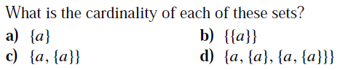
Problem 2:
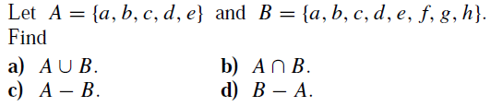

Problem 3:
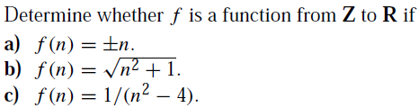

Problem 4:
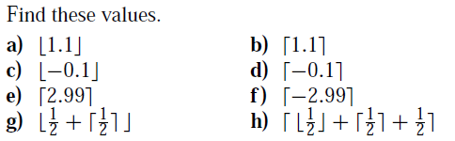
Problem 5:
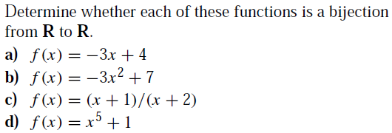
Problem 6:
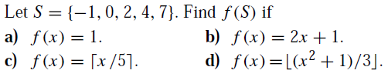

Problem 7:
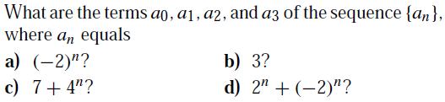
Problem 8:
