For Q1-Q3 Please write two paragraphs for each question. Also include a reference for each question.

Q1. managing complexity is paramount to the successful launch and implementation of an EA system. Discuss the principles of managing complexity from an IT managerial perspective.

Q2. Pick one of the seven Lean principles and discuss its application to an existing organization and discuss.
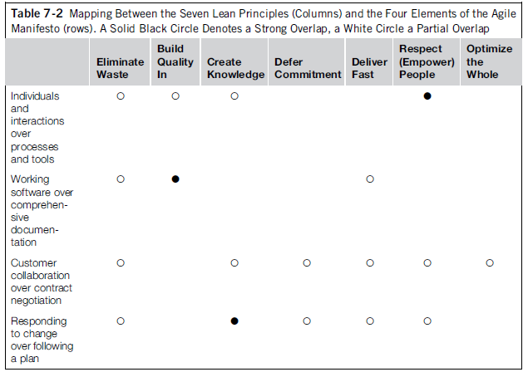

Q3. discuss the topic as it is applied in a real-time business/IT scenario (within 1 year). Your analysis should include how it benefited the organization through the use of EA.
Principles of managing complexity…
- Principle 1. Stay at coarse granularity in analyzing complex systems (such as enterprise architectures) and predicting their future.
- Principle 2. Strengthening a complex system’s ability to change wins over optimizing the status quo.
- Principle 3. Management, in particular EA, has about the same complexity as the system it manages.
- Principle 4. Complex systems (such as enterprises) cannot be managed at an object level but only at a meta level (management by rules).
- Principle 5. Complex systems (such as enterprises) are best managed at the edge of chaos.

Question 1

If an EA initiative is not performing and headed towards failure, it is most likely due to a lack of consensus between strategic vision and ground-level reality.
True
False
1 points

Question 2

According to your textbook, Lean teaches us how to approach a problem in an iterative manner.
True
False
1 points

Question 3

Managing complex systems is the main thrust of EA. The complexity of these systems have characteristic properties that indicate:
 | 1. | Their origins are based the systems requirements
 | 2. | Their structure and behavior are similar to simple systems
 | 3. | Their ability to grow an EA system is less difficult
 | 4. | Their structure and behavior are fundamentally different from simple systems
2 points

Question 4

The following are some structural characteristics of complex systems except for:
 | 1. | Composed of many components
 | 2. | A variety of states
 | 3. | Many channels of interaction with the environment
 | 4. | Shows similar behavior under similar external conditions
 | 5. | The system has an internal state
2 points

Question 5

The textbook suggests that one of the guiding principles of managing complexity in EA is strengthen the complex system's ability to change, rather than to optimize the current state.
True
False
1 points

Question 6

EA as practiced currently has methodologies, frameworks, and tools but it lacks an effective __________________ and ___________________ into the enterprise context.
2 points

Question 7

A Lean and Agile Architecture Factory form building blocks that get rid of waste, involve stakeholders, and practice iterative architecture.
True
False
2 points

Question 8

Lean principles can be used to streamline top-down decision-making or design processes; which process is not representative of lean principles:
 | 1. | EA vision
 | 2. | IT strategy
 | 3. | IT infrastructure and framework design
 | 4. | Design of complex IT transformation
2 points

Question 9

The most well-known characteristic of agility is its__________, time-boxed approach.
2 points

Question 10

According to Lean principles geared to EA, there is waste in EA. Redundant processes, task switching and delays are examples of waste in EA.
True
False
2 points

Question 11

Poppendieck and Poppendieck eventually established lean techniques as a _____________________ method by condensing lean thinking into seven principles, adapted to the software creation process.
2 points

Question 12

In reference to the textbook's continuing example of Bank4U, getting rid of waste by streamlining architecture processes is a good starting point, but not all analysis can be performed by eliminating waste.
True
False
2 points

Question 13

The core Lean principle is to eliminate:
 | 1. | Complexity
 | 2. | Waste
 | 3. | Processes
 | 4. | Overflow
2 points

Question 14

Lean defines ___________, whereas Agile describes _____________.

