G00139176 James Carbaugh
ET-115 Week 3 Lab

  - Consider the circuit below:
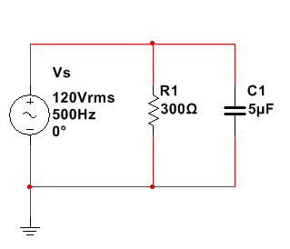
For the circuit above, determine the following (express all answers in phasor form):
    - X_{C}
Xc = $\frac{1}{2πfC}$
Xc = 63.6619 ∟-90◦ Ω
    - Z_{eq}
Zeq = R1||Xc
=62.2752 ∟-78.019◦ Ω
    - I_{T}
I_{T} = V/Zeq
=1.926∟78.019◦ A
    - _{R1}
R1 = 300 ∟0◦ Ω

    - I_{C1}
Ic1 = V/Xc
= 1.8849 ∟90◦ A

  - Construct the circuit with MultiSIM using a 5% tolerance for the resistor and the capacitor. Adjust the frequency according to the table below and obtain measurements from MultiSIM using AC Analysis and express in polar form.

Circuit
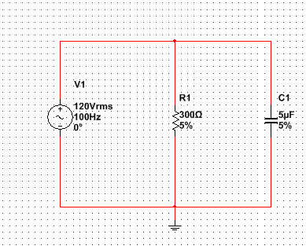

For 100Hz
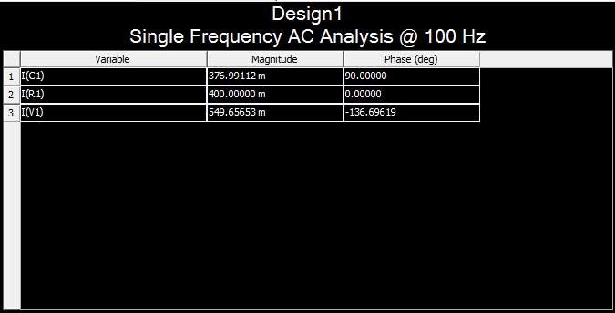

For 500Hz
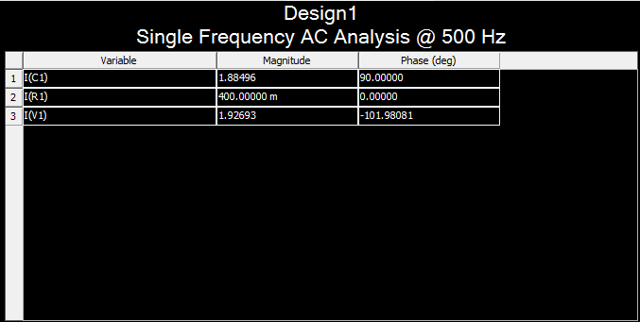

For 1000Hz
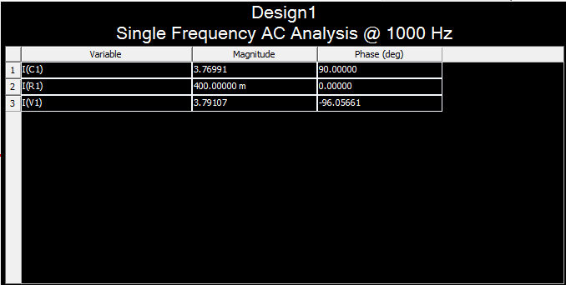

For 1500 Hz
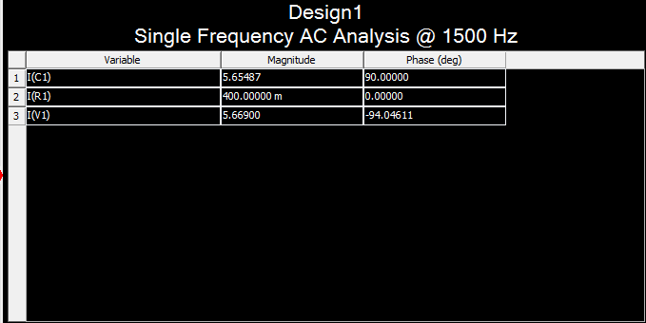

For 10000 Hz
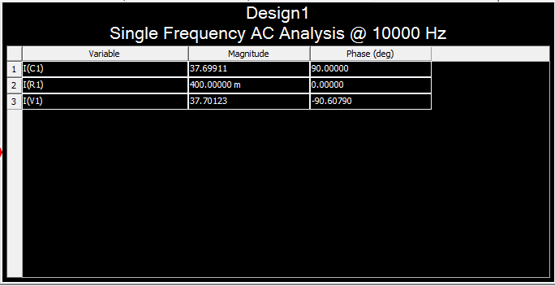

For 20000Hz
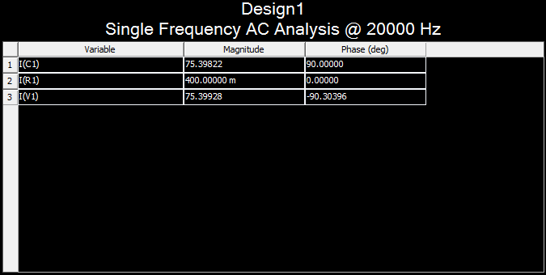

Frequency | I_{T} | I_{R1} | I_{C1}
100 Hz | 549.6m∟-136.69◦A | 400m∟0◦ A | 376.99m ∟90◦ A
500 Hz | 1.92693∟-101.98◦A | 400m ∟0◦ A | 1.8849 ∟90◦ A
1000 Hz | 3.79107∟-96.0566◦A | 400m∟0◦ A | 3.76991 ∟90◦ A
1500 Hz | 5.669∟-94.611◦A | 400m∟0◦ A | 5.65487 ∟90◦ A
10000 Hz | 37.7012∟-90.607◦ A | 400m∟0◦ A | 37.6991∟90◦ A
20000 Hz | 75.3982∟-90.3039◦A | 400m∟0◦ A | 75.39822∟90◦ A

  - Discuss the following:
    - Describe the relationship between the frequency and I_{T.}
As frequency increase I_{T} increases.

    - What effect does frequency have on Z_{eq}?
Ans b.
Zeq will decrease with the increase of frequency.

    - How could the circuit be modified to bring the phase angle closer to 0○?
You could use a resistor instead of a capacitor of the same impedance.

    - How could the circuit be modified to bring the phase angle closer to -90○?
You could use an inductor instead of a capacitor of same impedance.

