Week 5 Lab - Series and Parallel Inductive Reactive Circuits
G00139176 James Carbaugh

- Watch the video
  - Week 5 Video Lecture – Multisim Parallel Inductive Reactive Circuit
Construct the series and parallel inductive reactive circuits from this week’s assignment in MultiSIM and perform Single AC Frequency Analysis on each circuit to confirm your calculations. Use a 5% tolerance for each resistor or inductor. Capture a screenshot of the output of the analysis to confirm your calculations. Also, construct a table to show expected and measured results.

- Include a discussion of any differences noticed between the calculations and the simulations.

Include all calculations, your table, and screenshots of the analysis in a word processing document and submit as EE115W5LabYourGID.docx, or an equivalent word processing file extension.

Calculated
Series circuit
IT = 9.91_ -72.7º mA
V_{L1} = 4.98_17.3º V
V_{L2} = 9.34_17.3º V
V_{R1} = 1.49_-72.7º V
V_{R2} = 2.97_-72.7º V
Parallel circuit
IT = 156_-16.96º mA
I_{L1} = 29.84_-90º mA
I_{L2} = 15.91_-90º mA
I_{R1} = 100mA
I_{R2} = 50mA

Multisim program
Parallel circuit
(The readings appear to be incorrect.)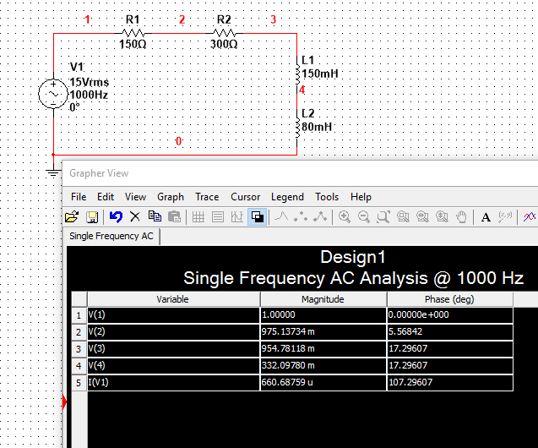

Series circuit
The program continues to cancel the simulation, if you look at the bottom left corner it says “ac simulation canceled”

