Week 3- Case Study Analysis

The California Medical Hospital is a full service hospital in Burbank, CA. Kathy Potts, the Chief Surgeon and Regina Johnson, the Hospital Administrator, have been working on a project to bring a new product to their hospital, knee replacements, to expand the services provided in hopes of bringing in additional revenue.
After much analysis and market studies the two are ready to present their findings to the board. You are the Finance Director who has put the information together.
They have decided that a new knee replacement will cost $17,000. The supplies used will cost the hospital $9,500 and the selling expenses paid amount to $3,000 per knee. The wing they will use will rent for $15,500 per month and the surgeon will receive a fixed salary of $25,000 per month.
- Determine the number of knee replacements (in units) that particular wing must perform each month to break even. (Break-Even Point or BEP). In other words how many knee replacements must the surgeon perform each month to break-even?
Break-even point (in units) = total fixed cost / (price – variable cost)
(15,500 + 25,000) / (17,000 – (9,500+3,000))
40,500 / 4,500
9 knee replacements must the surgeon perform each month to break-even.

- Determine the number of knee replacements that particular wing must perform in order to generate a profit of $100,000 per month.
Unit sales = (fixed cost + profits) / (selling price – variable cost)
To generate $100,000, the hospital needs 31. 22 knee replacements (=140,500/4500). To arrive at a whole number since we are talking about units, there should be 32 units to be sold to generate $103, 500 worth of profit.
- Assume that the surgeon can now open a clinic on his own with the following costs:
Variable costs = $9,500 per knee
One additional employee at a cost of $1,000 per month
Everything else remains the same from above
Considered the changes above, the total fixed cost would be $41,500; the variable costs would be $9,500; price per unit is $17,000.
- Determine the number of knee replacements to break-even.
Break-even (in units) would be 6 knee replacements (= 41,500 / (17,000- 9,500).
- Determine the number of knee replacements needed to generate a profit of $100,000 per month
There should be 19 knee replacements to generate a profit of $101,000 (= 41,500 + 100,000 / 7,500).

- What scenario would you recommend and why?
The second scenario would be better for California Medical Hospital. The break-even point is smaller than the first scenario, which means the hospital can survive even though they are at the lower capacity level. There is also lower number of units to be sold to generate a profit of $100,000, which is better because the capacity level is lower compared to the first scenario.
- Please graph scenario #1 only. You may use excel or draw and attach the graph. I encourage you to try MS Excel for the experience. Label the X and Y axis. Plot the break-even point and show the fixed cost line.
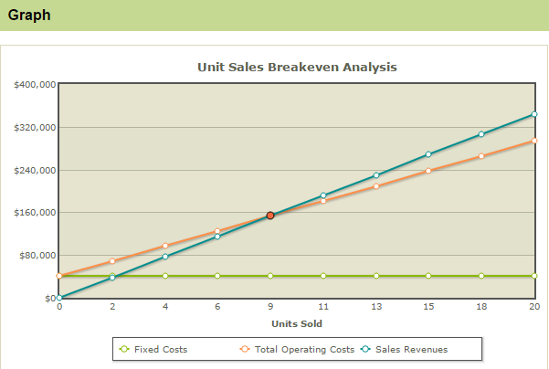

- Define break even analysis and its importance in the health care industry
Breakeven Analysis is used by businesses to know whether they can accumulate their expenses in a given time and when they can begin generating profits (SBA, 2016). To be beneficial in business, it is essential to recognize what your break-even point is. It is also the time when complete total income is equal with aggregate expenses or costs. A business could be turning over a considerable measure of cash, yet be making a misfortune. Knowing what is the break-even point is useful in choosing costs, setting deals spending plans and setting up a strategy for success. This computation is a helpful device to break down basic benefit drivers of your business including deals volume, normal generation expenses and normal deals cost.
- Define variable costs
Variable costs can be simply defined as the costs that depend on the number of units to be produced. It is an expense that differs in connection to changes in the volume of movement. The variable cost idea can be utilized to demonstrate the future budgetary execution of a business, and also to set least value focuses. It is to a great degree valuable to comprehend the extent of variable expenses in a business, since a high extent implies that a business can keep on working at a moderately low income level. On the other hand, a high extent of altered expenses requires that a business keep up a high income level with a specific end goal to stay in business (BIS, n. d).
- Define contribution margin
Contribution margin, in accounting, is characterized as income less variable costs. At the end of the day, this uncovers the amount of an organization's income will be contributing (in the wake of covering the variable costs) to the organization's settled costs and net salary. It is an imperative cost bookkeeping idea. It is useful in numerous settling on numerous vital business choices. For instance, think about a circumstance in which a business director discovers that a specific item has a 25% contribution margin, which is underneath that of organization's different items. They can utilize this to figure out if variable expenses for that item should be decreased or if the cost of the final item should be expanded (CBS News, 2007).
- Define fixed costs
Fixed costs will be costs that must be paid by an organization, free of any business movement. It is one of the two segments of the aggregate expense of a decent or administration, alongside variable expense. An organization with a generally huge measure of variable expenses might display more unsurprising per-unit overall revenues than an organization with a moderately extensive measure of settled expenses. This implies if a firm has a lot of altered costs, overall revenues can truly get crushed when deals fall, which adds a level of danger to the supplies of these organizations. On the other hand, the same high-settled costs organization will encounter amplification of benefits since any income increments are connected over a steady cost level. In this manner, as should be obvious in the illustration, fixed expenses are an essential piece of benefit projections and the estimation of breakeven point focuses for a business or task (BIS, n. d).
- Compare and contrast a variance analysis and a sensitivity analysis.
Variance analysis takes a gander at the execution of a venture, organization, division, office, and so forth and contrasts genuine execution and standard execution. Administration builds up the benchmarks against which execution will be measured, for example, a dollar sum sales objective, number of hours worked in a particular timeframe, or a specific number of sequential days with no wounds in a work site. Affectability examination gives a strategy for evaluating the measure of danger included in a proposed venture. On the other hand, sensitivity analysis additionally includes ascertaining the effect of minor departure from various quantifiable parts of an undertaking, offering administration some assistance with identifying potential pitfalls. Both give helpful data to directors of little organizations as they look to build organization execution and diminish the organization's dangers. While both types of examination give profitable data, one structure offers administrators some assistance with assessing future danger while alternate enhances over past execution in the organization (Frey & Patil, n. d).

References
BIS (n. d). Covering fixed and variable costs. Retrieved Jan 2016 from https://www.nibusinessinfo.co.uk/content/covering-fixed-and-variable-costs
CBS News (2007). Analyzing contribution margin. Retrieved Jan 2016 from http://www.cbsnews.com/news/analyzing-contribution-margin/
Frey, C. & Patil, S. (n. d.) Identification and review of sensitivity analysis method. Retrieved Jan 2016 from http://www.ce.ncsu.edu/risk/pdf/frey.pdf
SBA (2016). Breakeven analysis. Retrieved Jan 2016 from https://www.sba.gov/content/breakeven-analysis

