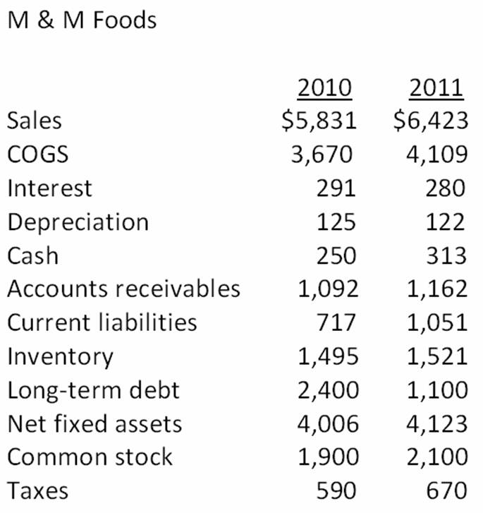

Use the above information for the following questions (1-7):
- What is the change in net working capital from 2010 to 2011?
Change in NWC = Ending NWC – Beginning NWC
NWC = Current assets – Current liabilities
Assets 2010= 5,831+ 250 + 1,092 + 1,495 + 4,006 = $12,674
Liabilities 2010=3,670 + 291 + 125 + 717 + 2,400 + 1,900 + 590 = $6,023
NWC 2010= $6651

Assets 2011=6,423+313+1,162+1,521+4,123 = $13,545
Liabilities 2011=4,109+ 280+ 122+ 1,051+1,100+2,100+670 = $9,432
NWC 2011= $4,113

Change in NWC= 4,113-6651= -2,538

- What is the net capital spending for 2011?

Net Capital Spending= NFAend- NFAbeg+ Depreciation
Net Capital Spending= 4,123-4,006 + 122
Net Capital spending = $239

- What is the operating cash flow for 2011?

OFC= EBIT + Depreciation – Taxes
OCF= 2192 + 122 – 670
OCF = 1,644

EBIT = Cash – COGS – Depreciation

- What is the cash flow from assets for 2011?

CFFA = OCF – NCS – Changes in NWC
CFFA = 1,644 – 239 – (-2,538)
CFFA = 3,943

- What is net new borrowing for 2011?

Net new borrowing = End Long term debt- Beg Long term debt
Net new borrowing 2011 = 1,100-2,400
Net new borrowing 2011= -1,300

- What is the cash flow to creditors for 2011?

CFC = Interest paid – Net new borrowing
CFC = 280 – (-1,300)
CFC 2011 = 1,580

- What is the cash flow to stockholders for 2011?

CFS = Dividends paid – Net new equity raised
CFS = 0 – 200
CFS = -200

