LAB 9A: POWERPOINT & MLA
- Using the completed paper on Homelessness (see page 2), plan and create a 9-10 slides powerpoint presentation that supports its purpose or thesis statement.

- The presentation should not be a duplication of the report but a tool to review the report with an audience.

- All slides should have a title and use bullets not paragraphs to outline your points on the slides.

- Your presentation should have a title slide, an overview/introduction slide, a summary slide, a conclusion slide and a Works Cited slide.

- Select a Design Theme that is appropriate for an informative speech about homelessness.

- Create a Title slide and add your name and a date to the slide. The date should be set to update automatically.

- Create an Overview slide for the presentation.

- Create 5 to 7 additional slides that identify the key arguments from the speech using the homelessness paper as your source material.

- Create a Conclusions slide that summarizes the key points of the conclusions section of the paper.

- Create a Works Cited slide that has all the works cited from the paper and any other sources you used in preparing this presentation

- Insert page numbers on all slides.

- Embed the graphics from Lab5B_Word&MLA.docx into an appropriate place in the presentation. Captions consisting of the figure number, description and in text citation should be created for the images you incorporate into your PowerPoint presentations to which you do not own the rights.

- Embed the charts from Lab8B_Excel&MLA into an appropriate place in the presentation. Captions consisting of figure number, description and in text citation should be created for the charts you incorporate into your PowerPoint presentations to which you do not own the rights.

- Cite your graphics, charts or information in your presentation to which you do not own the rights. Place your in-text parenthetical citation as needed in your slides and the actual MLA citation on a Works Cited page on the very last slide of your presentation (see the PowerPoint presentation in the Learning Materials page this week for an example)

- There should be speaker notes on at least 50% of the slides. The speaker notes can be sections of text copied from the paper appropriate to the slide.

- There should be transitions added between all slides and at least one animation.

- Remember to Spell Check your presentation

- Save your PowerPoint presentation as LastName_Lab9A.pptx and submit into Blackboard.
Attachments: (see page below)
Homelessness
Your Name
Instructor Name
INFO1001
30 December, 2009
Homelessness In America

Homelessness throughout America has been on the rise. This is making many states as well as the country as a whole look at the issue of homelessness. “From the last counts and estimates nationwide, there has been at least a 35-45% increase in homelessness and poverty” (Shaft). Can you begin to imagine if one of your children or family members was faced with living on the streets or in a homeless shelter? What a devastating fact to come to terms with.
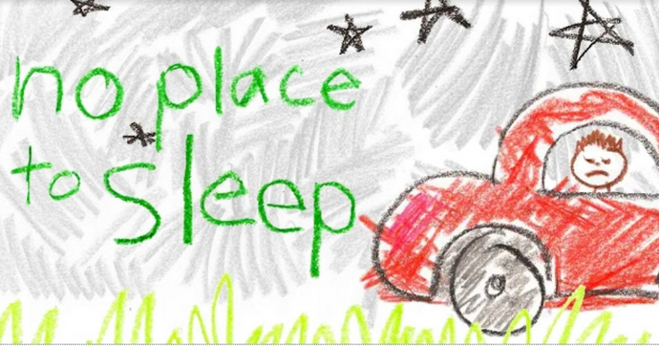
Homelessness throughout America is affecting many children every day. “It estimates that 1.5 million children experience homelessness at least once that year, and says the problem is surely worse now because of the foreclosures and job losses of the deepening recession” (Crary). This statistic is evidence of the millions of innocent children in our country who are affected and suffering from homelessness. Homelessness can also have another impact on children, affecting their academics, self- esteem, and relationships with their peer group. One report states children that are homeless are at a much greater risk to go hungry, get sick, and do poorly when it comes to academics. This can have many harmful long-term affects when it comes to family and the child’s peer group (Crary). Overall this is stating that homelessness as a child can have a major impact on the child’s future and into adulthood. This is an image on how devastating homelessness is. Homelessness today is affecting many people, families, and children throughout the country.
Figure 1 More Homeless Children now ("Study..)
Homelessness affects many families as a whole. Many parents have both parents working and yet still have a hard time making ends meet. Making sure there is a meal on the table everyday is often a struggle for many families. The effects of the recession have a great deal to do with this. The increase in the number of people losing their jobs as well as their houses has forced families into homelessness (Mostrous). This is evidence of how the growing unemployment rate is sending families on their way to homelessness and poverty. A statement from HUD Secretary Shaun Donovan says, “The typical homeless person has changed to become less focused on the chronically homeless or single-individual to somebody who is part of a family, whether it be a mother or a father or a child in a homeless family. I think what that tells us is that the economic crisis is forcing more families who had previously been well-housed into homelessness.” This is not only affecting individuals, but also families ("Home for the Holidays..").
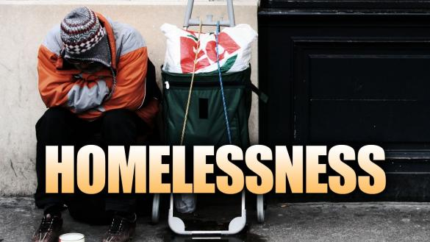
States are also being affected by the rise in homelessness in our country. Many times the state steps in to offer funds to help the homeless when nothing else is coming through, but those funds often and eventually run dry. An article on States Coping With Homelessness states, “Nearly 700 homeless families in Massachusetts are living in hotels at state expense because emergency shelters are full” (Vestal). This here is proof that the state is picking up the extra financial costs that are included with the rise in homelessness. With the increasing number of homeless, states nationwide are finding they are unable to keep up with the financial demand (Vestal). Eventually, the state will run out of funds in their budget which could make it so they are unable to help or contribute to the homeless in need.

Figure 2 Homelessness (RiguePlanet)
So where is the help in this homeless crisis? In an article posted in USA TODAY, Wendy Koch states “An extra 1.5 billion in federal stimulus funds would be available next month. It is meant to prevent homelessness by helping with utility bills, moving costs, or security deposits.” In this image you can see how homelessness is affecting this individual. This obviously will help our country some but it won’t fix the problem completely. “We simply can’t keep up with the need” (Koch).
With all of these things being taken into account it is obvious that homelessness is currently affecting many people, families, and children throughout America. Parents are losing not only their jobs but their houses as well and with no specific solution to this problem it may become worse. This is definitely a problem that is going to take time to resolve. It is time for the government to come up with a plan of action for these desperate and struggling families, children, and homeless. In my eyes it needs to begin to become a priority.

Works Cited
Crary, David. "1 in 50 American Children Experiences Homelessness." Ithaca Journal (Ithaca, NY) Mar. 10 2009: n.p. SIRS Researcher. Web. 21 December 2014.
"Home for the Holidays - Shaun Donovan." POLITICO Magazine. N.p., n.d. Web. 3 Aug. 2015.
"Homelessness." Almanac of Policy Issues, n.d. Web. 29 Apr. 2015. <http://www.policyalmanac.org/social_welfare/homeless.shtml>.
Koch, Wendy. "Cutbacks Pinch Homeless Programs." USA TODAY 24 Aug. 2009. Print.
Mostrous, Alexi. "More Families Are Becoming Homeless." Washington Post (Washington, DC) 12 Jul 2009: A.4. SIRS Researcher. Web. 21 December 2014.
RoguePlanet. Homeless. Digital image. http://crooksandliars.com/. Flickr, 12 Dec. 2013. Web. 29 Apr. 2015.
Shaft, Jay. "US Homelessness and Poverty Rates Skyrocket." Information Clearing House. 30 July 2003. Web. 30 Dec. 2014.
"Study: More Homeless Children Now Than Any Point in US History." CommonDreams. National Center for Family Homelessness, 17 Nov. 2014. Web. 6 May 2015.
Vestal, Christine. "States Cope with Rising Homelessness." stateline.org 19 Mar 2009: n.p. SIRS Researcher. Web. 21 December 2014.

