Q1) This question is similar to the sample question:
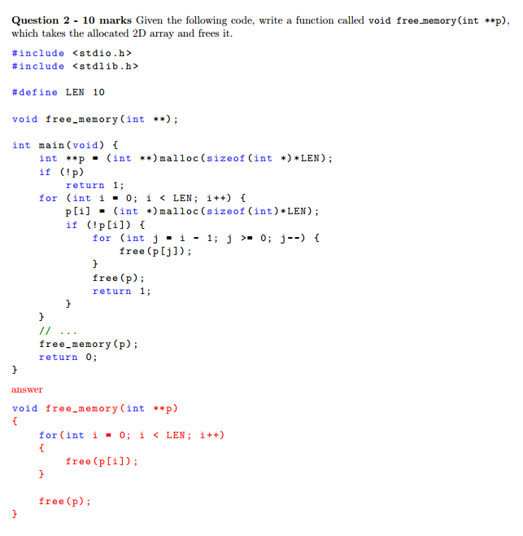
BUT in this question it will be to write a function void free_memory(struct sec *)

Q2) For this question they given integer array and the result. We need to write a code to print out the result given, and if the array is empty, return 0.
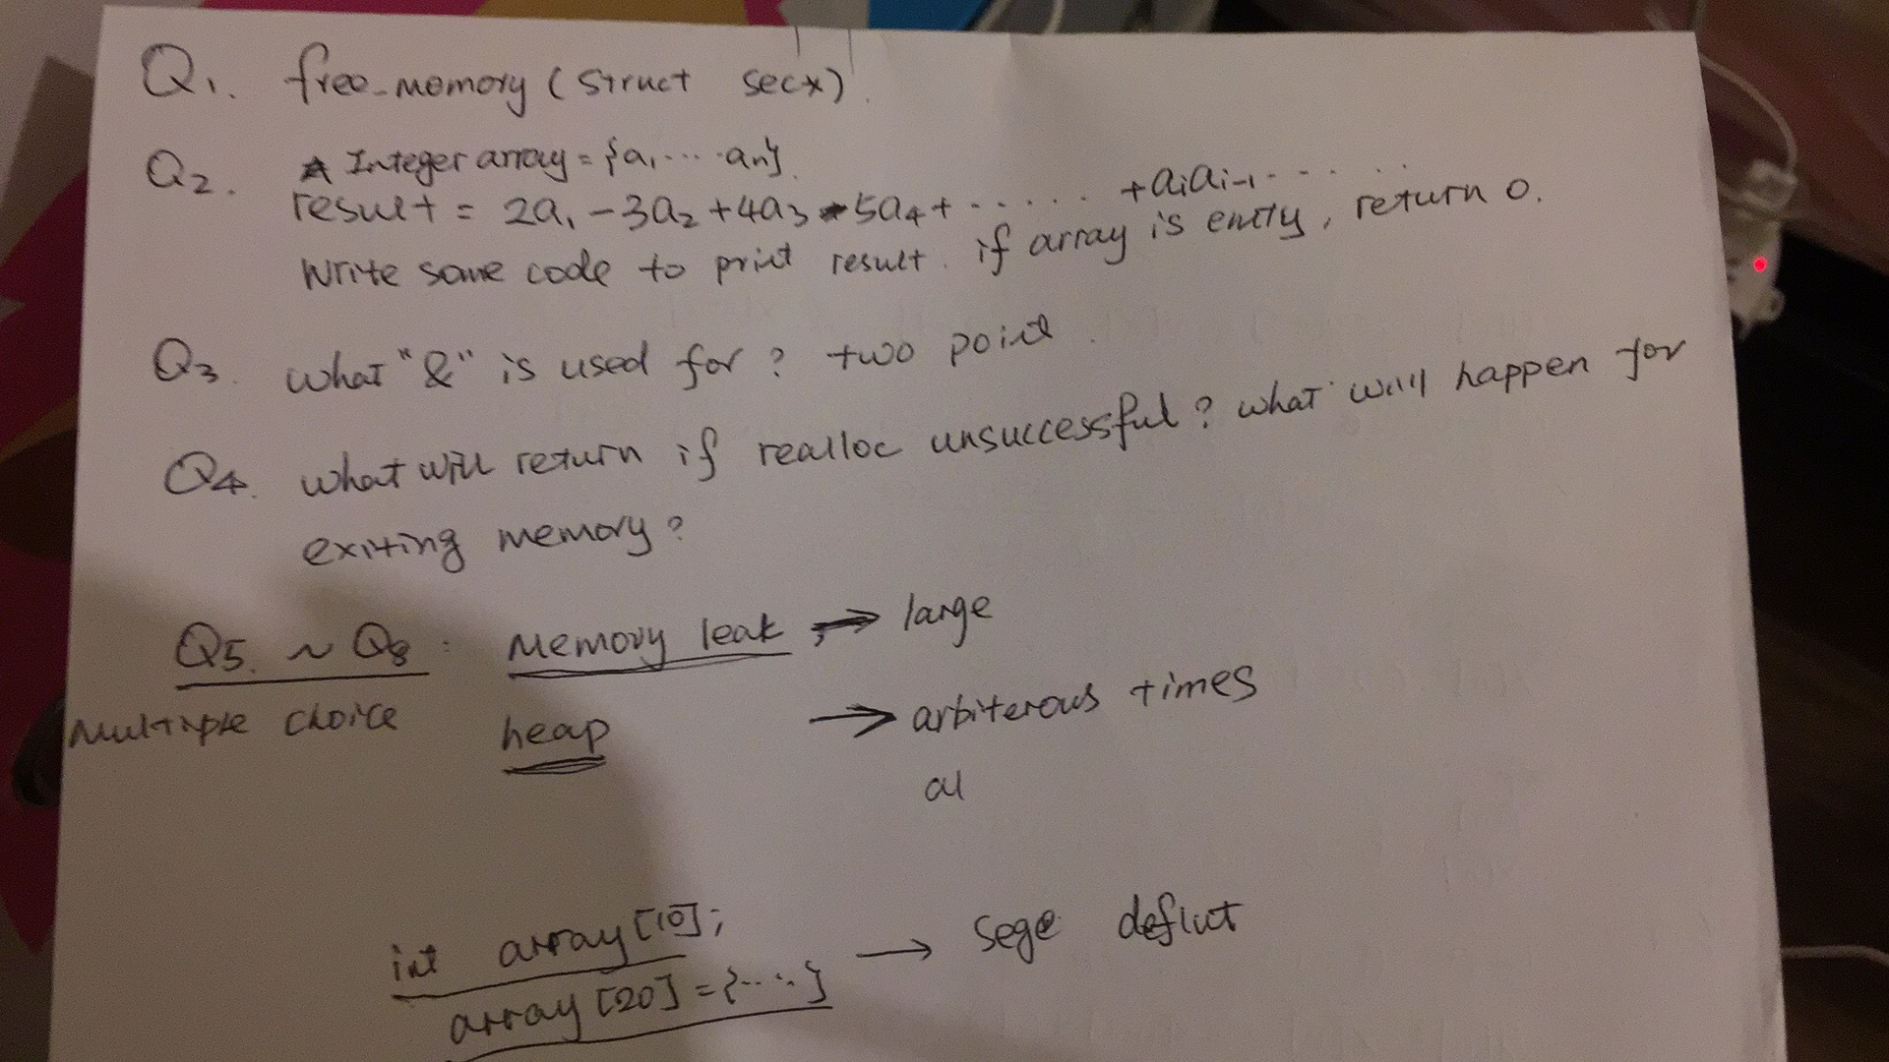
Q3) if realloc is unsuccessful what does it return? What will happen to the existing memory?
Q4) Explian what is typedef and give an example.
Q5) a) what is
define (x,y) = x>y? x:y
b) what is
(a,b+=a)

