Week 5- Forum
What are Globalized Portfolio risks

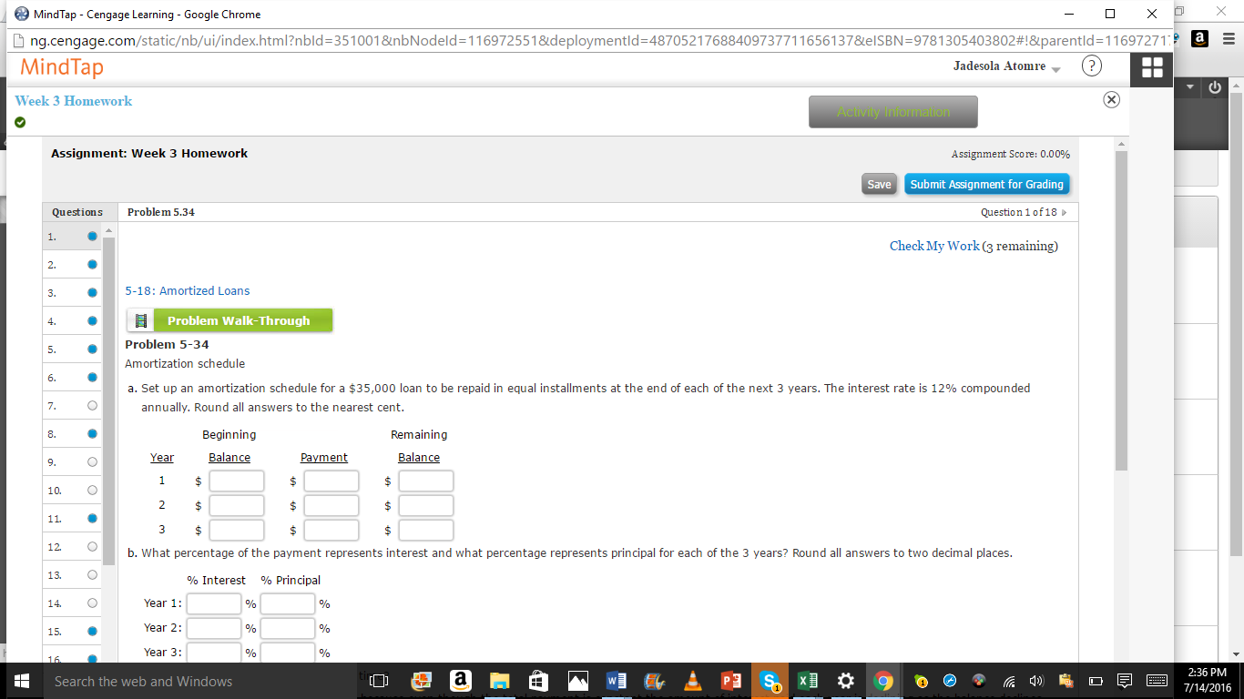









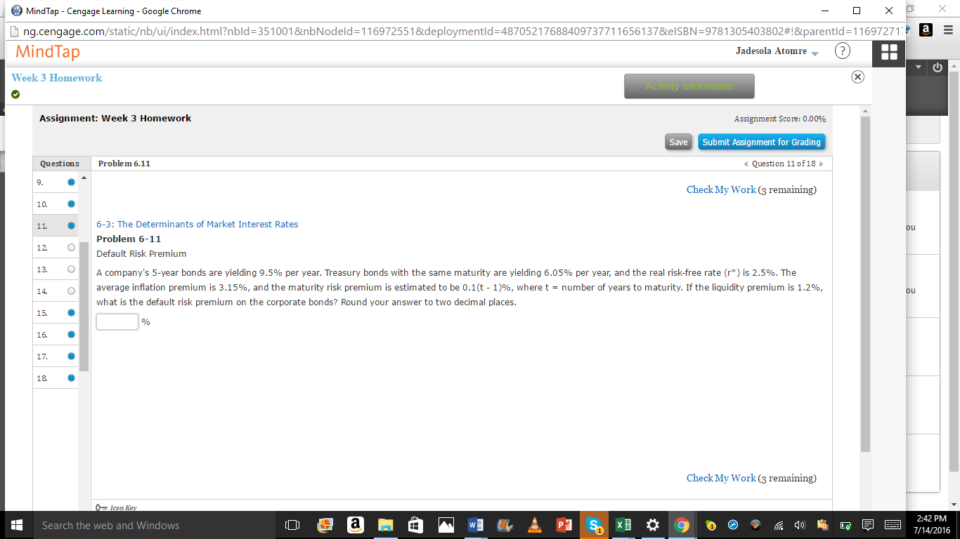

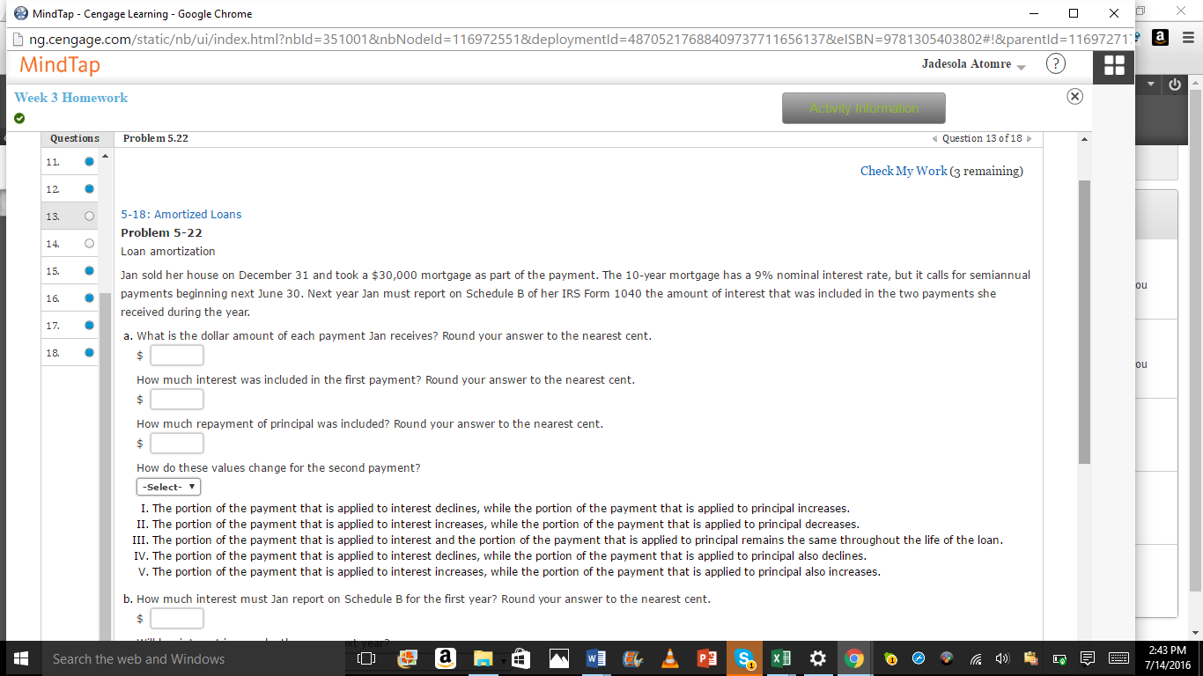
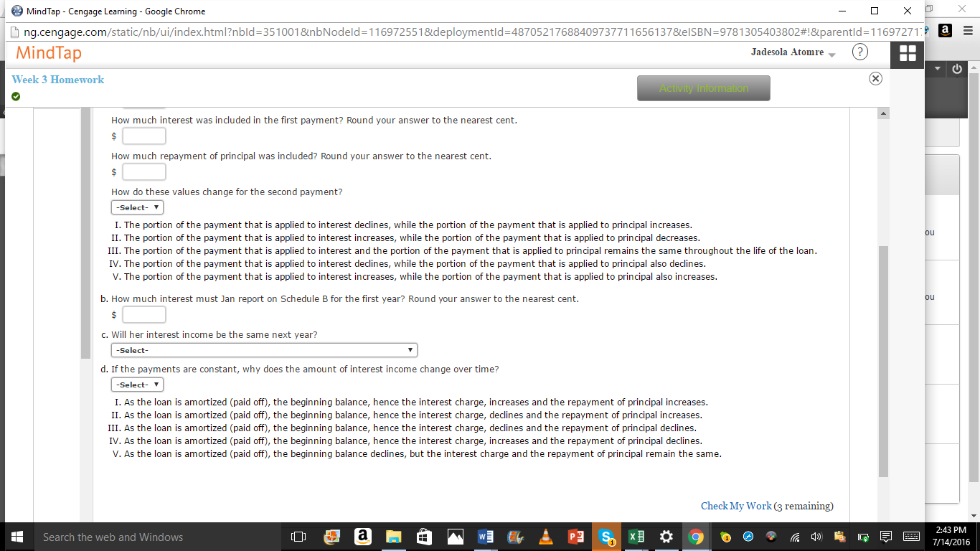

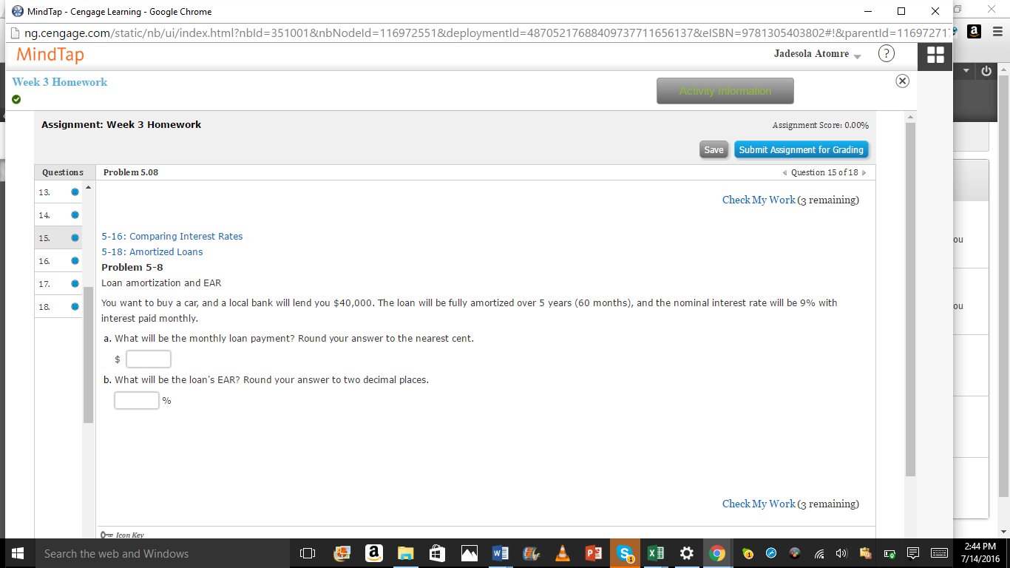



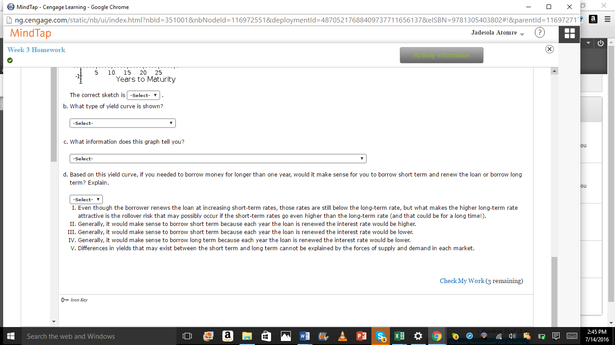



Hi Raquel,
I like your simple but direct presentation on the topic- which is the most important of the financial statements. However, I have the following to add to the discussion. To start with, the income statement, statement of cash flow and the balance sheet are the principal components of the financial statements. These three documents work together in presenting a valid picture the company’s financial situation. Each of these documents are very important but the ultimate answer would be based on the need of the user. Bluest, K., (n.d)
For the majority of users, the most important financial statement would likely be the income statement. The shows the ability of the company to make ends meet by making profit. Also the information here are relatively current and accurate though it does not show the actual amount of its assets and liabilities.
The balance sheet could be ranked third by users. Why? It does not show the result of operations and some of its information may be old. The balance sheet however, is of immense value when combined with the income statement. These then shows the investment amount needed to support the sales and profit on the income statement. Codija, M., (n.d.).
The statement of cash flows possibly could be the most important as it depicts the cash flow results and focuses on monetary expenditures and inflows. This is a more realistic and accurate assessment tool even above the income statement because this could be ‘cooked’.
Conclusively, as said earlier, it is all based on the need of the user. To the Auditor, the balance sheet is the most important document since this is what they audit. To the investors it is the cash flow analysis, whilst an attorney would be more interested in the balance sheet to determine if litigation is going to be productive and Management for ‘fine tuning’ purposes would be more interested in the income statement. Dimitrijevic, D., (2015).
References

Bluest, K., (n.d). What Are the Benefits of Financial Statements in Small Businesses? Small Business. Retrieved
Codija, M., (n.d.). What Are the Three Most Important Financial Statements for Financial Management? Small Business. Retrieved
Dimitrijevic, D., (2015). The detection and prevention of manipulations in the balance sheet and the cash flow statement. Economic Horizon, 17(2), 135-151.

Wagaka,
Great post. Allow me however to add some findings on ongoing controversies and measures to go above the limitations of the financial statements. By the way I wrote also on this topic. Without doing an overkill, more research on these limitations with an attempt at fixing these anomalies might still be needful. The fact is that this is an important area of intellectual exercise as any area of the financial statement could generate heated arguments. For example, a casual perusal of what the auditor’s report is communicating, through the balance sheet are very likely to be flawed—and sometimes, like the comments from the non-professional investors, the perceptions are far from reality.
One critical finding of contemporary research performed on a focused group even further reveals the lack of consensus as to what is the intended communication of the auditor’s report (2008). (). Lanham: Even the participating auditors have difficulty describing and agreeing on the intended communication of the auditor’s report. The stakeholders provided rich discussions on their perceptions regarding the auditor’s report concepts, their experiences on using the reports, and their suggestions about possible improvements to the reports. The stakeholders also provided concerns associated with those suggestions. Currently, auditors do not disclose materiality levels and sample sizes publicly, do not quantify the level of assurance, and the auditor’s report is silent on some aspects of the audit, such as fraud. All said, a paradigm shift regarding disclosures might be needful. Poonawala, N. (2007).
References-
Self-regulatory organizations; financial industry regulatory authority, inc.; notice of filing and immediate effectiveness of proposed rule change relating to amendments to the codes of arbitration procedure to remove the page limit on statements of claim filed through the online arbitration claim filing system. (2008). (). Lanham: Federal Information & News Dispatch, Inc. Retrieved.

Poonawala, N. (2007). The effect of long audit firm tenure on financial statement quality when managers have an incentive and ability to manipulate earnings (3302054). Available from ProQuest Central. (304852249). Retrieved. (2008). (). Lanham:

