1- add instructor
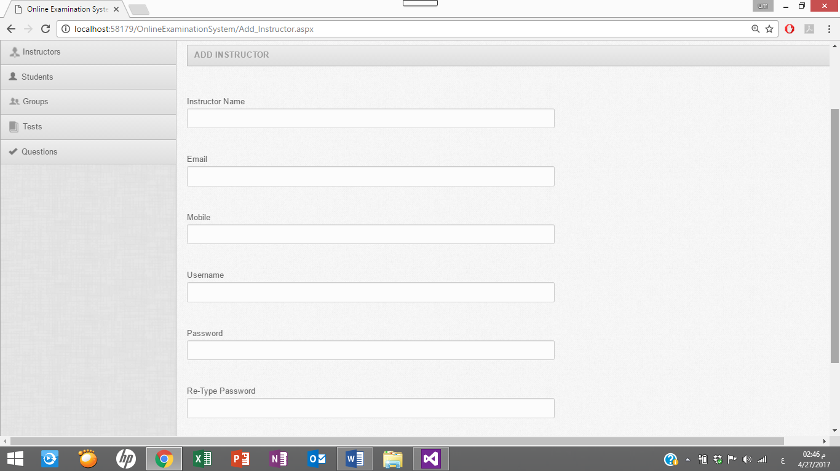
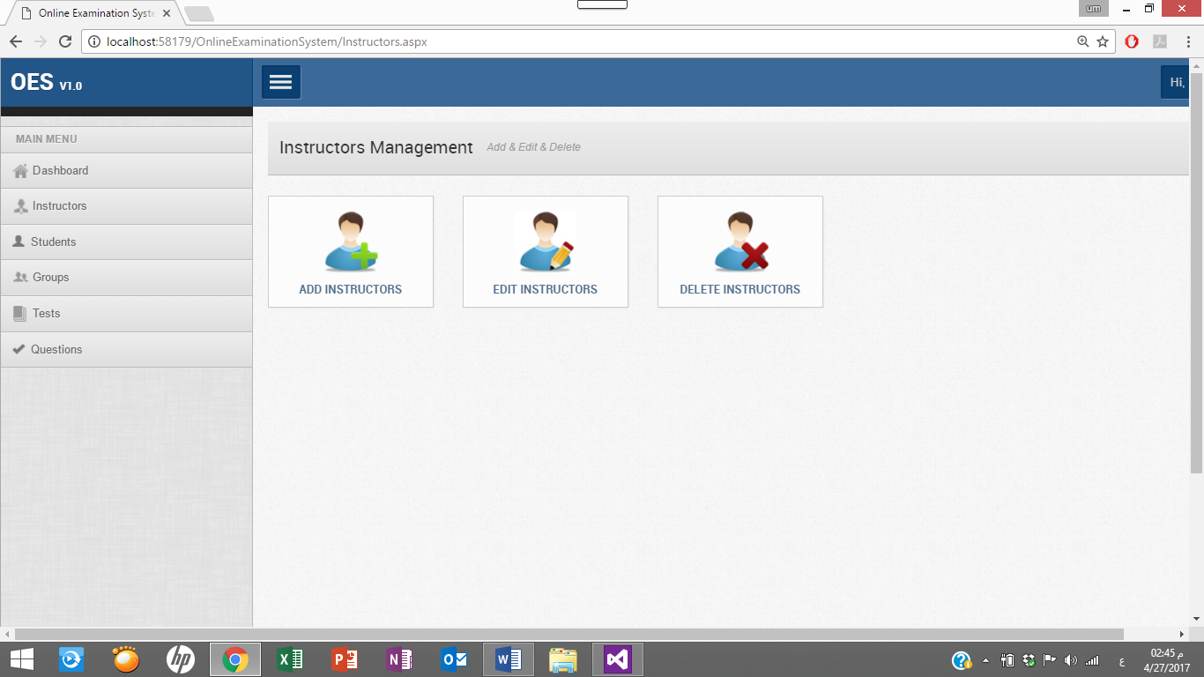

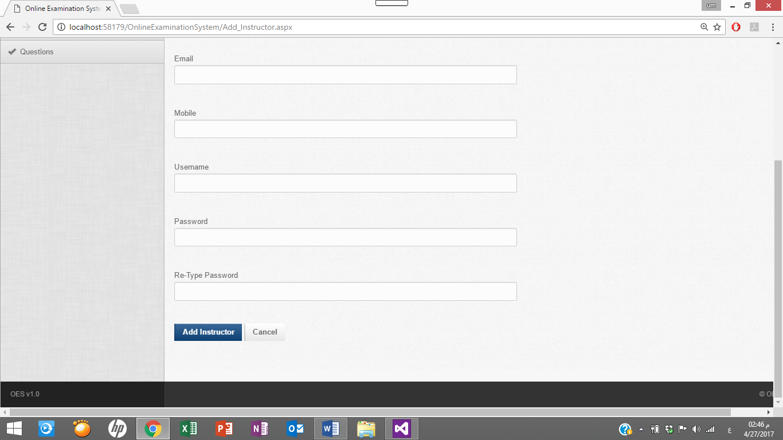

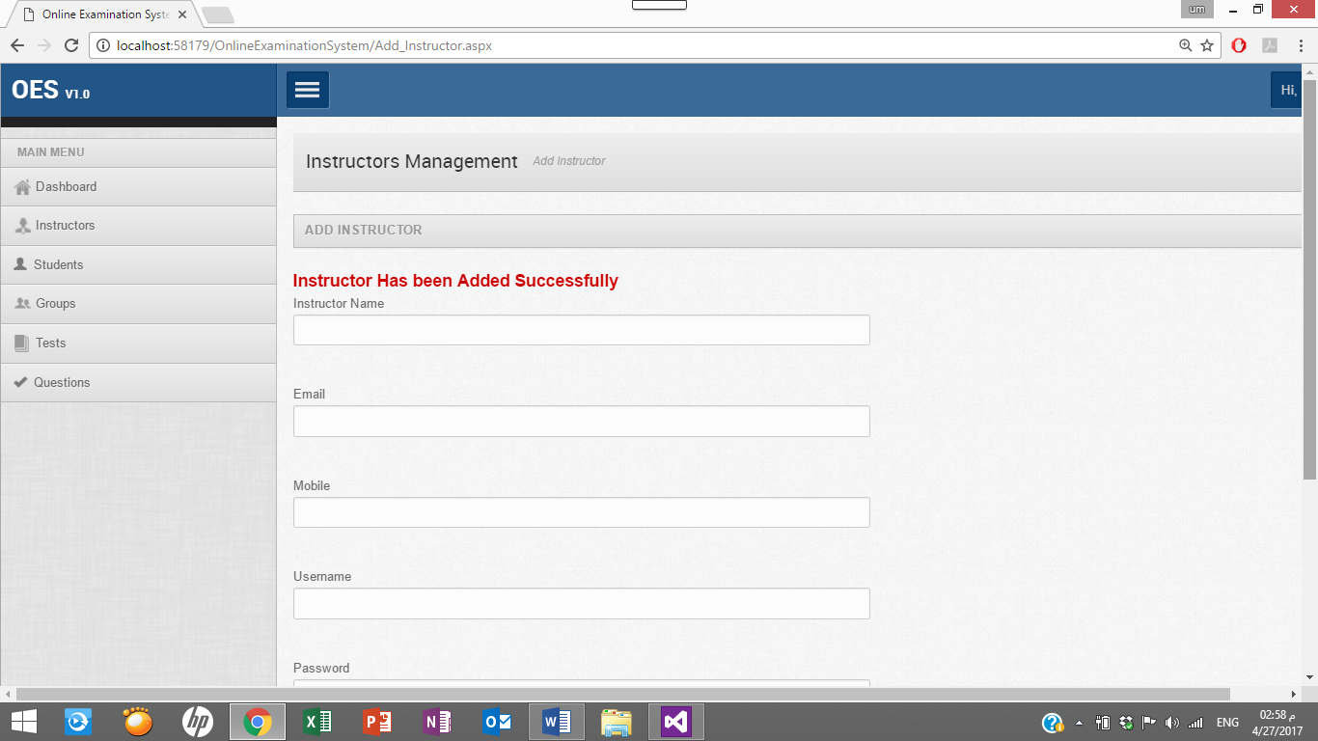
after fill the fields the and the press add instructor button this messages will become

2-edit instructor

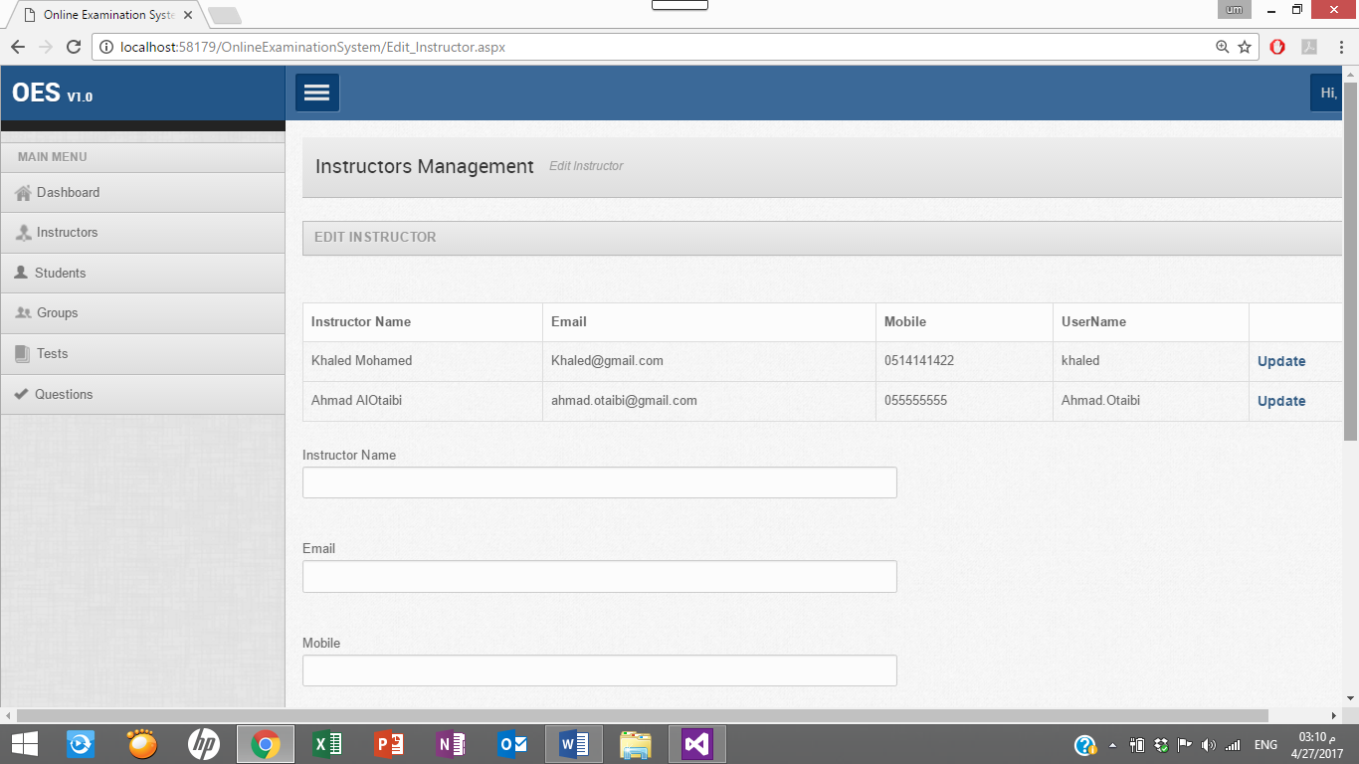
When move to edit instructor page we will see this information

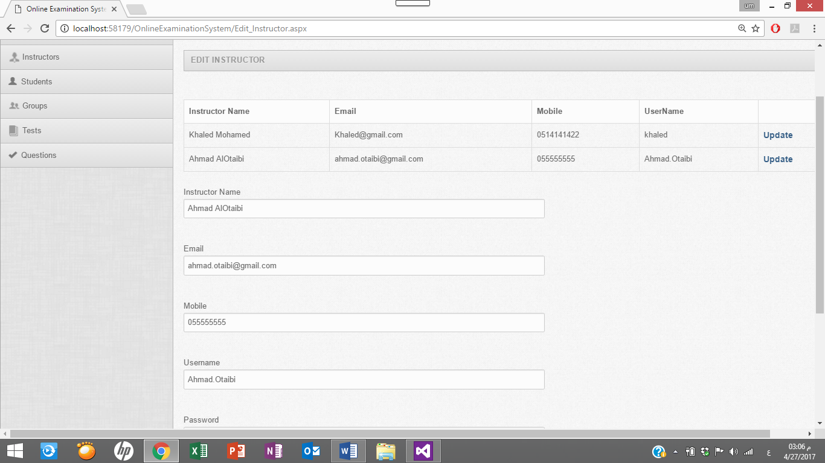
When press the update end of the row of instructor information all information will fill in their fields
After the user update the information press submit button.
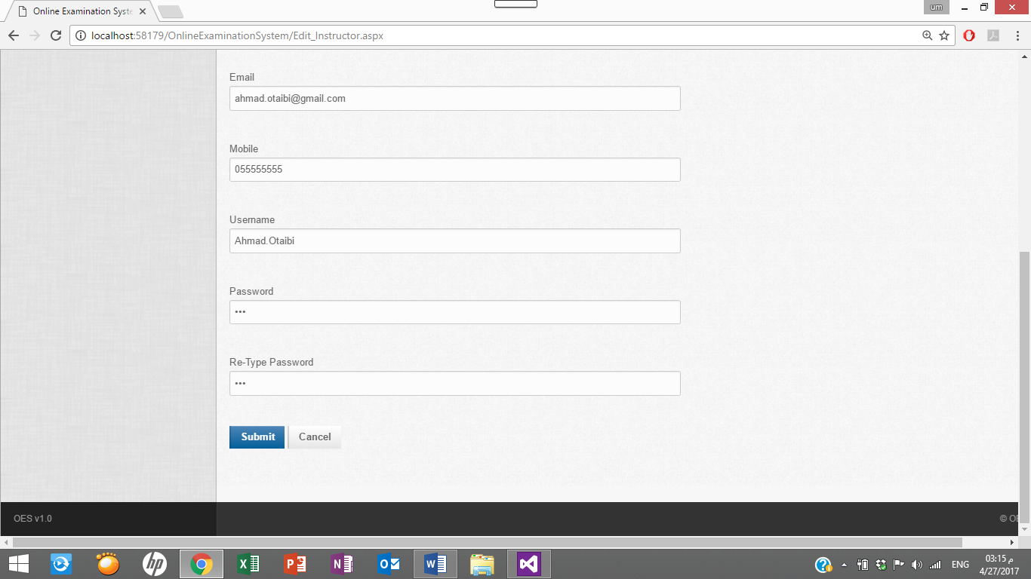 and the message will appear
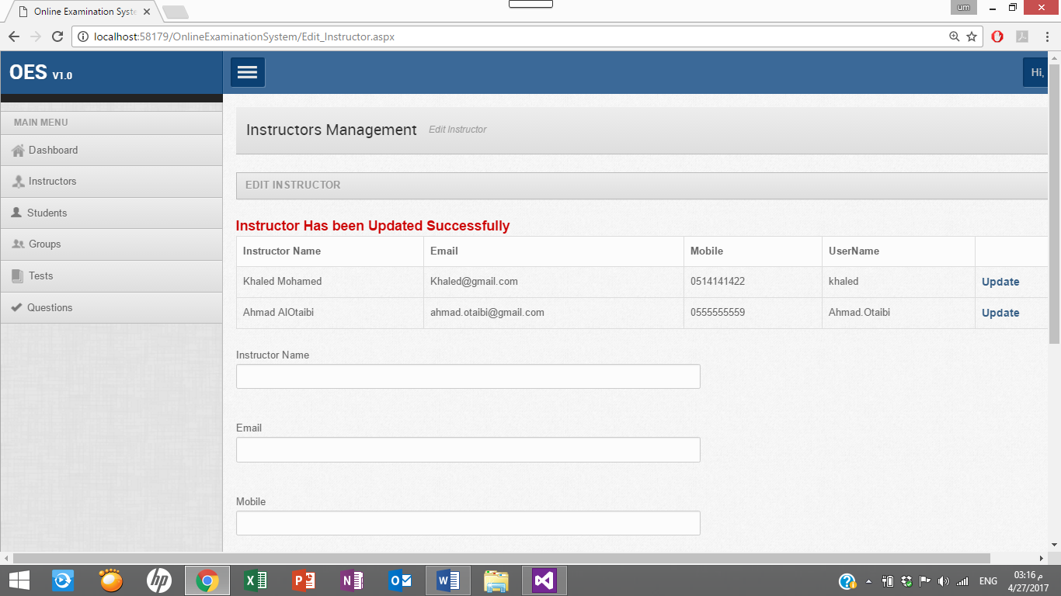

3-delete instructor
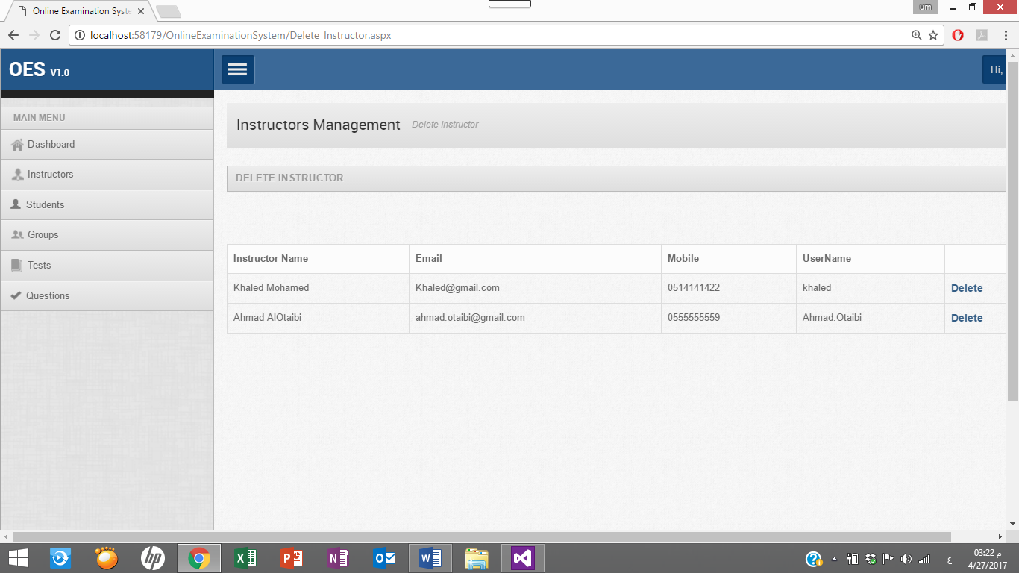

When we want delete any instructor information click on Delete in the last row information of instructor
And then the message will appear
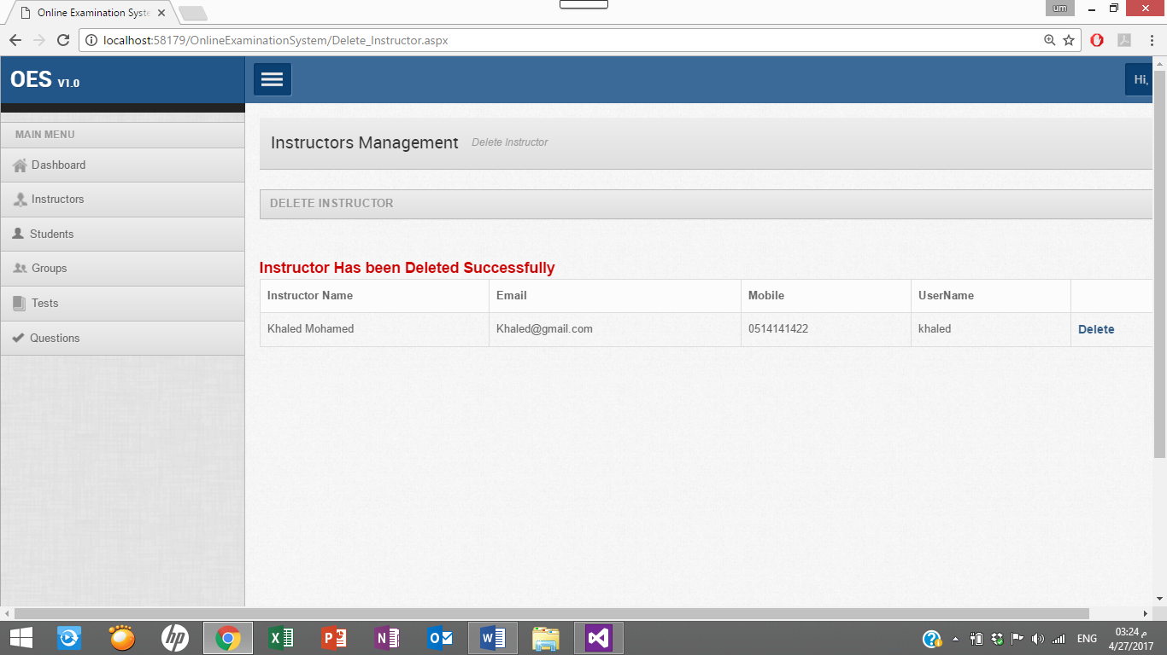

Write the use cases of the instructor pages depend on CRUD

Use-Case 1
Identifier |  | UC-1
Purpose |  | …
Priority |  | <Choose one from {High, Medium, Low}>
Pre-conditions |  | …
Post-conditions |  | …
Typical Course of Action
S# | Actor Action |  | System Response
1
2
3
…
Alternate Course of Action
S# | Actor Action |  | System Response
1
2
3
…
Table 1: UC-1

Use-Case 2 (and so on)

Software Testing
< Fill out the following template for each test case. Each tst case should be followed by brief description>

Test Case 01

Identifier | TC-1
Priority | <Choose one from {High, Medium, Low}>
Related requirements(s) | <Include use-case identifier(s) for functional requirement(s) and SRS section/sub-section number(s) for other requirement(s).>
Short description | …
Pre-condition(s) | …
Input data | …
Detailed steps | …
Expected result(s) | …
Post-condition(s) | …
Table 2: TC-1

Test Case 02 (and so on)

Software Verification
(Independent verification & validation)
< List all the defects found in the project during testing and their current status using the template given below>

S# | Defect Description | Origin Stage | Status | Fix Time
 |  |  |  | Hours | Minutes
1
2
3
Table 3: List of non-trivial defects

