Homework #4

- You may do this homework with Oracle or Teradata database software. Write and run SQL queries for the two problems described below.
- Create a new Microsoft Word document and write your name at the top of the document. For each of the two queries, write query # and paste the screenshot below it.

QUERY 1: How many different (unique) products each customer has purchased from this business? (Note: sales records are available in the LINE table.) Output should be sorted in descending order of unique products customers bought.

Your query output should like the sample (partial) output shown below. Please capture and paste a single screenshot of the query and its complete output in the Word document.

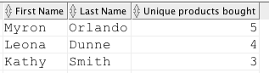

QUERY 2: For each vendor, display vendor code and vendor name along with total dollar amount of sales generated by selling products supplied by each vendor.

Your query output should like the partial sample output shown below. Please capture and paste a single screenshot of the query and its complete output in the Word document. Please sort the output in descending order of dollar amount of sales.

