Lab 6

2. Modify the code to be able to input an undetermined number of students. You will still only have 3 exams for each student. Support your experimentation with screen captures of executing the new code.

// C code

// This program will calculate the average of 3 exams for 5 students.

// Developer: Faculty CMIS102

// Date: Jan 31, XXXX

#include <stdio.h>
int main ()

{

/* variable definition: */
char StudentName[100];
float ExamValue, Sum, Avg;
int students,exams,choice;

// Loop through 5 Students

while(1)
{
//reset Sum to 0
Sum =0.0;
printf("Enter Student Name: ");
scanf("%s", StudentName);
// Nested Loop for Exams
for (exams=0; exams < 3; exams++)
{
printf ("Enter exam grade: ");
scanf("%f", &ExamValue);
Sum += ExamValue;
}

Avg = Sum/3.0;

printf( "Average for %s is %f\n",StudentName,Avg);
printf("Enter 1 to continue or 0 to exit: ");
scanf("%d",&choice);
if(choice==0)
break;
}
printf("Bye!!!");
return 0;

}

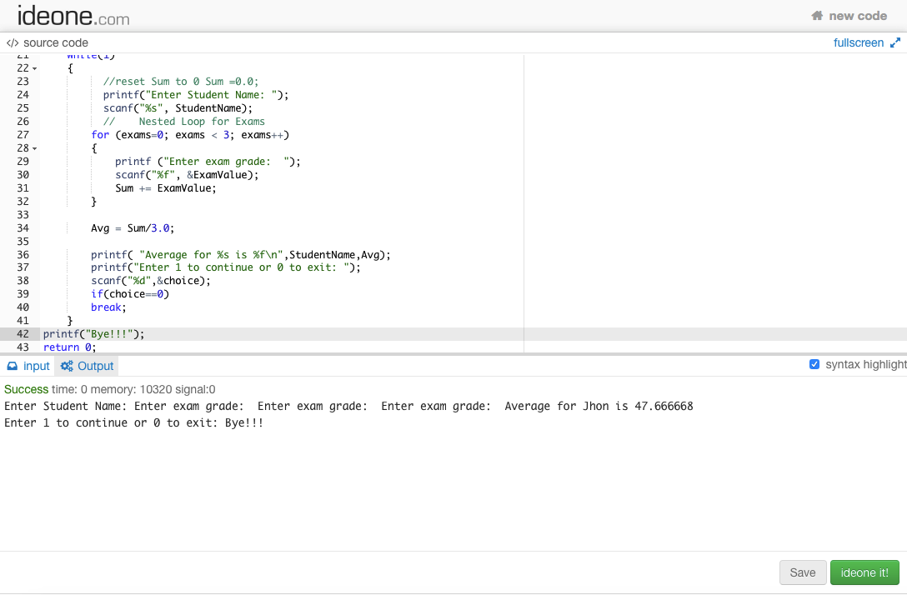

3. Prepare a new test table with at least 3 distinct test cases listing input and expected output for the code you created after step 1.

Test Case | Input | Expected Output
1 | Student Name=Jon  ExamValue1=50  ExamValue2=50  ExamValue3=50  Choice=0 | Average for Jon is 50.000000  Bye!!!
2 | Student Name=Jon  ExamValue1=50  ExamValue2=50  ExamValue3=50  Choice=1  Student Name=Smith  ExamValue1=33  ExamValue2=45  ExamValue3=65  Choice=1  Student Name=Mark  ExamValue1=30  ExamValue2=50  ExamValue3=40  Choice=0 | Average for Jon is 50.000000  Average for Smith is 47.666668  Average for Mark is 40.000000  Bye!!!
3 | Student Name=Jon  ExamValue1=50  ExamValue2=50  ExamValue3=50  Choice=1  Student Name=Smith  ExamValue1=30  ExamValue2=50  ExamValue3=90  Choice=0 | Average for Jon is 50.000000  Average for Smith is 56.666666  Bye!!!

4. What is the line of code doing?

Char studentName[100] is an array of character that can hold a student name whose length is up to 100. Statement char studentName[100] declare an array of 100 bytes( char is of one byte) for the student name storage.

5. What would happen if you moved the Set Sum = 0.0 from inside the for loop to right after the declaration.

Moving the stamen sum=0 out of the loop will calculate the sum of marks of all the student which will give wrong answer to the average value after first student. For only one student the output will not change but for more than 1 student the program will produce a wrong output.
