The Ashland MultiComm Services (AMS) marketing department wants to increase subscriptions for its 3-For-All telephone, cable, and Internet combined service. AMS marketing has been conducting an aggressive direct-marketing campaign that includes postal and electronic mailings and telephone solicitations. Feedback from these efforts indicates that including premium channels in this combined service is a very important factor for both current and prospective subscribers. After several brainstorming sessions, the marketing department has decided to add premium cable channels as a no-cost benefit of subscribing to the 3-For-All service.
The research director, Mona Fields, is planning to conduct a survey among prospective customers to determine how many premium channels need to be added to the 3-For-All service in order to generate a subscription to the service. Based on past campaigns and on industry- wide data, she estimates the following:
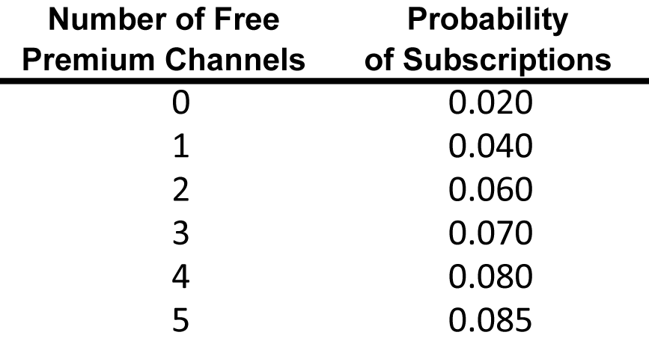

figure 4
a. If a sample of 50 prospective customers is selected and no free premium channels are included in the 3-For-All service offer, given past results, what is the probability that
i. Fewer than 3 customers will subscribe to the 3-For-All service offer?
ii. 0 customers or 1 customers will subscribe to the 3-For-All service offer?
iii. More than 4 customers will subscribe to the 3-For-All service offer?
Suppose that in the actual survey of 50 prospective customers, 4 customers subscribe to the 3-For-All service offer.
iv. What does this tell you about the previous estimate of the proportion of customers who would subscribe to the 3- For-All service offer?
b. Instead of offering no premium free channels as in (a) above, suppose that two free premium channels are included in the 3-For-All service offer, Given past results, what is the probability that:
i. Fewer than 3 customers will subscribe to the 3-For-All service offer?
ii. 0 customers or 1 customer will subscribe to the 3-For-All service offer?
iii. More than 4 customers will subscribe to the 3-For-All service offer?
iv. Compare the results of (a) through (c) to those of 1. Suppose that in the actual survey of 50 prospective customers, 6 customers subscribe to the 3-For-All service offer.
v. What does this tell you about the previous estimate of the proportion of customers who would subscribe to the 3-For-All service offer?
vi. What do the results in (e) tell you about the effect of offering free premium channels on the likelihood of obtaining subscriptions to the 3-For-All service?
c. Suppose that additional surveys of 50 prospective customers were conducted in which the number of free premium channels was varied. The results were as follows:
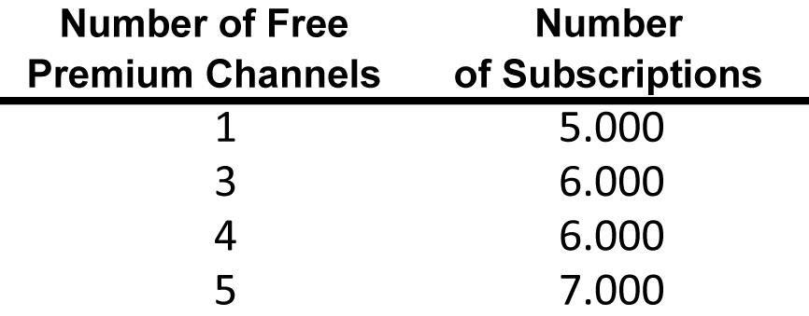
figure 5

How many free premium channels should the research director recommend for inclusion in the 3-For-All service? Explain.

