Lab 5 (This lab is worth 40 points and)
Many applications in computer graphics involve determining the relative positions of pixels in the plane. The following formula computes the distance between two points (x1,y1) and (x2,y2):

Create a Web page named distance.html that computes the distance between two arbitrary points. Your page should have text boxes where the user can enter the coordinates, then display the distance between those points at the click of a button. The button should call the function that performs the calculation. The figure below shows a screen shot of what your page might look like. (25 points).
Make sure the value of distance is rounded to 2 decimal places (5 points)

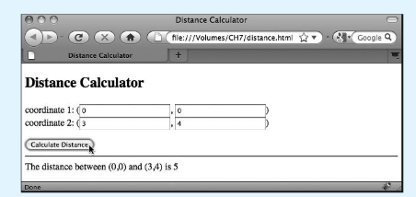

Add an ONLOAD attribute to your web page. Within that attribute, place a call to the alert function so that a greeting is displayed when the page loads. For example, the alert window might display the message 'Hello and welcome to my page!' (10 points)

